第 一 章
Chapter 1
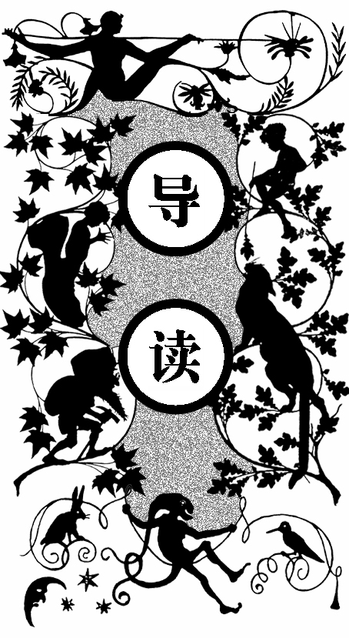
在丰盛的晚饭后，时间旅行家向我们讲述起他新近研究的深奥问题。他认为，在空间除了长度、宽度和高度三维以外，还存在第四维，就像在二维平面描绘三维图画一样，通过三维空间也同样可以表现四维空间。同一个人在不同时间的肖像，便正是用三维表现的四维生命。
在座的医生与心理学家对这一论断产生了很大的疑问——如果确实存在第四维时间，那么我们自然能够在时间里自由来回，可事实并非如此。这个问题正好问到了点上。如果文明人可以通过飞机或气球抵制地心引力，那么就可以通过一种机器来穿越时间，这正是时间旅行家的伟大发明。
时间旅行家很自豪地把他的时间机器呈现在我们面前，并借助心理学家的手指按下时间机器的白色杠杆，眼看着它慢慢变得模糊直到消失。我们面面相觑。
时间旅行家对大家的反应感到很满足，但他还不能断定这台小小的时间机器是走向了未来，还是回到了过去。他还带我们参观了他的实验室，并认真地告诉我们，他要完成一台真正可以载人的时间机器，带着他穿越时空，揭开时间的奥秘。

he Time Traveler was expounding a recondite matter to us. His gray eyes shone and twinkled, and his usually pale face was flushed and animated.
T
The fire burned brightly, and the soft radiance of the incandescent lights in the lilies of silver caught the bubbles that flashed and passed in our glasses.
Our chairs, being his patents, embraced and caressed us rather than submitted to be sat upon, and there was that luxurious after-dinner atmosphere when thought roams gracefully free of the trammels of precision. And he put it to us in this way—marking the points with a lean forefinger—as we sat and lazily admired his earnestness over this new paradox (as we thought it) and his fecundity.
‘You must follow me carefully. I shall have to controvert one or two ideas that are almost universally accepted. The geometry, for instance, they taught you at school is founded on a misconception.’
‘Is not that rather a large thing to expect us to begin upon?’ said Filby, an argumentative person with red hair.
‘I do not mean to ask you to accept anything without reasonable ground for it. You will soor admit as much as I need from you. You know of course that a mathematical line, a line of thickness NIL, has no real existence. They taught you that? Neither has a mathematical plane. These things are mere abstractions.’
‘That is all right,’ said the Psychologist. ‘Nor, having only length, breadth, and thickness, can a cube have a real existence.’
‘There I object,’ said Filby. ‘Of course a solid body may exist. All real things—’
‘So most people think. But wait a moment. Can an instantaneous cube exist?’
‘Don’ t follow you,’ said Filby.
‘Can a cube that does not last for any time at all, have a real existence?’ Filby became pensive.
‘Clearly,’ the Time Traveler proceeded, ‘any real body must have extension in FOUR directions: it must have Length, Breadth, Thickness, and —Duration. But through a natural infirmity of the flesh, which I will explain to you in a moment, we incline to overlook this fact. There are really four dimensions, three which we call the three planes of Space, and a fourth, Time. There is, however, a tendency to draw an unreal distinction between the former three dimensions and the latter, because it happens that our consciousness moves intermittently in one direction along the latter from the beginning to the end of our lives.’
‘That,’ said a very young man, making spasmodic efforts to relight his cigar over the lamp. ‘that…very clear indeed.’
‘Now, it is very remarkable that this is so extensively overlooked,’ continued the Time Traveler, with a slight accession of cheerfulness. ‘Really this is what is meant by the Fourth Dimension, though some people who talk about the Fourth Dimension do not know they mean it. It is only another way of looking at Time. There is no difference between time and any of the three dimensions of space except that our consciousness moves along it. But some foolish people have got hold of the wrong side of that idea. You have all heard what they have to say about this Fourth Dimension?’
‘I have not,’ said the Provincial Mayor.
‘It is simply this. That Space, as our mathematicians have it, is spoken of as having three dimensions, which one may call Length, Breadth, and Thickness, and is always definable by reference to three planes, each at right angles to the others. But some philosophical people have been asking why three dimensions particularly—why not another direction at right angles to the other three? —and have even tried to construct a Four-Dimension geometry. Professor Simon Newcomb was expounding this to the New York Mathematical Society only a month or so ago. You know how on a flat surface, which has only two dimensions, we can represent a figure of a three-dimensional solid, and similarly they think that by models of three dimensions they could represent one of four—if they could master the perspective of the thing. See?’
‘I think so,’ murmured the Provincial Mayor. and, knitting his brows, he lapsed into an introspective state, his lips moving as one who repeats mystic words.
‘Yes, I think I see it now,’ he said after some time, brightening in a quite transitory manner.
‘Well, I do not mind telling you I have been at work upon this geometry of Four Dimensions for some time. Some of my results are curious. For instance, here is a portrait of a man at eight years old, another at fifteen, another at seventeen, another at twenty-three, and so on. All these are evidently sections, as it were, Three-Dimensional representations of his Four- Dimensioned being, which is a fixed and unalterable thing.
‘Scientific people,’ proceeded the Time Traveler, after the pause required for the proper assimilation of this, ‘know very well that Time is only a kind of Space. Here is a popular scientific diagram, a weather record. This line I trace with my finger shows the movement of the barometer. Yesterday it was so high, yesterday night it fell, then this morning it rose again, and so gently upward to here. Surely the mercury did not trace this line in any of the dimensions of Space generally recognized. But certainly it traced such a line, and that line, therefore, we must conclude was along the Time-Dimension.’
‘But,’ said the Medical Man, staring hard at a coal in the fire, ‘if Time is really only a fourth dimension of Space, why is it, and why has it always been, regarded as something different? And why cannot we move in Time as we move about in the other dimensions of Space?’
The Time Traveler smiled. ‘Are you sure we can move freely in Space? Right and left we can go, backward and forward freely enough, and men always have done so. I admit we move freely in two dimensions. But how about up and down? Gravitation limits us there.’
‘Not exactly,’ said the Medical Man. ‘There are balloons.’
‘But before the balloons, save for spasmodic jumping and the inequalities of the surface, man had no freedom of vertical movement.’
‘Still they could move a little up and down,’ said the Medical Man.
‘Easier, far easier down than up.’
‘And you cannot move at all in Time, you cannot get away from the, present moment.’
‘My dear sir, that is just where you are wrong. That is just where the whole world has gone wrong. We are always getting away from the present moment. Our mental existences, which are immaterial and have no dimensions, are passing along the Time-Dimension with a uniform velocity from the cradle to the grave. Just as we should travel down if we began our existence fifty miles above the earth’s surface.’
‘But the great difficulty is this,’ interrupted the Psychologist. ‘You can move about in all directions of Space, but you cannot move about in Time.’
‘That is the germ of my great discovery. But you are wrong to say that we cannot move about in Time. For instance, if I am recalling an incident very vividly I go back to the instant of its occurrence: I become absent- minded, as you say. I jump back for a moment. Of course we have no means of staying back for any length of Time, any more than a savage or an animal has of staying six feet above the ground. But a civilized man is better off than the savage in this respect. He can go up against gravitation in a balloon, and why should he not hope that ultimately he may be able to stop or accelerate his drift along the Time-Dimension, or even turn about and travel the other way?’
‘Oh, this,’ began Filby. ‘is all—’
‘Why not?’ said the Time Traveler.
‘It’ s against reason,’ said Filby.
‘What reason?’ said the Time Traveler.
‘You can show black is white by argument,’ said Filby. ‘but you will never convince me.’
‘Possibly not,’ said the Time Traveler. ‘But now you begin to see the object of my investigations into the geometry of Four Dimensions. Long ago I had a vague inkling of a machine—’
‘To travel through Time!’ exclaimed the Very Young Man.
‘That shall travel indifferently in any direction of Space and Time, as the driver determines.’ Filby contented himself with laughter.
‘But I have experimental verification,’ said the Time Traveler.
‘It would be remarkably convenient for the historian,’ the Psychologist suggested. ‘One might travel back and verify the accepted account of the Battle of Hastings, for instance!’
‘Don’t you think you would attract attention?’ said the Medical Man. ‘Our ancestors had no great tolerance for anachronisms.’
‘One might get one’ s Greek from the very lips of Homer and Plato,’ the Very Young Man thought.
‘In which case they would certainly plough you for the Little-go. The German scholars have improved Greek so much.’
‘Then there is the future,’ said the Very Young Man. ‘Just think! One might invest all one’ s money, leave it to accumulate at interest, and hurry on ahead!’
‘To discover a society ,’ said I. ‘erected on a strictly communistic basis.’
‘Of all the wild extravagant theories!’ began the Psychologist.
‘Yes, so it seemed to me, and so I never talked of it until—’
‘Experimental verification!’ cried I. ‘You are going to verify that?’
‘The experiment!’ cried Filby, who was getting brain-weary.
‘Let’ s see your experiment anyhow,’ said the Psychologist. ‘though it’ s all humbug, you know.’
The Time Traveler smiled round at us. Then, still smiling faintly, and with his hands deep in his trousers pockets, he walked slowly out of the room, and we heard his slippers shuffling down the long passage to his laboratory.
The Psychologist looked at us. ‘I wonder what he’ s got?’
‘Some sleight-of-hand trick or other,’ said the Medical Man, and Filby tried to tell us about a conjurer he had seen at Burslem; but before he had finished his preface the Time Traveler came back, and Filby’ s anecdote collapsed.
The thing the Time Traveler held in his hand was a glittering metallic framework, scarcely larger than a small clock, and very delicately made. There was ivory in it, and some transparent crystalline substance.
And now I must be explicit, for this that follows—unless his explanation is to be accepted—is an absolutely unaccountable thing.
He took one of the small octagonal tables that were scattered about the room, and set it in front of the fire, with two legs on the hearthrug.
On this table he placed the mechanism. Then he drew up a chair, and sat down.
The only other object on the table was a small shaded lamp, the bright light of which fell upon the model. There were also perhaps a dozen candles about, two in brass candlesticks upon the mantel and several in sconces, so that the room was brilliantly illuminated.
I sat in a low armchair nearest the fire, and I drew this forward so as to be almost between the Time Traveler and the fireplace.
Filby sat behind him, looking over his shoulder. The Medical Man and the Provincial Mayor watched him in profile from the right, the Psychologist from the left. The Very Young Man stood behind the Psychologist. We were all on the alert. It appears incredible to me that any kind of trick, however subtly conceived and however adroitly done, could have been played upon us under these conditions.
The Time Traveler looked at us, and then at the mechanism.
‘Well?’ said the Psychologist.
‘This little affair,’ said the Time Traveler, resting his elbows upon the table and pressing his hands together above the apparatus, ‘is only a model. It is my plan for a machine to travel through time. You will notice that it looks singularly askew, and that there is an odd twinkling appearance about this bar, as though it was in some way unreal.’ He pointed to the part with his finger. ‘Also, here is one little white lever, and here is another.’
The Medical Man got up out of his chair and peered into the thing. ‘It’ s beautifully made,’ he said.
‘It took two years to make,’ retorted the Time Traveler. Then, when we had all imitated the action of the Medical Man, he said: ‘Now I want you clearly to understand that this lever, being pressed over, sends the machine gliding into the future, and this other reverses the motion. This saddle represents the seat of a time traveler. Presently I am going to press the lever, and off the machine will go. It will vanish, pass into future Time, and disappear. Have a good look at the thing. Look at the table too, and satisfy yourselves there is no trickery. I don’ t want to waste this model, and then be told I’m a quack.’
There was a minute’s pause perhaps.
The Psychologist seemed about to speak to me, but changed his mind.
Then the Time Traveler put forth his finger towards the lever.
‘No,’ he said suddenly. ‘Lend me your hand.’ And turning to the Psychologist, he took that individual’ s hand in his own and told him to put out his forefinger.
So that it was the Psychologist himself who sent forth the model Time Machine on its interminable voyage. We all saw the lever turn. I am absolutely certain there was no trickery. There was a breath of wind, and the lamp flame jumped. One of the candles on the mantel was blown out, and the little machine suddenly swung round, became indistinct, was seen as a ghost for a second perhaps, as an eddy of faintly glittering brass and ivory; and it was gone—vanished! Save for the lamp the table was bare.
Everyone was silent for a minute.
Then Filby said he was damned.
The Psychologist recovered from his stupor, and suddenly looked under the table.
At that the Time Traveler laughed cheerfully. ‘Well?’ he said, with a reminiscence of the Psychologist. Then, getting up, he went to the tobacco jar on the mantel, and with his back to us began to fill his pipe.
We stared at each other.
‘Look here,’ said the Medical Man. ‘are you in earnest about this? Do you seriously believe that that machine has traveled into time?’
‘Certainly,’ said the Time Traveler, stooping to light a spill at the fire. Then he turned, lighting his pipe, to look at the Psychologist’s face.
The Psychologist, to show that he was not unhinged, helped himself to a cigar and tried to light it uncut.
‘What is more, I have a big machine nearly finished in there,’ he indicated the laboratory. ‘and when that is put together I mean to have a journey on my own account.’
‘You mean to say that that machine has traveled into the future?’ said Filby.
‘Into the future or the past—I don’ t, for certain, know which.’
After an interval the Psychologist had an inspiration. ‘It must have gone into the past if it has gone anywhere,’ he said.
‘Why?’ said the Time Traveler.
‘Because I presume that it has not moved in space, and if it traveled into the future it would still be here all this time, since it must have traveled through this time.’
‘But,’I said. ‘If it traveled into the past it would have been visible when we came first into this room; and last Thursday when we were here; and the Thursday before that; and so forth!’
‘Serious objections,’ remarked the Provincial Mayor, with an air of impartiality, turning towards the Time Traveler.
‘Not a bit,’ said the Time Traveler, and, to the Psychologist: ‘You think. You can explain that. It’ s presentation below the threshold, you know, diluted presentation.’
‘Of course,’ said the Psychologist, and reassured us. ‘That’ s a simple point of psychology. I should have thought of it. It’ s plain enough, and helps the paradox delightfully. We cannot see it, nor can we appreciate this machine, any more than we can the spoke of a wheel spinning, or a bullet flying through the air. If it is traveling through time fifty times or a hundred times faster than we are, if it gets through a minute while we get through a second, the impression it creates will of course be only one-fiftieth or one- hundredth of what it would make if it were not traveling in time. That’ s plain enough.’ He passed his hand through the space in which the machine had been. ‘You see?’ he said, laughing.
We sat and stared at the vacant table for a minute or so. Then the Time Traveler asked us what we thought of it all.
‘It sounds plausible enough tonight,’ said the Medical Man. ‘but wait until tomorrow. Wait for the common sense of the morning.’
‘Would you like to see the Time Machine itself?’ asked the Time Traveler. And therewith, taking the lamp in his hand, he led the way down the long, draughty corridor to his laboratory.
I remember vividly the flickering light, his queer, broad head in silhouette, the dance of the shadows, how we all followed him, puzzled but incredulous, and how there in the laboratory we beheld a larger edition of the little mechanism which we had seen vanish from before our eyes.
Parts were of nickel, parts of ivory, parts had certainly been filed or sawn out of rock crystal. The thing was generally complete, but the twisted crystalline bars lay unfinished upon the bench beside some sheets of drawings, and I took one up for a better look at it. Quartz it seemed to be.
‘Look here,’ said the Medical Man, ‘are you perfectly serious? Or is this a trick—like that ghost you showed us last Christmas?’
‘Upon that machine,’ said the Time Traveler, holding the lamp aloft, ‘I intend to explore time. Is that plain? I was never more serious in my life.’
None of us quite knew how to take it.
I caught Filby’s eye over the shoulder of the Medical Man, and he winked at me solemnly.

第 二 章
Chapter 2
时间旅行家是一个聪明得令人害怕的人，在场的所有人宁可相信时间机器是真实存在的，也不会轻信他的话。所以在接下来的一周，我们都没有太多地谈论时间机器。
又到了周四，我照常来到位于里士满的时间旅行家的家。我到那里时医生已经到了，同在的还有心理学家、一名编辑、一名记者和一个沉默寡言的陌生人。时间旅行家给我们留了字条，说如果七点他还没回来，就让我们先吃饭。
恭敬不如从命，我们正吃着饭，时间旅行家回来了，他完全是一副乞丐模样，脚也受了伤。对于我们十分好奇的询问，开始时他置之不理，等他洗干净吃饱了饭才向我们讲起了他的时间之旅。他不许我们插嘴，我们只得默默地听着。

think that at that time none of us quite believed in the Time Machine. The fact is, the Time Traveler was one of those men who are too clever to be believed: you never felt that you saw all round him; you always suspected some subtle reserve, some ingenuity in ambush, behind his lucid frankness.
I
Had Filby shown the model and explained the matter in the Time Traveler’s words, we should have shown him far less skepticism. For we should have perceived his motives. a pork butcher could understand Filby.
But the Time Traveler had more than a touch of whim among his elements, and we distrusted him. Things that would have made the frame of a less clever man seemed tricks in his hands. It is a mistake to do things too easily.
The serious people who took him seriously never felt quite sure of his deportment; they were somehow aware that trusting their reputations for judgment with him was like furnishing a nursery with eggshell china.
So I don’ t think any of us said very much about time traveling in the interval between that Thursday and the next, though its odd potentialities ran, no doubt, in most of our minds: its plausibility, that is, its practical incredibleness, the curious possibilities of anachronism and of utter confusion it suggested.
For my own part, I was particularly preoccupied with the trick of the model. That I remember discussing with the Medical Man, whom I met on Friday at the Linnaean. He said he had seen a similar thing at Tubingen, and laid considerable stress on the blowing out of the candle. But how the trick was done he could not explain.
The next Thursday I went again to Richmond—I suppose I was one of the Time Traveler’s most constant guests—and, arriving late, found four or five men already assembled in his drawing room. The Medical Man was standing before the fire with a sheet of paper in one hand and his watch in the other. I looked round for the Time Traveler. ‘It’ s half past seven now,’ said the Medical Man. ‘I suppose we’d better have dinner?’
‘Where’ s—?’ said I, naming our host.
‘You’ve just come? It’ s rather odd. He’ s unavoidably detained. He asks me in this note to lead off with dinner at seven if he’ s not back. Says he’ll explain when he comes.’
‘It seems a pity to let the dinner spoil,’ said the Editor of a well-known daily paper; and thereupon the Doctor rang the bell.
The Psychologist was the only person besides the Doctor and myself who had attended the previous dinner. The other men were Blank, the Editor aforementioned, a certain journalist, and another—a quiet, shy man with a beard—whom I didn’ t know, and who, as far as my observation went, never opened his mouth all the evening.
There was some speculation at the dinner table about the Time Traveler’s absence, and I suggested time traveling, in a half-jocular spirit. The Editor wanted that explained to him, and the Psychologist volunteered a wooden account of the ‘ingenious paradox and trick’ we had witnessed that day week.
He was in the midst of his exposition when the door from the corridor opened slowly and without noise. I was facing the door, and saw it first.
‘Hallo!’ I said. ‘At last!’
And the door opened wider, and the Time Traveler stood before us.
I gave a cry of surprise.
‘Good heavens! Man, what’ s the matter?’ cried the Medical Man, who saw him next. And the whole tableful turned towards the door.
He was in an amazing plight. His coat was dusty and dirty, and smeared with green down the sleeves; his hair disordered, and as it seemed to me grayer—either with dust and dirt or because its color had actually faded. His face was ghastly pale; his chin had a brown cut on it—a cut half healed; his expression was haggard and drawn, as by intense suffering.
For a moment he hesitated in the doorway, as if he had been dazzled by the light. Then he came into the room. He walked with just such a limp as I have seen in footsore tramps. We stared at him in silence, expecting him to speak.
He said not a word, but came painfully to the table, and made a motion towards the wine.
The Editor filled a glass of champagne, and pushed it towards him. He drained it, and it seemed to do him good: for he looked round the table, and the ghost of his old smile flickered across his face.
‘What on earth have you been up to, man?’ said the Doctor.
The Time Traveler did not seem to hear. ‘Don’ t let me disturb you,’ he said, with a certain faltering articulation. ‘I’ m all right.’ He stopped, held out his glass for more, and took it off at a draught.
‘That’ s good,’ he said. His eyes grew brighter, and a faint color came into his cheeks.
His glance flickered over our faces with a certain dull approval, and then went round the warm and comfortable room. Then he spoke again, still as it were feeling his way among his words. ‘I’ m going to wash and dress, and then I’ll come down and explain things... Save me some of that mutton. I’ m starving for a bit of meat.’
He looked across at the Editor, who was a rare visitor, and hoped he was all right. The Editor began a question. ‘Tell you presently,’ said the Time Traveler. ‘I’m—funny! Be all right in a minute.’
He put down his glass, and walked towards the staircase door.
Again I remarked his lameness and the soft padding sound of his footfall, and standing up in my place, I saw his feet as he went out. He had nothing on them but a pair of tattered blood-stained socks. Then the door closed upon him. I had half a mind to follow, till I remembered how he detested any fuss about himself. For a minute, perhaps, my mind was woolgathering.
Then, ‘Remarkable Behavior of an Eminent Scientist,’ I heard the Editor say, thinking (after his wont ) in headlines. And this brought my attention back to the bright dinner table.
‘What’ s the game?’ said the Journalist. ‘Has he been doing the Amateur Cadger? I don’t follow.’
I met the eye of the Psychologist, and read my own interpretation in his face. I thought of the Time Traveler limping painfully upstairs. I don’ t think any one else had noticed his lameness.
The first to recover completely from this surprise was the Medical Man, who rang the bell—the Time Traveler hated to have servants waiting at dinner—for a hot plate. At that the Editor turned to his knife and fork with a grunt, and the Silent Man followed suit.
The dinner was resumed.
Conversation was exclamatory for a little while, with gaps of wonderment; and then the Editor got fervent in his curiosity. ‘Does our friend eke out his modest income with a crossing? Or has he his Nebuchadnezzar phases?’ he inquired.
‘I feel assured it’ s this business of the Time Machine,’ I said, and took up the Psychologist’ s account of our previous meeting.
The new guests were frankly incredulous.
The Editor raised objections. ‘What was this time traveling? A man couldn’t cover himself with dust by rolling in a paradox, could he?’ And then, as the idea came home to him, he resorted to caricature. ‘Hadn’t they any clothes-brushes in the Future?’
The Journalist too, would not believe at any price, and joined the Editor in the easy work of heaping ridicule on the whole thing. They were both the new kind of journalist—very joyous, irreverent young men.
‘Our Special Correspondent in the Day after Tomorrow reports,’ the Journalist was saying—or rather shouting—when the Time Traveler came back. He was dressed in ordinary evening clothes, and nothing save his haggard look remained of the change that had startled me.
‘I say,’ said the Editor hilariously, ‘these chaps here say you have been traveling into the middle of next week! Tell us all about little Rosebery, will you? What will you take for the lot?’
The Time Traveler came to the place reserved for him without a word. He smiled quietly, in his old way. ‘Where’ s my mutton?’ he said. ‘What a treat it is to stick a fork into meat again!’
‘Story !’ cried the Editor.
‘Story be damned !’ said the Time Traveler. ‘I want something to eat. I won’ t say a word until I get some peptone into my arteries. Thanks. And the salt.’
‘One word,’ said I. ‘Have you been time traveling?’
‘Yes,’ said the Time Traveler, with his mouth full, nodding his head.
‘I’ d give a shilling a line for a verbatim note,’ said the Editor.
The Time Traveler pushed his glass towards the Silent Man and rang it with his fingernail, at which the Silent Man, who had been staring at his face, started convulsively, and poured him wine.
The rest of the dinner was uncomfortable.
For my own part, sudden questions kept on rising to my lips, and I dare say it was the same with the others.
The Journalist tried to relieve the tension by telling anecdotes of Hettie Potter.
The Time Traveler devoted his attention to his dinner, and displayed the appetite of a tramp.
The Medical Man smoked a cigarette, and watched the Time Traveler through his eyelashes.
The Silent Man seemed even more clumsy than usual, and drank champagne with regularity and determination out of sheer nervousness.
At last the Time Traveler pushed his plate away, and looked round us. ‘I suppose I must apologize,’ he said. ‘I was simply starving. I’ ve had a most amazing time.’ He reached out his hand for a cigar, and cut the end. ‘But come into the smoking room. It’ s too long a story to tell over greasy plates.’ And ringing the bell in passing, he led the way into the adjoining room.
‘You have told Blank, and Dash, and Chose about the machine?’ he said to me, leaning back in his easy chair and naming the three new guests.
‘But the thing’ s a mere paradox,’ said the Editor.
‘I can’ t argue tonight. I don’ t mind telling you the story, but I can’ t argue. I will,’ he went on, ‘tell you the story of what has happened to me, if you like, but you must refrain from interruptions. I want to tell it. Badly. Most of it will sound like lying. So be it! It’ s true—every word of it, all the same. I was in my laboratory at four o’ clock, and since then... I’ ve lived eight days… such days as no human being ever lived before! I’ m nearly worn out, but I shan’ t sleep till I’ ve told this thing over to you. Then I shall go to bed. But no interruptions! Is it agreed?’
‘Agreed,’ said the Editor, and the rest of us echoed ‘Agreed.’
And with that the Time Traveler began his story as I have set it forth.
He sat back in his chair at first, and spoke like a weary man. Afterwards he got more animated.
In writing it down I feel with only too much keenness the inadequacy of pen and ink—and, above all, my own inadequacy—to express its quality. You read, I will suppose, attentively enough; but you cannot see the speaker’ s white, sincere face in the bright circle of the little lamp, nor hear the intonation of his voice. You cannot know how his expression followed the turns of his story!
Most of us hearers were in shadow, for the candles in the smoking room had not been lighted, and only the face of the Journalist and the legs of the Silent Man from the knees downward were illuminated. At first we glanced now and again at each other. After a time we ceased to do that, and looked only at the Time Traveler’s face.

第 三 章
Chapter 3
时间旅行家正是驾驶时间机器“出游”的。
他把启动杆按到了极端。黑暗与光明瞬间更替，刺痛了他的眼睛。渐渐地，月圆月缺极速变换，太阳变成了一道火焰。整个地球都变了，四季刹那间轮番出场。他开始变得无比兴奋，各种奇异的想法与恐惧占据了思绪，他要停下来，不顾一切后果地。于是旅行家拉动了操作杆，尔后便被狠狠地抛了出去。
他来到了一块小草坪，耳边的混乱声消失了，但被大雨淋透了全身，这一切使旅行家有点愤懑与恐惧。也许在这奇怪的空间，他会变成一种凶猛的野兽。他感到惊慌，想要再度起程。这时天渐渐晴了，雨后明媚的阳光洒向大地，使他又恢复了勇气。他看到了身穿紫袍、腰束皮带的人，他们是那么漂亮优雅。好奇心驱使他观察着这个遥远的世界。

told some of you last Thursday of the principles of the Time Machine, and showed you the actual thing itself, incomplete in the workshop. There it is now, a little travel-worn, truly; and one of the ivory bars is cracked, and a brass rail bent; but the rest of it’ s sound enough. I expected to finish it on Friday, but on Friday, when the putting together was nearly done, I found that one of the nickel bars was exactly one inch too short, and this I had to get remade; so that the thing was not complete until this morning.
‘I

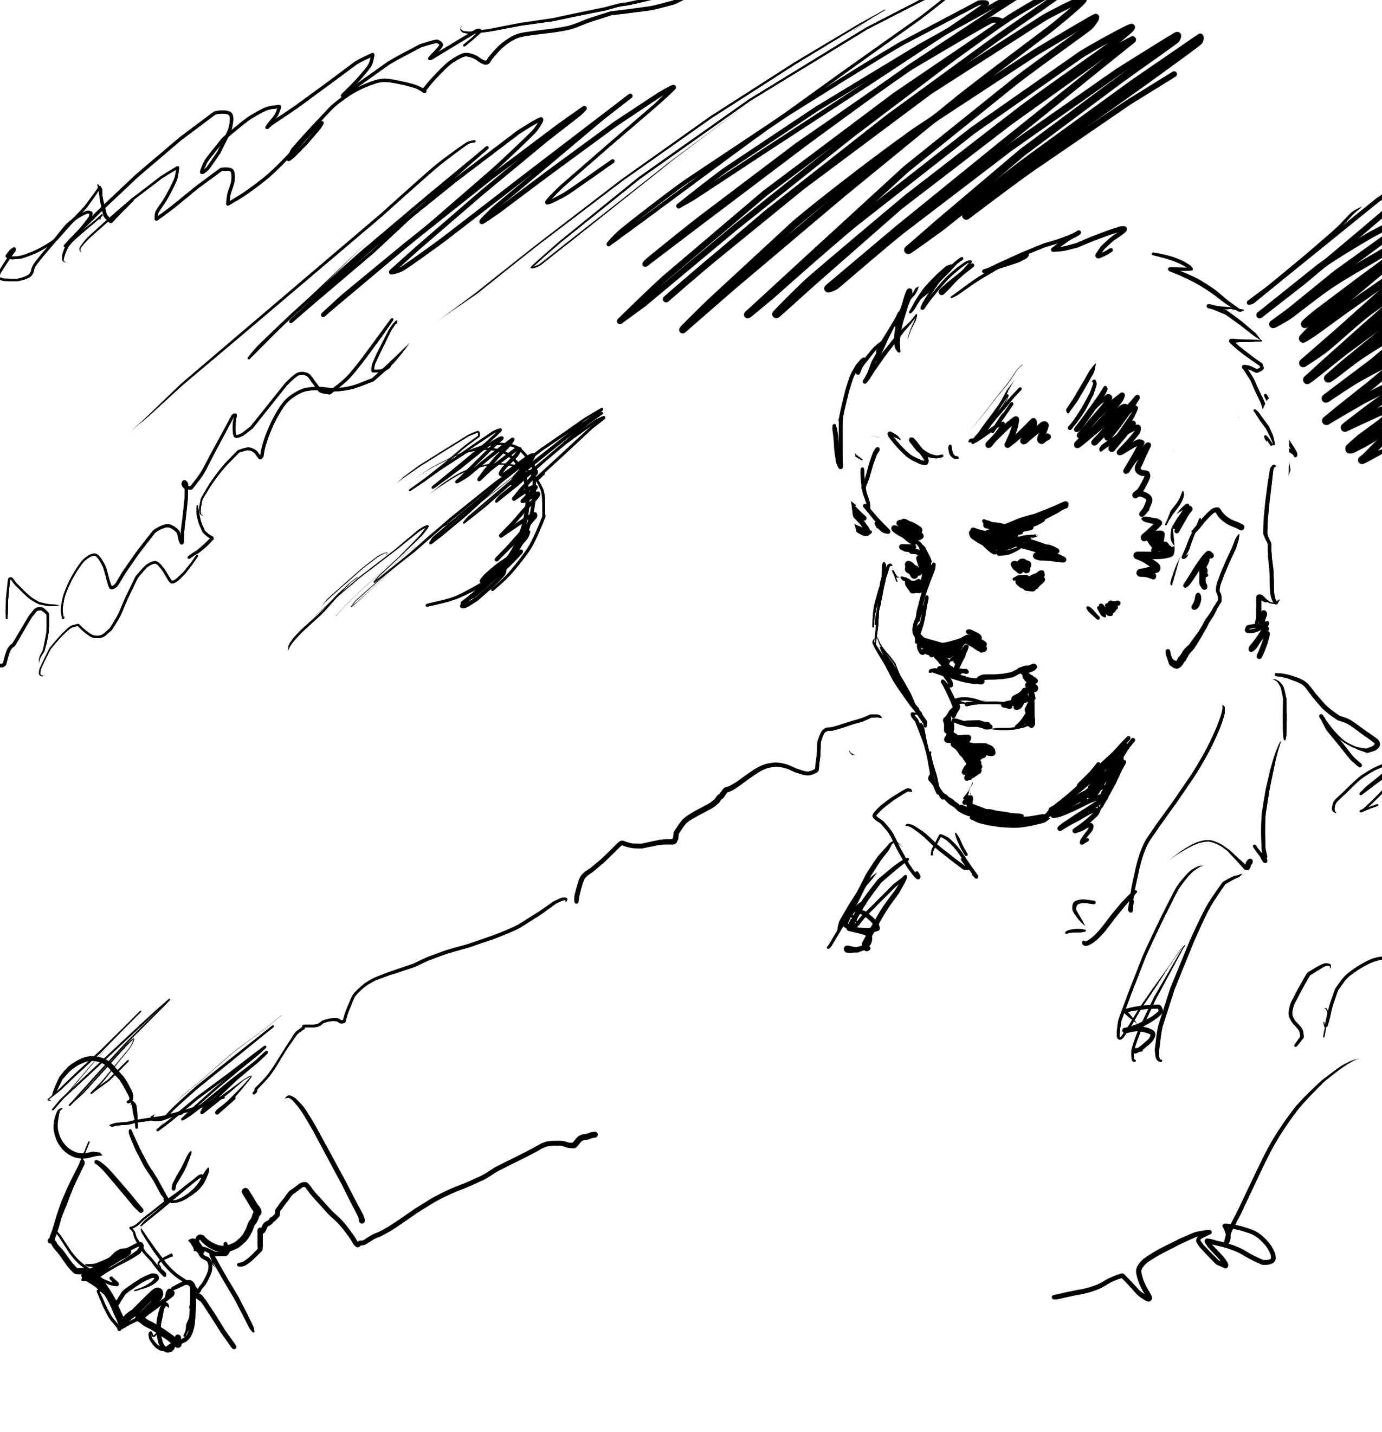

It was at ten o’ clock today that the first of all Time Machines began its career. I gave it a last tap, tried all the screws again, put one more drop of oil on the quartz rod, and sat myself in the saddle. I suppose a suicide who holds a pistol to his skull feels much the same wonder at what will come next as I felt then. I took the starting lever in one hand and the stopping one in the other, pressed the first, and almost immediately the second. I seemed to reel. I felt a nightmare sensation of falling; and, looking round, I saw the laboratory exactly as before. Had anything happened? For a moment I suspected that my intellect had tricked me. Then I noted the clock. A moment before, as it seemed, it had stood at a minute or so past ten; now it was nearly half-past three!
I drew a breath, set my teeth, gripped the starting lever with both hands, and went off with a thud. The laboratory got hazy and went dark. Mrs. Watchett came in and walked, apparently without seeing me, towards the garden door. I suppose it took her a minute or so to traverse the place, but to me she seemed to shoot across the room like a rocket. I pressed the lever over to its extreme position. The night came like the turning out of a lamp, and in another moment came tomorrow. The laboratory grew faint and hazy, then fainter and ever fainter. Tomorrow night came back, then day again, night again, day again, faster and faster still. An eddying murmur filled my ears, and a strange, dumb confusedness descended on my mind.
I am afraid I cannot convey the peculiar sensations of time traveling. They are excessively unpleasant. There is a feeling exactly like that one has upon a switchback—of a helpless headlong motion! I felt the same horrible anticipation, too, of an imminent smash.
As I put on pace, night followed day like the flapping of a black wing. The dim suggestion of the laboratory seemed presently to fall away from me, and I saw the sun hopping swiftly across the sky, leaping it every minute, and every minute marking a day. I supposed the laboratory had been destroyed and I had come into the open air.
I had a dim impression of scaffolding, but I was already going too fast to be conscious of any moving things. The slowest snail that ever crawled dashed by too fast for me. The twinkling succession of darkness and light was excessively painful to the eye. Then, in the intermittent darkness, I saw the

