泰尔亲王伯利克里
Pericles, Prince of Tyre
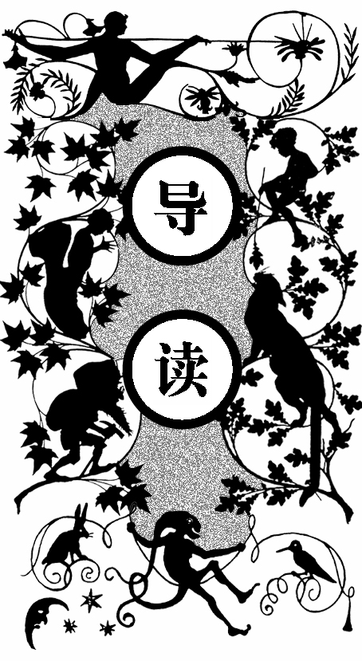
由于泰尔亲王伯利克里发现了希腊皇帝暗中做的坏事，这个皇帝要报复泰尔城的百姓。为了避免灾难发生，伯利克里主动到海外流亡。泰尔则由能臣赫勒堪纽斯来管理。伯利克里首先到达了塔瑟斯，救济了这里的百姓，塔瑟斯总督克里翁和百姓都很感谢伯利克里。但是为了躲避希腊皇帝的追杀，伯利克里只好继续流亡。
不幸的伯利克里遇上了风暴，但他幸免于难，被渔夫救起。现在伯利克里正在本塔波利斯国，国王的女儿泰萨要在第二天生日的时候比武招亲。伯利克里很为自己丢失的铠甲惋惜，那是父亲的遗物，否则就可以穿着去比武了。这时渔夫把铠甲还给了伯利克里，原来铠甲也被渔夫打捞起来了。
伯利克里打败了所有的竞争者，一下子被本塔波利斯的国王看中，国王把自己的女儿泰萨嫁给了伯利克里，不过伯利克里为了躲避追杀并没有显露自己真正的身份。很快，伯利克里接到赫勒堪纽斯的消息，希腊国王死了，而泰尔城百姓要拥立赫勒堪纽斯，赫勒堪纽斯希望伯利克里尽快回来。本塔波利斯的国王知道自己的女儿嫁给了亲王，很高兴，但是现在女儿怀着身孕，不得不跟伯利克里分别。不过泰萨坚持要与丈夫一起回国，国王和亲王都只好同意。
但是不幸的伯利克里在返回的途中又遇到了风暴，泰萨受了惊吓，生下孩子以后就不省人事了。伯利克里非常难过，但是为了祈求风暴平息，只好将死去的王后投入大海。伯利克里还在装有泰萨尸体的箱子上写明了泰萨的名字和身份，希望好心人能帮忙掩埋。这个箱子被塞利蒙捞起，塞

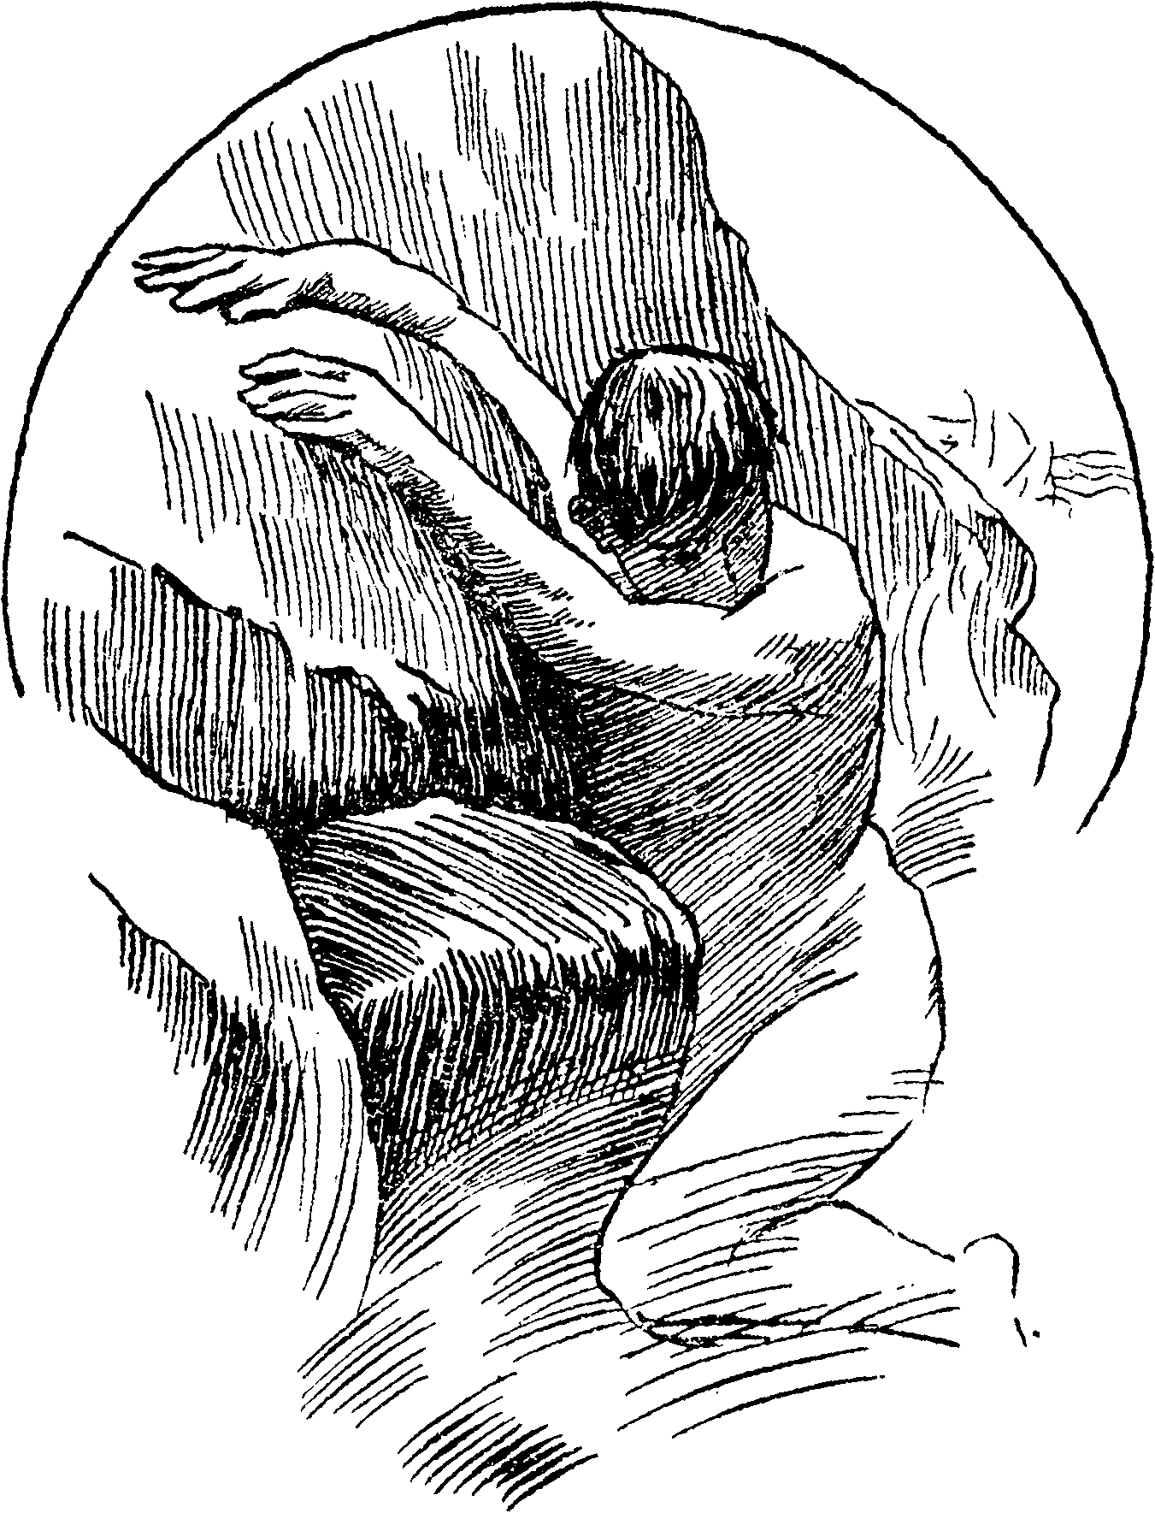
他被冲到海边的怪石上

利蒙不相信泰萨已经身亡，后来设法把泰萨救活，原来泰萨只是昏迷而已。泰萨看了丈夫的字条，以为丈夫在风暴中丧生，就去神庙里做了女祭司，虔诚祈祷。
而伯利克里这边，担心刚刚生下的女婴坚持不到泰尔，就在路过塔瑟斯的时候将其托付给了克里翁夫妇。克里翁夫妇答应会把这个女孩儿养大成人，并且接受最好的教育。伯利克里很放心，就把女儿玛莉娜的奶妈一起留了下来。
一晃十四年过去了，泰尔政通人和，玛莉娜也长大成人，而且多才多艺，深受大家喜爱，而克里翁自己的孩子则相差甚远，克里翁的妻子迪奥妮萨很是嫉妒。于是，这个女人决定趁玛莉娜为自己刚刚去世的奶妈哭泣的时候派人杀掉玛莉娜。迪奥妮萨先哄骗玛莉娜跟着仆人里欧奈恩去散步，然后让里欧奈恩趁机杀掉玛莉娜。
一路上玛莉娜都在讲着自己出生的那个故事，可里欧奈恩还是要杀掉玛莉娜，就在里欧奈恩将要动手的时候，玛莉娜被海盗掳走了。海盗把玛莉娜卖到了米迪林。由于玛莉娜很有才华，米迪林的总督赖斯莫克斯很尊重这个女孩儿，甚至想要弄清玛丽娜的底细，然后向玛莉娜求婚。
里欧奈恩回去撒谎说已经杀死了玛莉娜，迪奥妮萨就为玛莉娜立了一个墓碑。伯利克里来接自己的女儿，却只看到墓碑，他悲痛欲绝，在船上一声不吭，郁郁寡欢。伯利克里的船经过了米迪林，赖斯莫克斯前来迎接。赖斯莫克斯听说了亲王的状况，就把玛莉娜叫来，希望用玛莉娜的聪明才智使亲王恢复正常。
玛莉娜开始为亲王讲述自己的不幸，伯利克里觉得这个女孩儿很像自己死去的妻子，就问起了玛莉娜的身世。当亲王听说女孩就叫玛莉娜，还听说了女孩的其他经历，确信这是自己的女儿时，亲王欣喜若狂。这一晚，亲王做了一个奇怪的梦，梦里一个女神要亲王去艾菲索斯的神庙讲述自己的不幸，会让他遇到意外之喜。
第二天，赖斯莫克斯向玛莉娜求婚，亲王伯利克里要求自己的女儿和赖斯莫克斯先陪着自己去一趟艾菲索斯。亲王在艾菲索斯的神庙里诉说着自己的不幸，而这里的祭司正好就是泰萨，泰萨听出了亲王的声音，听了亲王的经历之后泰萨喊着亲王的名字晕倒了。这时塞利蒙告诉亲王这个祭司就是泰萨，又把泰萨当年的经历告诉亲王。亲王非常高兴，现在一家人终于团聚了，而泰萨也同意赖斯莫克斯迎娶自己的女儿玛莉娜。
品行端正的人历经千辛万苦终得圆满，而对像迪奥妮萨这样的坏人，塔瑟斯的百姓非常生气，火烧王宫，克里翁和迪奥妮萨都被烧死了。

人物事件词汇表
Tyre 泰尔 古菲尼基的港口，现在黎巴嫩
Pericles 伯利克里 泰尔的统治者，一位英明的亲王
Helicanus 赫勒堪纽斯 泰尔亲王的能臣，一位正直的大臣
Thrsus 塔瑟斯 古国西里西亚的首府
Cleon 克里翁 塔瑟斯的总督
Pentapolis 本塔波利斯 希腊文，意为“五座城”，疑为古希腊在北非利比亚的殖民地
Thaisa 泰萨 伯利克里的王后，本塔波利斯国王的女儿
Cerimon 塞利蒙 艾菲索斯一个有名望的人，略懂医术
Dionysia 迪奥妮萨 克里翁的妻子，一个妒贤嫉能的女人
Marina 玛莉娜 伯利克里的女儿，名字的意思是“海女”，在海上而生
Leonine 里欧奈恩 迪奥妮萨的仆人
Mitylene 米迪林 希腊的一个岛屿，在爱琴海中
Lysimachus 赖斯莫克斯 米迪林的总督，娶了伯利克里的女儿玛莉娜

P
ericles, Prince of Tyre, became a voluntary exile from his dominions, to avert the dreadful calamities which Antiochus, the wicked emperor of Greece, threatened to bring upon his subjects and city of Tyre, in revenge for a discovery which the prince had made of a shocking deed which the emperor had done in secret; as commonly it proves dangerous to pry into the hidden crimes of great ones. Leaving the government of his people in the hands of his able and honest minister, Helicanus, Pericles set sail from Tyre, thinking to absent himself till the wrath of Antiochus, who was mighty, should be appeased.

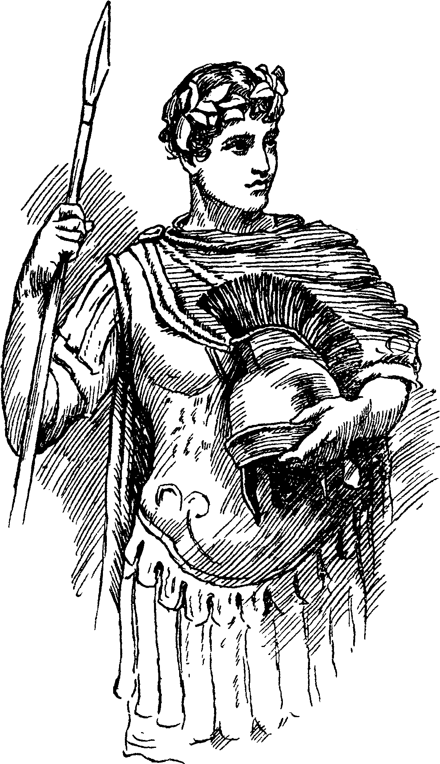
穿上了盔甲

The first place which the prince directed his course to was Tarsus, and hearing that the city of Tarsus was at that time suffering under a severe famine, he took with him a store of provisions for its relief. On his arrival he found the city reduced to the utmost distress; and, he coming like a messenger from heaven with his unhoped-for succor, Cleon, the governor of Tarsus, welcomed him with boundless thanks. Pericles had not been here many days before letters came from his faithful minister, warning him that it was not safe for him to stay at Tarsus, for Antiochus knew of his abode, and by secret emissaries despatched for that purpose sought his life. Upon receipt of these letters Pericles put out to sea again, amid the blessings and prayers of a whole people who had been fed by his bounty.
He had not sailed far when his ship was overtaken by a dreadful storm, and every man on board perished except Pericles, who was cast by the sea waves naked on an unknown shore, where he had not wandered long before he met with some poor fishermen, who invited him to their homes, giving him clothes and provisions. The fishermen told Pericles the name of their country was Pentapolis, and that their king was Simonides, commonly called the good Simonides, because of his peaceable reign and good government. From them he also learned that King Simonides had a fair young daughter, and that the following day was her birthday, when a grand tournament was to be held at court, many princes and knights being come from all parts to try their skill in arms for the love of Thaisa, this fair princess. While the prince was listening to this account, and secretly lamenting the loss of his good armor, which disabled him from making one among these valiant knights, another fisherman brought in a complete suit of armor that he had taken out of the sea with his fishing-net, which proved to be the very armor he had lost. When Pericles beheld his own armor he said: “Thanks, Fortune; after all my crosses you give me somewhat to repair myself This armor was bequeathed to me by my dead father, for whose dear sake I have so loved it that whithersoever I went I still have kept it by me, and the rough sea that parted it from me, having now become calm, hath given it back again, for which I thank it, for, since I have my father’s gift again, I

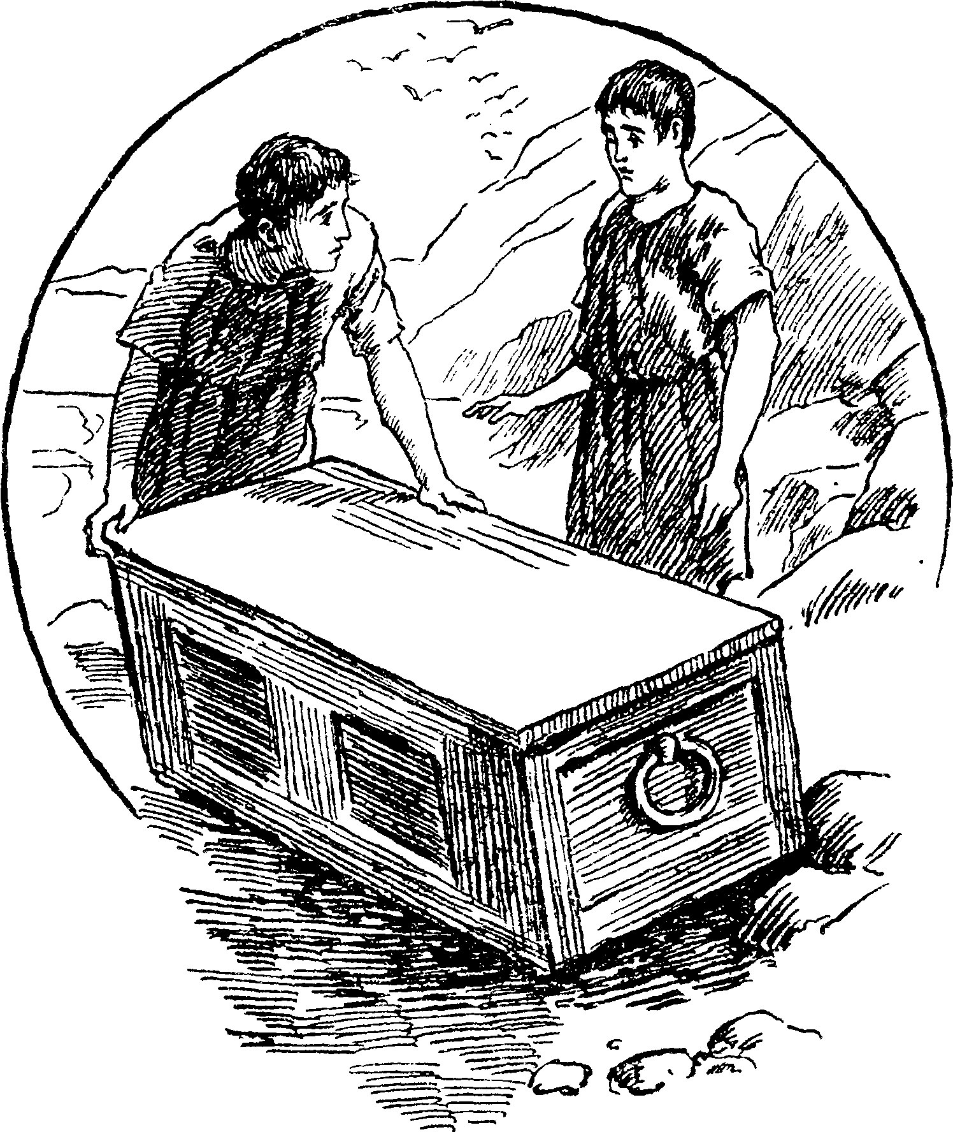
王后被放进箱子

think my shipwreck no misfortune.”
The next day Pericles, clad in his brave father’s armor, repaired to the royal court of Simonides, where he performed wonders at the tournament, vanquishing with ease all the brave knights and valiant princes who contended with him in arms for the honor of Thaisa’s love. When brave warriors contended at court tournaments for the love of kings’ daughters, if one proved sole victor over all the rest, it was usual for the great lady for whose sake these deeds of valor were undertaken to bestow all her respect upon the conqueror, and Thaisa did not depart from this custom, for she presently dismissed all the princes and knights whom Pericles had vanquished, and distinguished him by her especial favor and regard, crowning him with the wreath of victory, as king of that day’s happiness; and Pericles became a most passionate lover of this beauteous princess from the first moment he beheld her.
The good Simonides so well approved of the valor and noble qualities of Pericles, who was indeed a most accomplished gentleman and well learned in all excellent arts, that though he knew not the rank of this royal stranger (for Pericles for fear of Antiochus gave out that he was a private gentleman of Tyre), yet did not Simonides disdain to accept of the valiant unknown for a son-in-law, when he perceived his daughter’s affections were firmly fixed upon him.
Pericles had not been many months married to Thaisa before he received intelligence that his enemy Antiochus was dead, and that his subjects of Tyre, impatient of his long absence, threatened to revolt and talked of placing Helicanus upon his vacant throne. This news came from Helicanus himself, who, being a loyal subject to his royal master, would not accept of the high dignity offered him, but sent to let Pericles know their intentions, that he might return home and resume his lawful right. It was matter of great surprise and joy to Simonides to find that his son-in-law (the obscure knight) was the renowned Prince of Tyre; yet again he regretted that he was not the private gentleman he supposed him to be, seeing that he must now part both with his admired son-in-law and his beloved daughter, whom he feared to trust to the perils of the sea, because Thaisa was with child; and Pericles himself wished her to

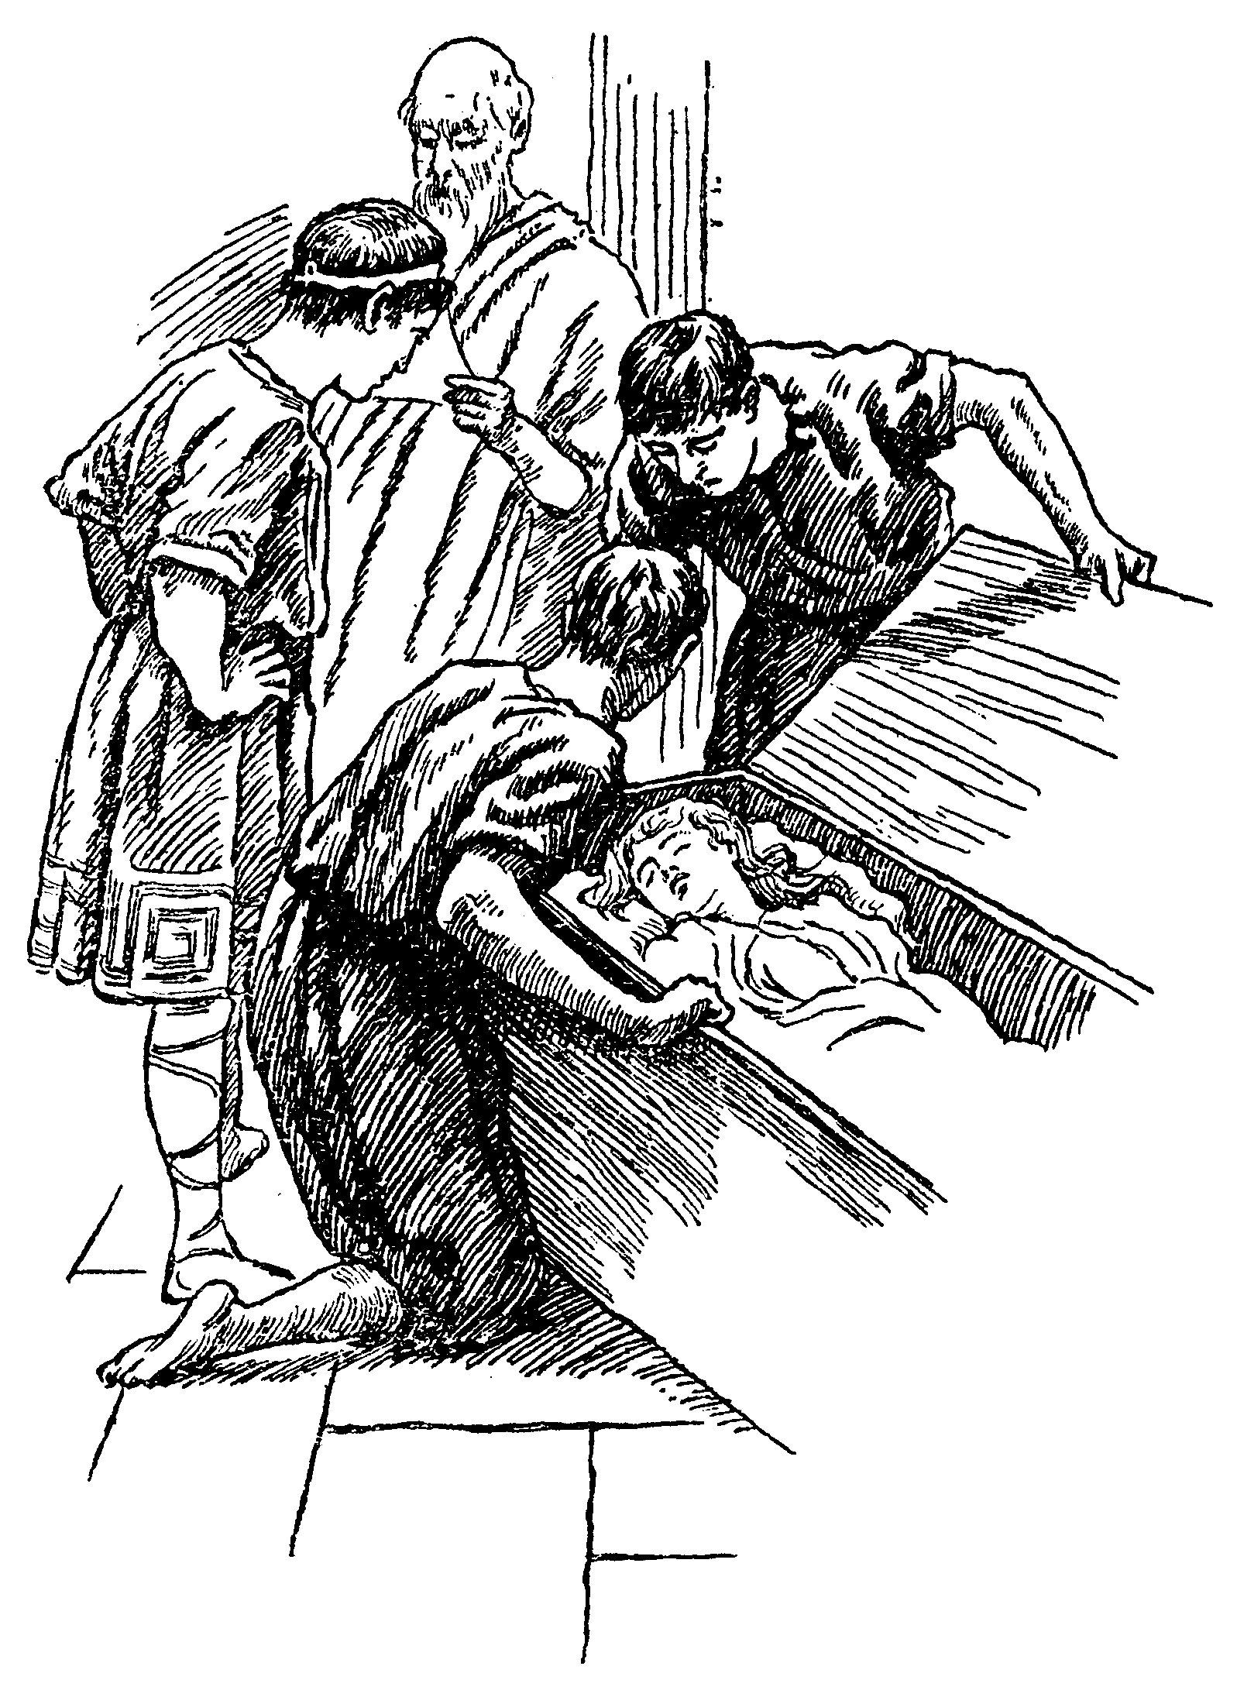
王后被人救起

remain with her father till after her confinement; but the poor lady so earnestly desired to go with her husband that at last they consented, hoping she would reach Tyre before she was brought to bed.
The sea was no friendly element to unhappy Pericles, for long before they reached Tyre another dreadful tempest arose, which so terrified Thaisa that she was taken ill, and in a short space of time her nurse, Lychorida, came to Pericles with a little child in her arms, to tell the prince the sad tidings that his wife died the moment her little babe was born. She held the babe toward its father, saying:
“Here is a thing too young for such a place. This is the child of your dead queen.”
No tongue can tell the dreadful sufferings of Pericles when he heard his wife was dead. As soon as he could speak he said:
“O you gods, why do you make us love your goodly gifts and then snatch those gifts away?”
“Patience, good sir,” said Lychorida, “here is all that is left alive of our dead queen, a little daughter, and for your child’s sake be more manly. Patience, good sir, even for the sake of this precious charge.”
Pericles took the newborn infant in his arms, and he said to the little babe: “Now may your life be mild, for a more blusterous birth had never babe! May your condition be mild and gentle, for you have had the rudest welcome that ever prince’s child did meet with! May that which follows be happy, for you have had as chiding a nativity as fire, air, water, earth, and heaven could make to herald you from the womb! Even at the first, your loss,” meaning in the death of her mother, “is more than all the joys, which you shall find upon this earth to which you are come a new visitor, shall be able to recompense.”
The storm still continuing to rage furiously, and the sailors having a superstition that while a dead body remained in the ship the storm would never cease, they came to Pericles to demand that his queen should be thrown overboard; and they said:
“What courage, sir? God save you!”

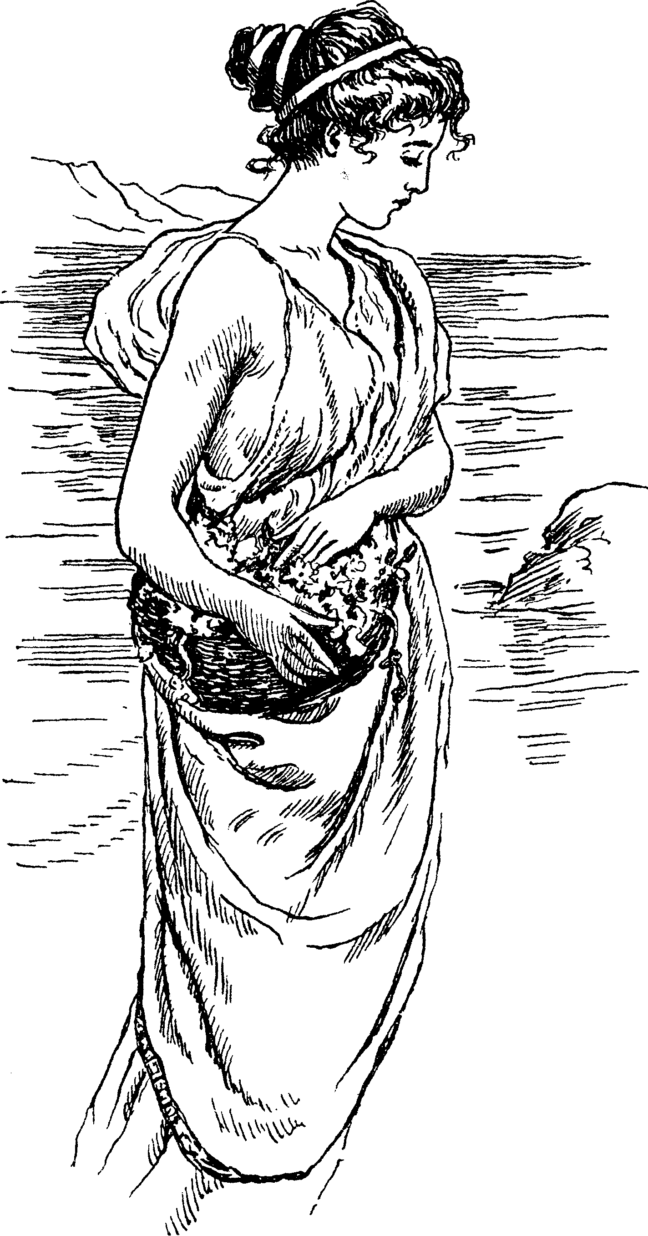
美丽的玛丽娜

“Courage enough,” said the sorrowing prince. “I do not fear the storm; it has done to me its worst; yet for the love of this poor infant, this fresh new seafarer, I wish the storm was over.”
“Sir,” said the sailors, “your queen must overboard. The sea works high, the wind is loud, and the storm will not abate till the ship be cleared of the dead.”
Though Pericles knew how weak and unfounded this superstition was, yet he patiently submitted, saying: “As you think meet. Then she must overboard, most wretched queen!”
And now this unhappy prince went to take a last view of his dear wife, and as he looked on his Thaisa he said: “A terrible childbed hast thou had, my dear; no light, no fire; the unfriendly elements forget thee utterly, nor have I time to bring thee hallowed to thy grave, but must cast thee scarcely coffined into the sea, where for a monument upon thy bones the humming waters must overwhelm thy corpse, lying with simple shells. O Lychorida, bid Nestor bring me spices, ink, and paper, my casket and my jewels, and bid Nicandor bring me the satin coffin. Lay the babe upon the pillow, and go about this suddenly, Lychorida, while I say a priestly farewell to my Thaisa.”
They brought Pericles a large chest, in which (wrapped in a satin shroud) he placed his queen, and sweet-smelling spices he strewed over her, and beside her he placed rich jewels, and a written paper telling who she was and praying if haply any one should find the chest which contained the body of his wife they would give her burial; and then with his own hands he cast the chest into the sea. When the storm was over, Pericles ordered the sailors to make for Tarsus. “For,” said Pericles, “the babe cannot hold out till we come to Tyre. At Tarsus I will leave it at careful nursing.”
After that tempestuous night when Thaisa was thrown into the sea, and while it was yet early morning, as Cerimon, a worthy gentleman of Ephesus and a most skilful physician, was standing by the seaside, his servants brought to him a chest, which they said the sea waves had thrown on the land.
“I never saw,” said one of them, “so huge a billow as cast it on our shore.”

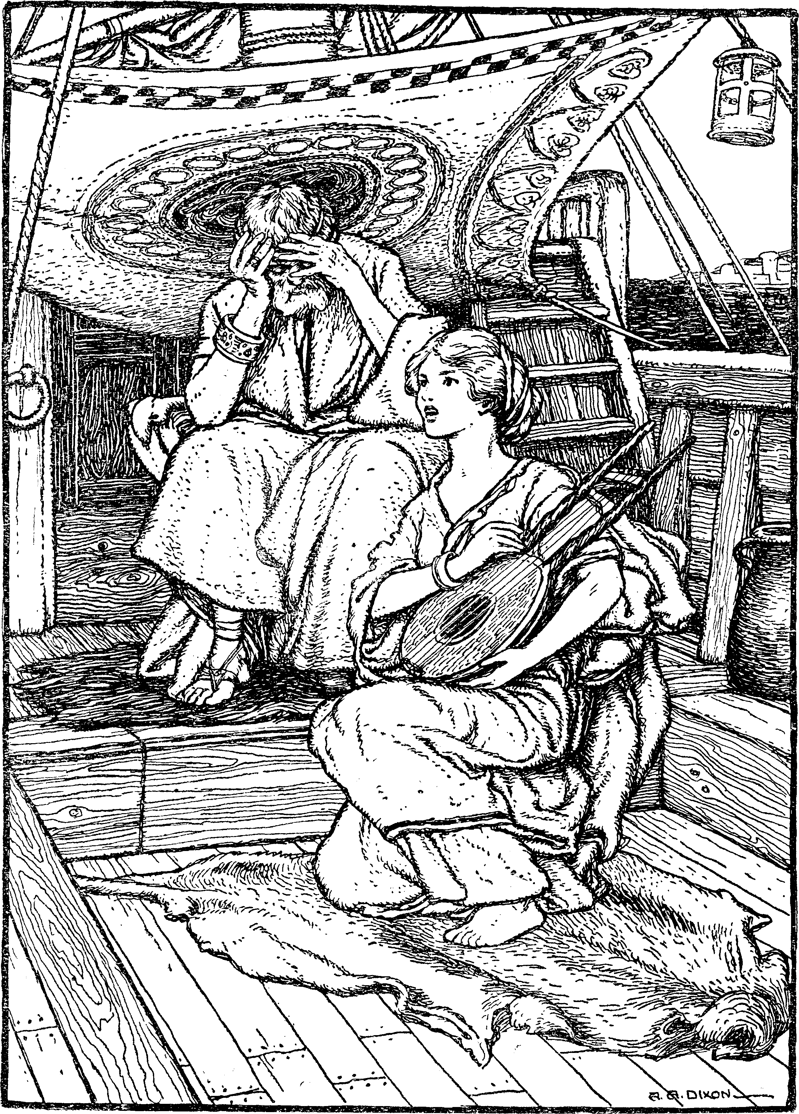
对着父亲唱起了歌

Cerimon ordered the chest to be conveyed to his own house, and when it was opened he beheld with wonder the body of a young and lovely lady; and the sweet-smelling spices and rich casket of jewels made him conclude it was some great person who was thus strangely entombed. Searching farther, he discovered a paper, from which he learned that the corpse which lay as dead before him had been a queen, and wife to Pericles, Prince of Tyre; and much admiring at the strangeness of that accident, and more pitying the husband who had lost this sweet lady, he said: “If you are living, Pericles, you have a heart that even cracks with woe.” Then, observing attentively Thaisa’s face, he saw how fresh and unlike death her looks were, and he said, “They were too hasty that threw you into the sea”; for he did not believe her to be dead. He ordered a fire to be made, and proper cordials to be brought, and soft music to be played, which might help to calm her amazed spirits if she should revive; and he said to those who crowded round her, wondering at what they saw, “O, I pray you, gentlemen, give her air; this queen will live; she has not been entranced above five hours; and see, she begins to blow into life again; she is alive; behold, her eyelids move; this fair creature will live to make us weep to hear her fate.”
Thaisa had never died, but after the birth of her little baby had fallen into a deep swoon which made all that saw her conclude her to be dead; and now by the care of this kind gentleman she once more revived to light and life; and, opening her eyes, she said:
“Where am I? Where is my lord? What world is this?”
By gentle degrees Cerimon let her understand what had befallen her; and when he thought she was enough recovered to bear the sight he showed her the paper written by her husband, and the jewels; and she looked on the paper and said:
“It is my lord’s writing. That I was shipped at sea I well remember, but whether there delivered of my babe, by the holy gods I cannot rightly say; but since my wedded lord I never shall see again, I will put on a vestal livery and never more have joy.”
“Madam,” said Cerimon, “if you purpose as you speak, the temple of

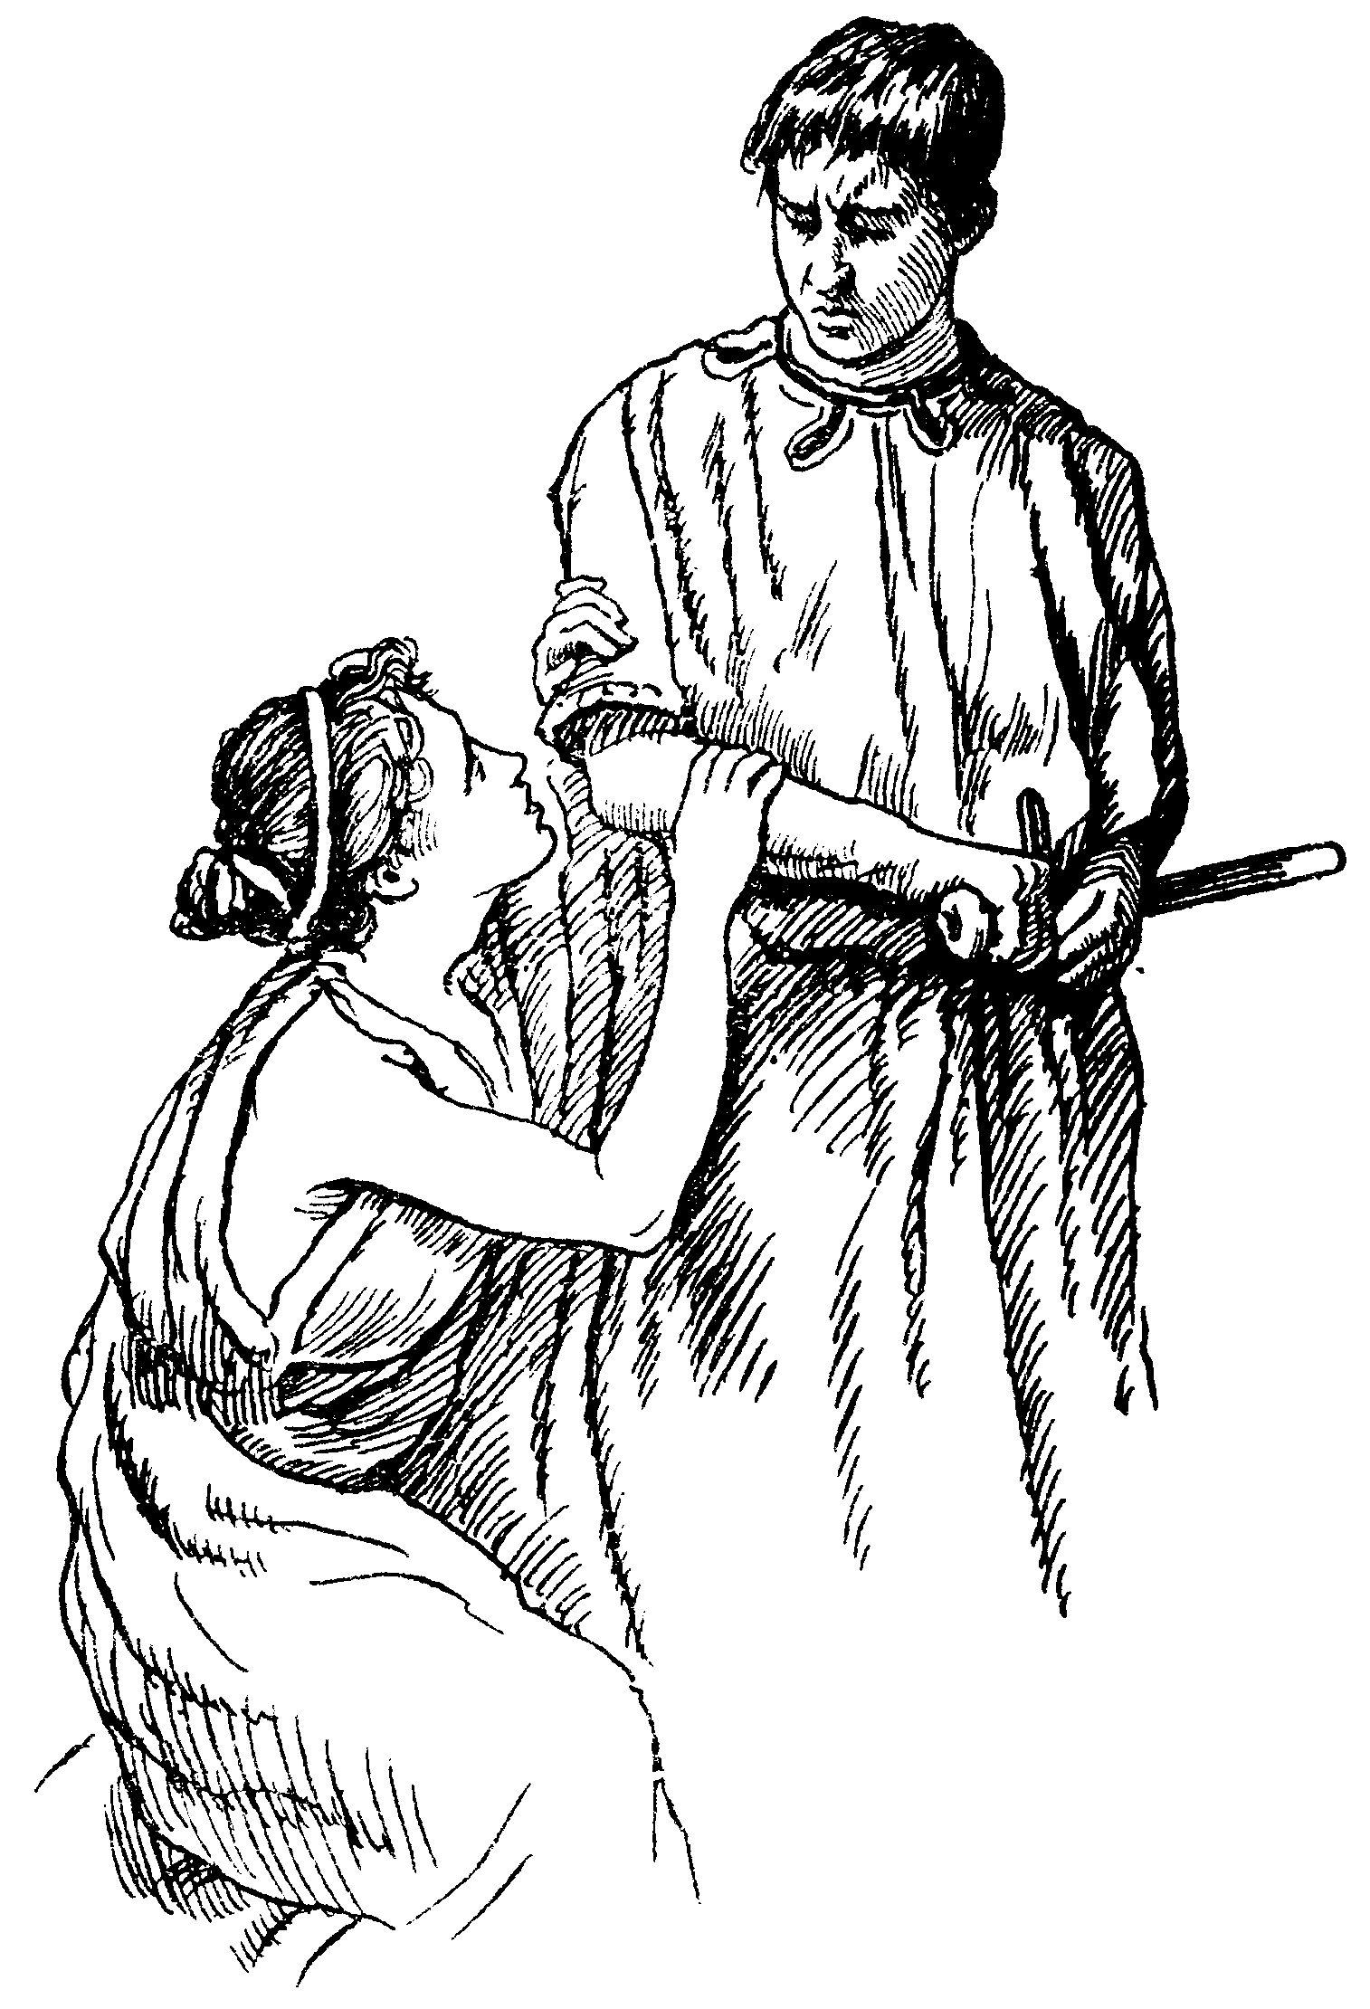
泰萨请求一起回国

Diana is not far distant from hence; there you may abide as a vestal. Moreover, if you please, a niece of mine shall there attend you.” This proposal was accepted with thanks by Thaisa; and when she was perfectly recovered, Cerimon placed her in the temple of Diana, where she became a vestal or priestess of that goddess, and passed her days in sorrowing for her husband’s supposed loss, and in the most devout exercises of those times.
Pericles carried his young daughter (whom he named Marina, because she was born at sea) to Tarsus, intending to leave her with Cleon, the governor of that city, and his wife Dionysia, thinking, for the good he had done to them at the time of their famine, they would be kind to his little motherless daughter. When Cleon saw Prince Pericles and heard of the great loss which had befallen him he said, “Oh, your sweet queen, that it had pleased Heaven you could have brought her hither to have blessed my eyes with the sight of her!”
Pericles replied: “We must obey the powers above us. Should I rage and roar as the sea does in which my Thaisa has, yet the end must be as it is. My gentle babe, Marina here, I must charge your charity with her. I leave her the infant of your care, beseeching you to give her princely training.” And then turning to Cleon’s wife, Dionysia, he said, “Good madam, make me blessed in your tare in bringing up my child.”
And she answered, “I have a child myself who shall not be more dear to my respect than yours, my lord.”
And Cleon made the like promise, saying: “Your noble services, Prince Pericles, in feeding my whole people with your corn (for which in their prayers they daily remember you) must in your child be thought on. If I should neglect your child, my whole people that were by you relieved would force me to my duty; but if to that I need a spur, the gods revenge it on me and mine to the end of generation.”
Pericles, being thus assured that his child would be carefully attended to, left her to the protection of Cleon and his wife Dionysia, and with her he left the nurse, Lychorida. When he went away the little Marina knew not her loss, but Lychorida wept sadly at parting with her royal master.

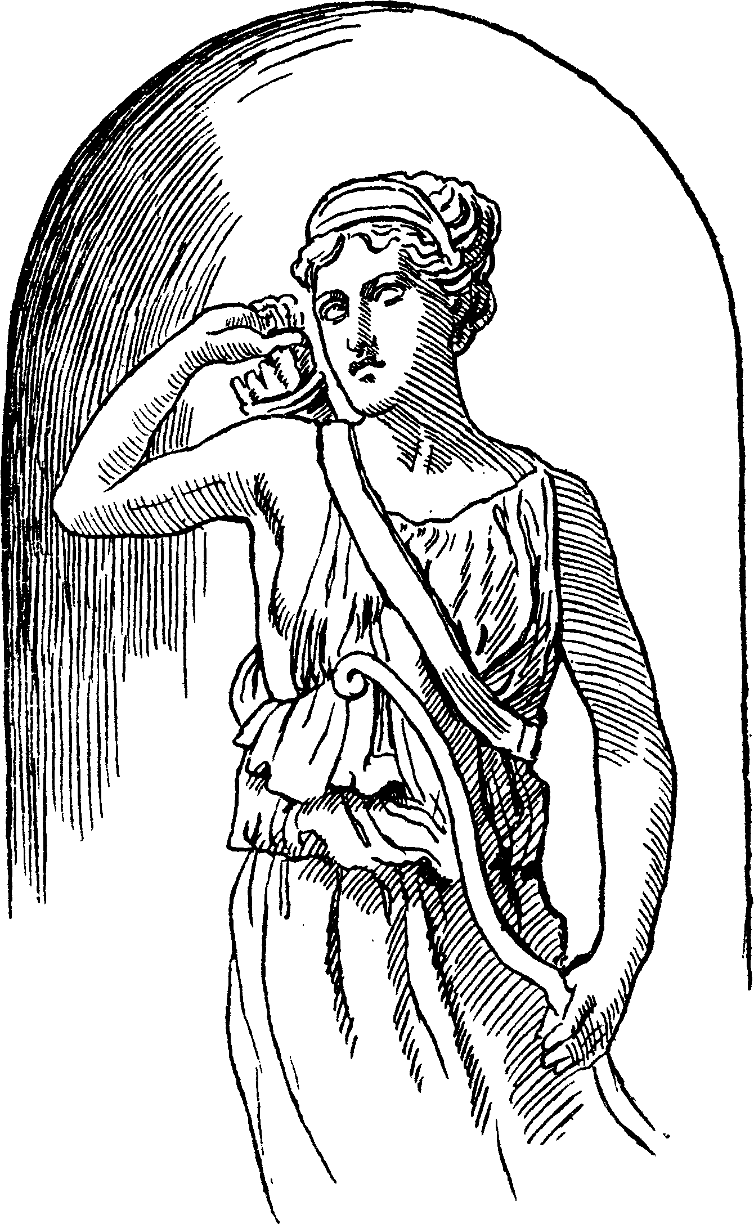
来到神庙

“Oh, no tears, Lychorida,” said Pericles; “no tears; look to your little mistress, on whose grace you may depend hereafter.”
Pericles arrived in safety at Tyre, and was once more settled in the quiet possession of his throne, while his woeful queen, whom he thought dead, remained at Ephesus. Her little babe Marina, whom this hapless mother had never seen, was brought up by Cleon in a manner suitable to her high birth. He gave her the most careful education, so that by the time Marina attained the age of fourteen years the most deeply learned men were not more studied in the learning of those times than was Marina. She sang like one immortal, and danced as goddess-like, and with her needle she was so skilful that she seemed to compose nature’s own shapes in birds, fruits, or flowers, the natural roses being scarcely more like to each other than they were to Marina’s silken flowers. But when she had gained from education all these graces which made her the general wonder, Dionysia, the wife of Cleon, became her mortal enemy from jealousy, by reason that her own daughter, from the slowness of her mind, was not able to attain to that perfection wherein Marina excelled; and finding that all praise was bestowed on Marina, while her daughter, who was of the same age and had been educated with the same care as Marina, though not with the same success, was in comparison disregarded, she formed a project to remove Marina out of the way, vainly imagining that her untoward daughter would be more respected when Marina was no more seen. To encompass this she employed a man to murder Marina, and she well timed her wicked design, when Lychorida, the faithful nurse, had just died. Dionysia was discoursing with the man she had commanded to commit this murder when the young Marina was weeping over the dead Lychorida. Leonine, the man she employed to do this bad deed, though he was a very wicked man, could hardly be persuaded to undertake it, so had Marina won all hearts to love her. He said:
“She is a goodly creature!”
“The fitter then the gods should have her,” replied her merciless enemy. “Here she comes weeping for the death of her nurse Lychorida. Are you resolved to obey me?”
Leonine, fearing to disobey her, replied, “I am resolved.” And so, in that one short sentence, was the matchless Marina doomed to an untimely death. She now approached, with a basket of flowers in her hand, which she said she would daily strew over the grave of good Lychorida. The purple violet and the marigold should as a carpet hang upon her grave, while summer days did last.
“Alas for met” she said, “poor unhappy maid, born in a tempest, when my mother died. This world to me is like a lasting storm, hurrying me from my friends.”
“How now, Marina,” said the dissembling Dionysia, “do you weep alone? How does it chance my daughter is not with you? Do not sorrow for Lychorida; you have a nurse in me. Your beauty is quite changed with this unprofitable woe. Come, give me your flowers—the sea air will spoil them—and walk with Leonine; the air is fine, and will enliven you. Come, Leonine, take her by the arm and walk with her.”
“No, madam,” said Marina, “I pray you let me not deprive you of your servant”; for Leonine was one of Dionysia’s attendants.
“Come, come,” said this artful woman, who wished for a pretense to leave her alone with Leonine, “I love the prince, your father, and I love you. We every day expect your father here; and when he comes and finds you so changed by grief from the paragon of beauty we reported you, he will think we have taken no care of you. Go, I pray you, walk, and be cheerful once again. Be careful of that excellent complexion which stole the hearts of old and young.”
Marina, being thus importuned, said, “Well, I will go, but yet I have no desire to it.”
As Dionysia walked away she said to Leonine, “Remember what I have said!” shocking words, for their meaning was that he should remember to kill Marina.
Marina looked toward the sea, her birthplace, and said, “Is the wind westerly that blows?”
“Southwest,” replied Leonine.
“When I was born the wind was north,” said she; and then the storm and tempest and all her father’s sorrows, and her mother’s death, came full into her mind, and she said, “My father, as Lychorida told me, did never fear, but cried, COURAGE, GOOD SEAMEN, to the sailors, galling his princely hands with the ropes, and, clasping to the masts, he endured a sea that almost split the deck.”
“When was this?” said Leonine.
“When I was born,” replied Marina. “Never were wind and waves more violent.” And then she described the storm, the action of the sailors, the boatswain’s whistle, and the loud call of the master, which,” said she, “trebled the confusion of the ship.”
Lychorida had so often recounted to Marina the story of her hapless birth that these things seemed ever present to her imagination. But here Leonine interrupted her with desiring her to say her prayers. “What mean you?” said Marina, who began to fear, she knew not why.
“If you require a little space for prayer, I grant it,” said Leonine; “but be not tedious; the gods are quick of ear and I am sworn to do my work in haste.”
“Will you kill me?” said Marina. “Alas! why?”
“To satisfy my lady,” replied Leonine.
“Why would she have me killed?” said Marina. “Now, as I can remember, I never hurt her in all my life. I never spake bad word nor did any ill turn to any living creature. Believe me now, I never killed a mouse nor hurt a fly. I trod upon a worm once against my will, but I wept for it. How have I offended?”
The murderer replied, “My commission is not to reason on the deed, but to do it.” And he was just going to kill her when certain pirates happened to land at that very moment, who, seeing Marina, bore her off as a prize to their ship.
The pirate who had made Marina his prize carried her to Mitylene and sold her for a slave, where, though in that humble condition, Marina soon became known throughout the whole city of Mitylene for her beauty and her virtues, and the person to whom she was sold became rich by the money she earned for him. She taught music, dancing, and fine needleworks, and the money she got by her scholars she gave to her master and mistress; and the fame of her

