第一章 在宫殿举行的宴会
Chapter 1 A Fete at the New Palace
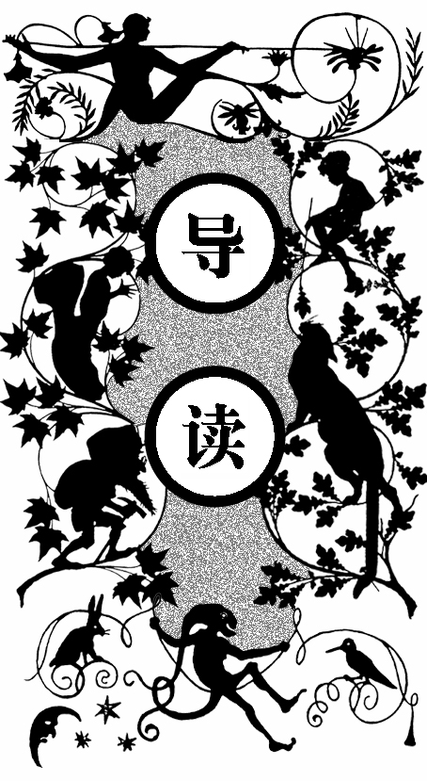
凌晨两点，在新宫举行晚会的高潮时刻，基索夫将军给沙皇陛下送来从托木斯克发来的电报，并报告说在此城市以外地方的电线都被切断了。陛下让他每隔一小时向托木斯克发一份电报。
舞会上，乐队演奏着从舞曲中精选出来的曲目。大元帅和他的副手负责整个晚会的各项事宜，达官显要、欧洲主要国家的外交使团成员和光彩照人的贵妇人在这里展示着他们的舞姿。
沙皇陛下出于不爱修饰自己的习惯，穿着一身近卫军军官的服饰。他高高的个子、面色凝重，很少说话，但一样让人觉得和蔼可亲。
陛下看到电报后，眉头锁得更紧了。他把将军带到一扇窗前，问了他一些问题。将军答道：昨天就和大公失去了联系，阿慕尔和雅库次克及越贝加尔各省的军队向伊尔库茨克进军的命令是最近一封电报下达的，并传到了贝加尔湖以外地区。原本还和其他各省保持着联系，但很快西伯利亚的边境就无法通过了，现在还没有叛徒伊万·奥加勒夫的消息。
陛下要求把叛徒的特征发往沿线各地，并对此保密。将军行了一个礼后就退下去了。
一身戎装的沙皇陛下恢复了镇定，走到了人群中间。关于他们刚才谈论的事情，有两个人已获得了准确的信息。这两个人来自诺曼底的盎格鲁和来自罗曼的高卢，法国人获得信息全靠眼睛，而英国人则靠耳朵。法国人眼观六路，英国人则耳听八方。
那个英国人是《电讯日报》的记者，那个法国人是个通讯员，他们都

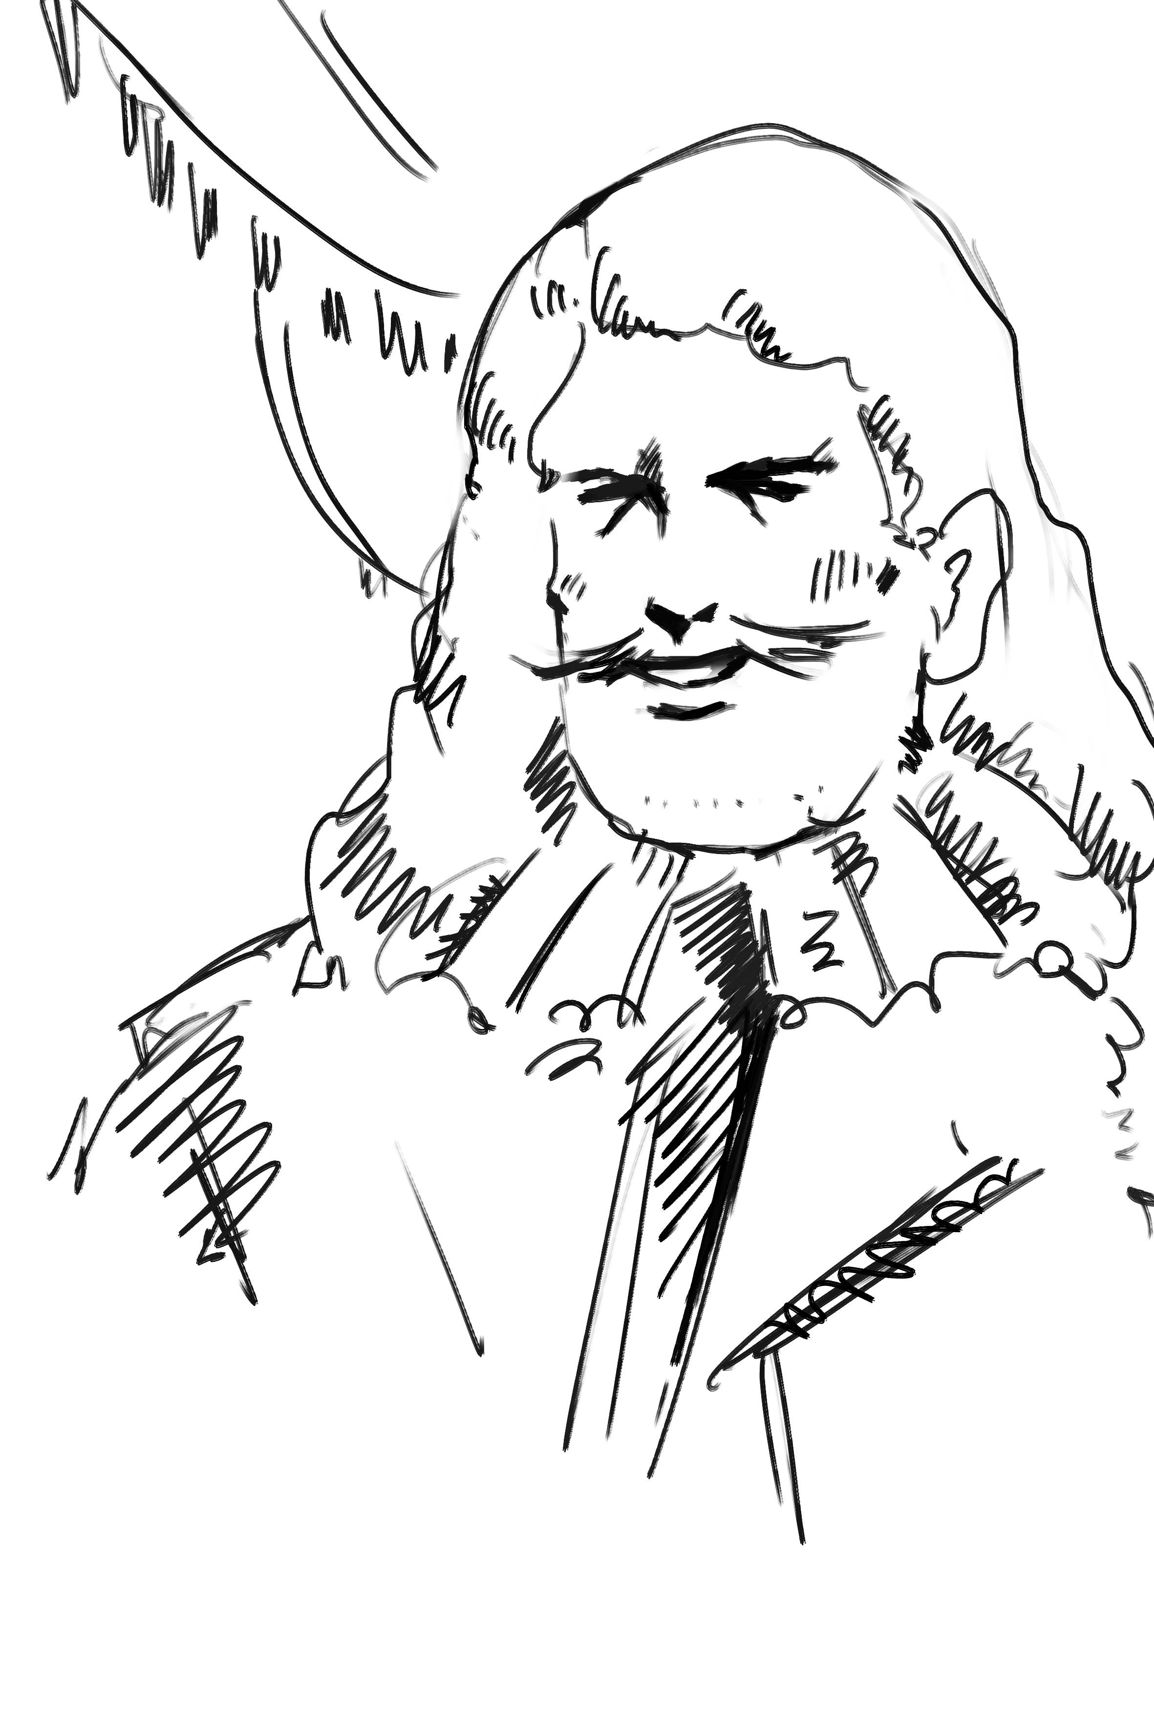

是以记者的身份来参加晚会的。
他们所服务的报社对他们不惜金钱，但他们从不违背道德去偷听、偷看。他们只是对一些政治和社会事件采取行动，并用各自的方式去判断。
法国记者阿尔西德· 若利韦和英国记者哈里· 布朗特是来参加晚会时才认识的。他们两人本应是竞争的关系，但他俩还是交换了看法：英国记者认为晚会非常精彩，而法国记者则表示感到了一股乌云。
他们又提到刚才陛下看到将军送来电报时的表现，就像一八一二年沙皇亚历山大在举行的晚会上收到报告说拿破仑和法国军队渡过了尼也门河时一样。
他们又谈到电报线路被截断后陛下命令部队集结的消息，这条明天将会在他们的报纸上出现。随后两人就分开了。
隔壁餐厅的门开了，里面的金银餐具中摆满了美味佳肴，客人们朝餐厅走去。
这时，基索夫将军回来告诉陛下，托木斯克的电报线路也断了。陛下让他派一个信使去送电报。随后沙皇到了隔壁的办公室，打开窗户，呼吸着新鲜空气。看着前面的莫斯科河，他抱着双臂在沉思。

ire, a fresh dispatch.”
“S
“Whence?”
“From Tomsk.”
“Is the wire cut beyond that city?”
“Yes, sire, since yesterday.”
“Telegraph hourly to Tomsk, General, and keep me informed of all that occurs.”
“Sire, it shall be done,” answered General Kissoff.
These words were exchanged about two hours after midnight, at the moment when the fete given at the New Palace was at the height of its splendor.
During the whole evening the bands of the Preobra-jensky and Paulowsky regiments had played without cessation polkas, mazurkas, schottisches, and waltzes from among the choicest of their repertoires. Innumerable couples of dancers whirled through the magnificent saloons of the palace, which stood at a few paces only from the “old house of stones” – in former days the scene of so many terrible dramas, the echoes of whose walls were this night awakened by the gay strains of the musicians.
The grand-chamberlain of the court, was, besides, well seconded in his arduous and delicate duties The grand-dukes and their aides-decamp, the chamberlains-in-waiting and other officers of the palace, presided personally in the arrangement of the dances. The grand duchesses, covered with diamonds, the ladies-in-waiting in their most exquisite costumes, set the example to the wives of the military and civil dignitaries of the ancient “city of white stone.” When, therefore, the signal for the “polonaise” resounded through the saloons, and the guests of all ranks took part in that measured promenade, which on occasions of this kind has all the importance of a national dance, the mingled costumes, the sweeping robes adorned with lace, and uniforms covered with orders, presented a scene of dazzling splendor, lighted by hundreds of lusters multiplied tenfold by the numerous mirrors adorning the walls.
The grand saloon, the finest of all those contained in the New Palace, formed to this procession of exalted personages and splendidly dressed women a frame worthy of the magnificence they displayed. The rich ceiling, with its gilding already softened by the touch of time, appeared as if glittering with stars. The embroidered drapery of the curtains and doors, falling in gorgeous folds, assumed rich and varied hues, broken by the shadows of the heavy masses of damask.
Through the panes of the vast semicircular bay-windows the light, with which the saloons were filled, shone forth with the brilliancy of a conflagration, vividly illuminating the gloom in which for some hours the palace had been shrouded. The attention of those of the guests not taking part in the dancing was attracted by the contrast. Resting in the recesses of the windows, they could discern, standing out dimly in the darkness, the vague outlines of the countless towers, domes, and spires which adorn the ancient city. Below the sculptured balconies were visible numerous sentries, pacing silently up and down, their rifles carried horizontally on the shoulder, and the spikes of their helmets glittering like flames in the glare of light issuing from the palace. The steps also of the patrols could be heard beating time on the stones beneath with even more regularity than the feet of the dancers on the floor of the saloon. From time to time the watchword was repeated from post to post, and occasionally the notes of a trumpet, mingling with the strains of the orchestra, penetrated into their midst. Still farther down, in front Of the facade, dark masses obscured the rays of fight which proceeded from the windows of the New Palace. These were boats descending the course of a river, whose waters, faintly illumined by a few lamps, washed the lower portion of the terraces.
The principal personage who has been mentioned, the giver of the fete, and to whom General Kissoff had been speaking in that tone of respect with which sovereigns alone are usually addressed, wore the simple uniform of an officer of chasseurs of the guard. This was no affectation on his part, but the custom of a man who cared little for dress, his contrasting strongly with the gorgeous costumes amid which he moved, encircled by his escort of Georgians, Cossacks, and Circassians — a brilliant band, splendidly clad in the glittering uniforms of the Caucasus.
This personage, of lofty stature, affable demeanor, and physiognomy calm, though bearing traces of anxiety, moved from group to group, seldom speaking, and appearing to pay but little attention either to the merriment of the younger guests or the graver remarks of the exalted dignitaries or members of the diplomatic corps who represented at the Russian court the principal governments of Europe. Two or three of these astute politicians — physiognomists by virtue of their profession — failed not to detect on the countenance of their host symptoms of disquietude, the source of which eluded their penetration; but none ventured to interrogate him on the subject.
It was evidently the intention of the officer of chasseurs that his own anxieties should in no way cast a shade over the festivities; and, as he was a personage whom almost the population of a world in itself was wont to obey, the gayety of the ball was not for a moment checked.
Nevertheless, General Kissoff waited until the officer to whom he had just communicated the dispatch forwarded from Tomsk should give him permission to withdraw; but the latter still remained silent. He had taken the telegram, he had read it carefully, and his visage became even more clouded than before. Involuntarily he sought the hilt of his sword, and then passed his hand for an instant before his eyes, as though, dazzled by the brilliancy of the light, he wished to shade them, the better to see into the recesses of his own mind.
“We are, then,” he continued, after having drawn General Kissoff aside towards a window, “since yesterday without intelligence from the Grand Duke?”
“Without any, sire; and it is to be feared that in a short time dispatches will no longer cross the Siberian frontier.”
“But have not the troops of the provinces of Amoor and Irkutsk, as those also of the TransBalkan territory, received orders to march immediately upon Irkutsk?”
“The orders were transmitted by the last telegram we were able to send beyond Lake Baikal.”
“And the governments of Yeniseisk, Omsk, Semipolatinsk, and Tobolsk— are we still in direct communication with them as before the insurrection?”
“Yes, sire; our dispatches have reached them, and we are assured at the present moment that the Tartars have not advanced beyond the Irtish and the Obi.”
“And the traitor Ivan Ogareff, are there no tidings of him?”
“None,” replied General Kissoff. “The head of the police cannot state whether or not he has crossed the frontier.”
“Let a description of him be immediately dispatched to Nijni-Novgorod, Perm, Ekaterenburg, Kasirnov, Tioumen, Ishim, Omsk, Tomsk, and to all the telegraphic stations with which communication is yet open.”
“Your majesty’s orders shall be instantly carried out.”
“You will observe the strictest silence as to this.”
The General, having made a sign of respectful assent, bowing low, mingled with the crowd, and finally left the apartments without his departure being remarked.
The officer remained absorbed in thought for a few moments, when, recovering himself, he went among the various groups in the saloon, his countenance reassuming that calm aspect which had for an instant been disturbed.
Nevertheless, the important occurrence which had occasioned these rapidly exchanged words was not so unknown as the officer of the chasseurs of the guard and General Kissoff had possibly supposed. It was not spoken of officially, it is true, nor even officiously, since tongues were not free; but a few exalted personages had been informed, more or less exactly, of the events which had taken place beyond the frontier. At any rate, that which was only slightly known, that which was not matter of conversation even between members of the corps diplomatique, two guests, distinguished by no uniform, no decoration, at this reception in the New Palace, discussed in a low voice, and with apparently very correct information.
By what means, by the exercise of what acuteness had these two ordinary mortals ascertained that which so many persons of the highest rank and importance scarcely even suspected? It is impossible to say. Had they the gifts of foreknowledge and foresight? Did they possess a supplementary sense, which enabled them to see beyond that limited horizon which bounds all human gaze? Had they obtained a peculiar power of divining the most secret events? Was it owing to the habit, now become a second nature, of living on information, that their mental constitution had thus become really transformed? It was difficult to escape from this conclusion.
Of these two men, the one was English, the other French; both were tall and thin, but the latter was sallow as are the southern Provencals, while the former was ruddy like a Lancashire gentleman. The Anglo-Norman, formal, cold, grave, parsimonious of gestures and words, appeared only to speak or gesticulate under the influence of a spring operating at regular intervals. The Gaul, on the contrary, lively and petulant, expressed himself with lips, eyes, hands, all at once, having twenty different ways of explaining his thoughts, whereas his interlocutor seemed to have only one, immutably stereotyped on his brain.
The strong contrast they presented would at once have struck the most superficial observer; but a physiognomist, regarding them closely, would have defined their particular characteristics by saying, that if the Frenchman was “all eyes,” the Englishman was “all ears.”
In fact, the visual apparatus of the one had been singularly perfected by practice. The sensibility of its retina must have been as instantaneous as that of those conjurors who recognize a card merely by a rapid movement in cutting the pack or by the arrangement only of marks invisible to others. The Frenchman indeed possessed in the highest degree what may be called “the memory of the eye.”
The Englishman, on the contrary, appeared especially organized to listen and to hear. When his aural apparatus had been once struck by the sound of a voice he could not forget it, and after ten or even twenty years he would have recognized it among a thousand. His ears, to be sure, had not the power of moving as freely as those of animals who are provided with large auditory flaps; but, since scientific men know that human ears possess, in fact, a very limited power of movement, we should not be far wrong in affirming that those of the said Englishman became erect, and turned in all directions while endeavoring to gather in the sounds, in a manner apparent only to the naturalist. It must be observed that this perfection of sight and hearing was of wonderful assistance to these two men in their vocation, for the Englishman acted as correspondent of the Daily Telegraph, and the Frenchman, as correspondent of what newspaper, or of what newspapers, he did not say; and when asked, he replied in a jocular manner that he corresponded with “his cousin Madeleine.” This Frenchman, however, neath his careless surface, was wonderfully shrewd and sagacious. Even while speaking at random, perhaps the better to hide his desire to learn, he never forgot himself. His loquacity even helped him to conceal his thoughts, and he was perhaps even more discreet than his confrere of the Daily Telegraph. Both were present at this fete given at the New Palace on the night of the 15th of July in their character of reporters.
It is needless to say that these two men were devoted to their mission in the world – that they delighted to throw themselves in the track of the most unexpected intelligence — that nothing terrified or discouraged them from succeeding — that they possessed the imperturbable sang froid and the genuine intrepidity of men of their calling. Enthusiastic jockeys in this steeplechase, this hunt after information, they leaped hedges, crossed rivers, sprang over fences, with the ardor of pure-blooded racers, who will run “a good first” or die!
Their journals did not restrict them with regard to money— the surest, the most rapid, the most perfect element of information known to this day. It must also be added, to their honor, that neither the one nor the other ever looked over or listened at the walls of private life, and that they only exercised their vocation when political or social interests were at stake. In a word, they made what has been for some years called “the great political and military reports.”
It will be seen, in following them, that they had gene rally an independent mode of viewing events, and, above all, their consequences, each having his own way of observing and appreciating.
The French correspondent was named Alcide Jolivet. Harry Blount was the name of the Englishman. They had just met for the first time at this fete in the New Palace, of which they had been ordered to give an account in their papers. The dissimilarity of their characters, added to a certain amount of jealousy, which generally exists between rivals in the same calling, might have rendered them but little sympathetic. However, they did not avoid each other, but endeavored rather to exchange with each other the chat of the day. They were sportsmen, after all, hunting on the same ground. That which one missed might be advantageously secured by the other, and it was to their interest to meet and converse.
This evening they were both on the look out; they felt, in fact, that there was something in the air.
“Even should it be only a wildgoose chase,” said Alcide Jolivet to himself, “it may be worth powder and shot.”
The two correspondents therefore began by cautiously sounding each other.
“Really, my dear sir, this little fete is charming!” said Alcide Jolivet pleasantly, thinking himself obliged to begin the conversation with this eminently French phrase.
“I have telegraphed already, ‘splendid!’” replied Harry Blount calmly, employing the word specially devoted to expressing admiration by all subjects of the United Kingdom.
“Nevertheless,” added Alcide Jolivet, “I felt compelled to remark to my cousin—”
“Your cousin?” repeated Harry Blount in a tone of surprise, interrupting his brother of the pen.
“Yes,” returned Alcide Jolivet, “my cousin Madeleine. It is with her that I correspond, and she likes to be quickly and well informed, does my cousin. I therefore remarked to her that, during this fete, a sort of cloud had appeared to overshadow the sovereign’s brow.”
“To me, it seemed radiant,” replied Harry Blount, who perhaps, wished to conceal his real opinion on this topic.
“And, naturally, you made it ‘radiant,’ in the columns of the Daily Telegraph.”
“Exactly.”
“Do you remember, Mr. Blount, what occurred at Zakret in 1812?”
“I remember it as well as if I had been there, sir,” replied the English correspondent.
“Then,” continued Alcide Jolivet, “you know that, in the middle of a fete given in his honor, it was announced to the Emperor Alexander that Napoleon had just crossed the Niemen with the vanguard of the French army. Nevertheless the Emperor did not leave the fete, and notwithstanding the extreme gravity of intelligence which might cost him his empire, he did not allow himself to show more uneasiness.”
“Than our host exhibited when General Kissoff informed him that the telegraphic wires had just been cut between the frontier and the government of Irkutsk.”
“Ah! you are aware of that?”
“I am !”
“As regards myself, it would be difficult to avoid knowing it, since my last telegram reached Udinsk,” observed Alcide Jolivet, with some satisfaction.
“And mine only as far as Krasnoiarsk,” answered Harry Blount, in a no less satisfied tone.
“Then you know also that orders have been sent to the troops of Nikolaevsk?”
“I do, sir; and at the same time a telegram was sent to the Cossacks of the government of Tobolsk to concentrate their forces.”
“Nothing can be more true, Mr. Blount; I was equally well acquainted with these measures, and you may be sure that my dear cousin shall know of them tomorrow.”
“Exactly as the readers of the Daily Telegraph shall know it also, M. Jolivet.”
“Well, when one sees all that is going on.…”
“And when one hears all that is said.…”
“An interesting campaign to follow, Mr. Blount.”
“I shall follow it, M. Jolivet!”
“Then it is possible that we shall find ourselves on ground less safe, perhaps, than the floor of this ball-room.”
“Less safe, certainly, but-”
“But much less slippery,” added Alcide Jolivet, holding up his companion, just as the latter, drawing back, was about to lose his equilibrium.
Thereupon the two correspondents separated, pleased that the one had not stolen a march on the other.
At that moment the doors of the rooms adjoining the great reception saloon were thrown open, disclosing to view several immense tables beautifully laid out, and groaning under a profusion of valuable china and gold plate. On the central table, reserved for the princes, princesses, and members of the corps diplomatique, glittered an epergne of inestimable price, brought from London, and around this chef-d’oeuvre of chased gold reflected under the light of the lusters a thousand pieces of most beautiful service from the manufactories of Sevres.
The guests of the New Palace immediately began to stream towards the supper-rooms.
At that moment. General Kissoff, who had just re-entered quickly approached the officer of chasseurs.
“Well?” asked the latter abruptly, as he had done the former time.
“Telegrams pass Tomsk no longer, sire.”
“A courier this moment!”
The officer left the hall and entered a large antechamber adjoining. It was a cabinet with plain oak furniture, situated in an angle of the New Palace. Several pictures, amongst others some by Horace Vernet, hung on the wall.
The officer hastily opened a window, as if he felt the want of air, and stepped out on a balcony to breathe the pure atmosphere of a lovely July night. Beneath his eyes, bathed in moonlight, lay a fortified inclosure, from which rose two cathedrals, three palaces, and an arsenal. Around this inclosure could be seen three distinct towns: Kitai-Gorod, Beloi-Gorod, Zemlianai-Gorod— European, Tartar, and Chinese quarters of great extent, commanded by towers, belfries, minarets, and the cupolas of three hundred churches, with green domes, surmounted by the silver cross. A little winding river, here and there reflected the rays of the moon.
This river was the Moskowa; the town Moscow; the fortified inclosure the Kremlin; and the officer of chasseurs of the guard, who, with folded arms and thoughtful brow, was listening dreamily to the sounds floating from the New Palace over the old Muscovite city, was the Czar.

