第一章 教授和他的家庭成员
Chapter I The Professor and his Family
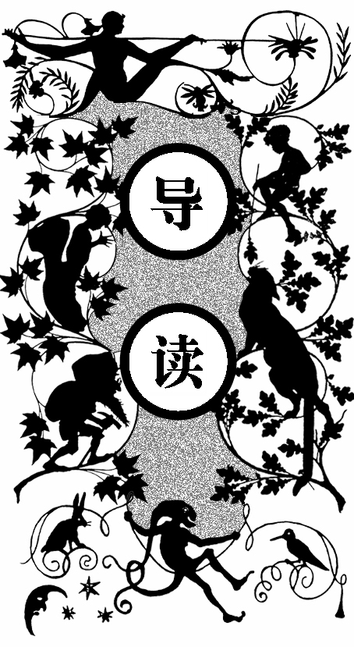
这是一八六三年五月二十四日，女佣玛尔塔刚开始做午饭，李登布洛克教授匆匆赶回位于三人堡旧城科尼街十九号的小房子。
阿克赛尔想躲开脾气暴躁的叔叔，赶紧回到楼上的房间。这时门突然被推开，教授来到楼上书房，并且把阿克赛尔叫了过去。
教授在约翰大学讲矿物学，说话不流利，许多来听课的人等教授说错发火时，就开始笑，并以此为乐。但教授具有地质学家的天才及矿物学家的敏锐观察力，他在所有学校和学术协会里享有盛名，很多有名望的教授也向他请教学术方面的棘手问题。
教授高瘦的身体长得十分结实，虽然已五十多岁，但看起来要年轻得多。由于急躁的性格，他一步能跨一点五英尺。教授的家中住着教女格劳本、女佣玛尔塔和已成为孤儿的侄子阿克赛尔。
阿克赛尔迷上了地质学，成了教授的实验助手。听到教授叫，阿克赛尔马上跑进他的书房。

n the 24th of May, 1863, my uncle, Professor Liedenbroek, rushed into his little house, No. 19 Köinigstrasse, one of the oldest streets in the oldest portion of the city of Hamburg.
O

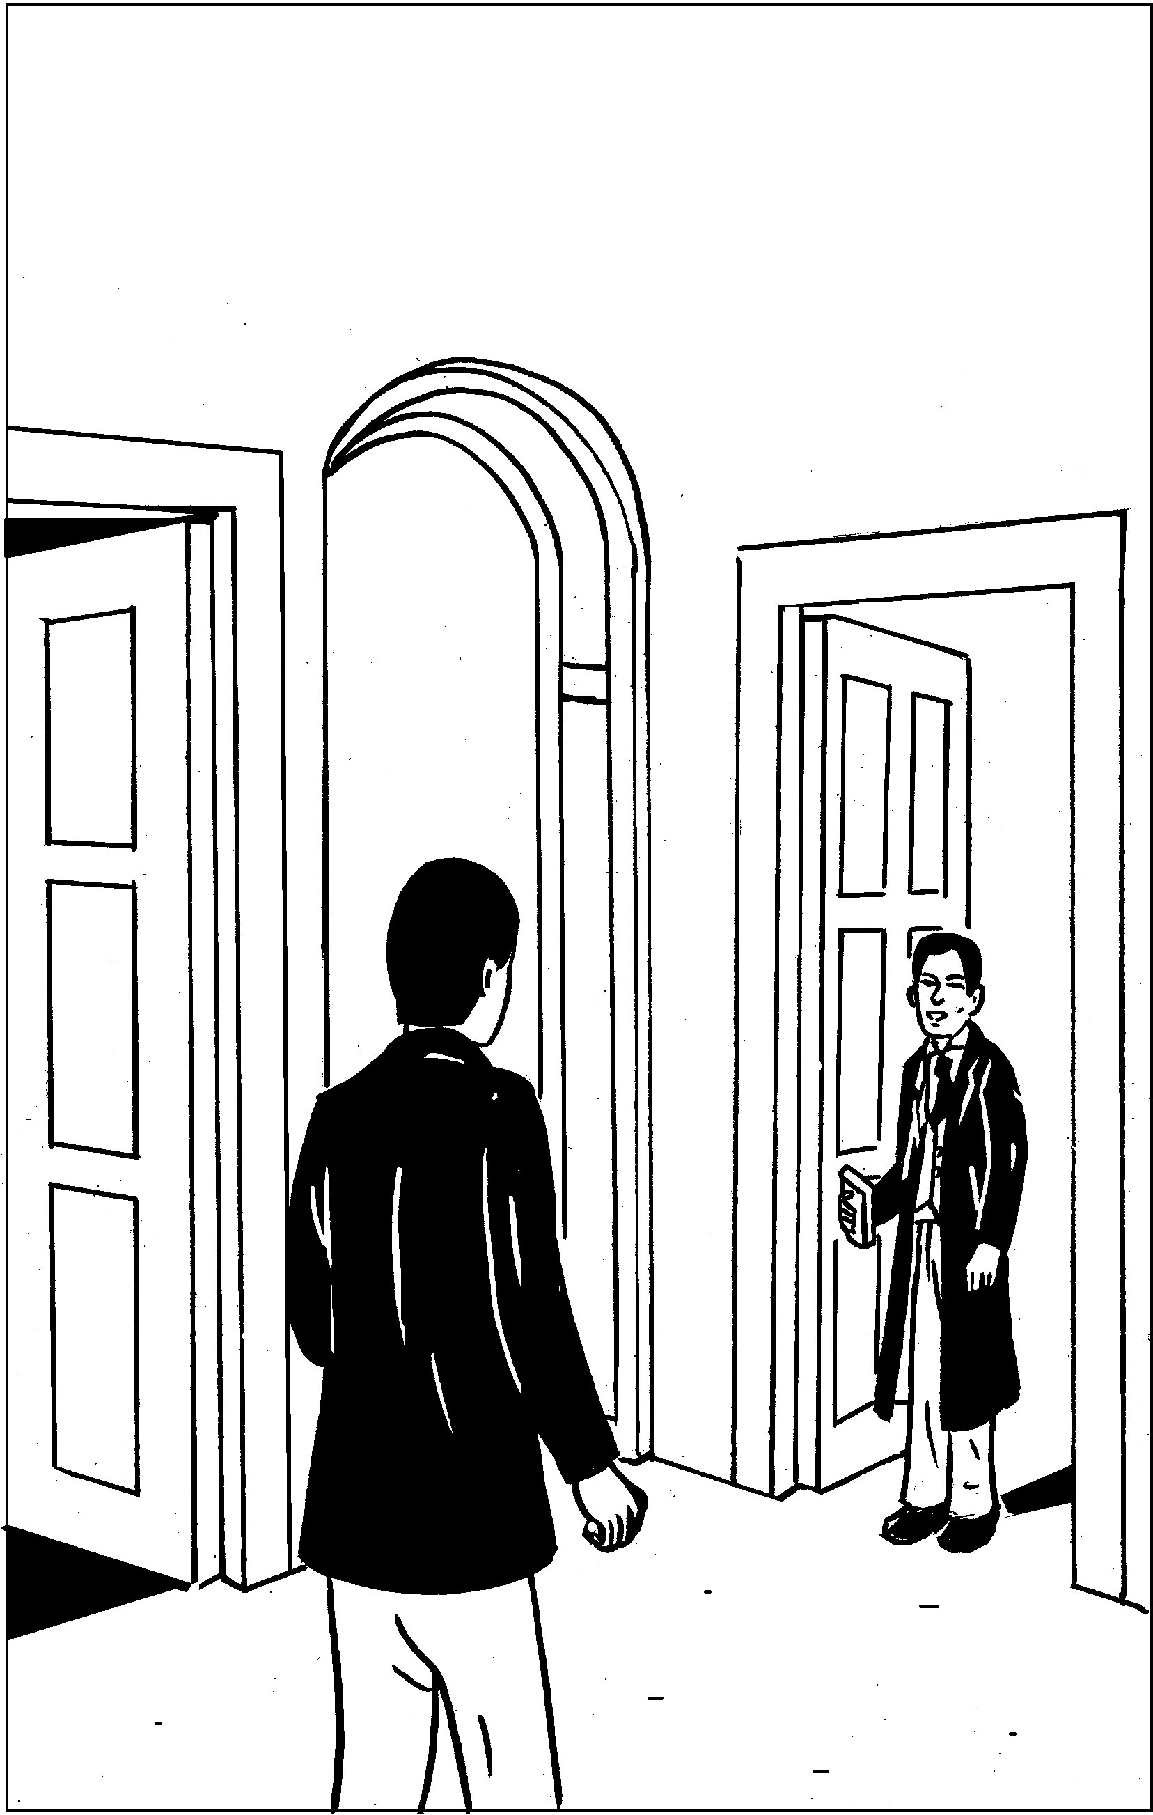
教授把阿克赛尔叫了过去
Martha must have concluded that she was very much behindhand, for the dinner had only just been put into the oven.
‘Well, now,’ said I to myself, ‘if that most impatient of men is hungry, what a disturbance he will make!’
‘M. Liedenbrock so soon!’ cried poor Martha in great alarm, half opening the dining-room door.
‘Yes, Martha; but very likely the dinner is not half cooked, for it is not two yet. Saint Michael’s dock has only just struck halfpast one.’
‘Then why has the master come home so soon?’
‘Perhaps he will tell us that himself.’
‘Here he is, Monsieur Axel; I will run and hide myself while you argue with him.’
And Martha retreated in safety into her own dominions.
I was left alone. But how was it possible for a man of my undecided turn of mind to argue successfully with so irascible a person as the Professor? With this persuasion I was hurrying away to my own little retreat upstairs, when the street door creaked upon its hinges; heavy feet made the whole flight of stairs to shake; and the master of the house, passing rapidly through the dining-room, threw himself in haste into his own sanctum.
But on his rapid way he had found time to fling his hazel stick into a corner, his rough broadbrim upon the table, and these few emphatic words at his nephew:
‘Axel, follow me!’
I had scarcely had time to move when the Professor was again shouting after me:
‘What! not come yet?’
And I rushed into my redoubtable master’s study.
Otto Liedenbrock had no mischief in him, I willingly allow that; but unless he very considerably changes as he grows older, at the end he will be a most original character.
He was professor at the Johannæum, and was delivering a series of lectures on mineralogy, in the course of every one of which he broke into a passion once or twice at least. Not at all that he was over-anxious about the improvement of his class, or about the degree of attention with which they listened to him, or the success which might eventually crown his labours. Such little matters of detail never troubled him much. His teaching was as the German philosophy calls it, ‘subjective’; it was to benefit himself, not others. He was a learned egotist. He was a well of science, and the pulleys worked uneasily when you wanted to draw anything out of it. In a word, he was a learned miser.
Germany has not a few professors of this sort.
To his misfortune, my uncle was not gifted with a sufficiently rapid utterance; not, to be sure, when he was talking at home, but certainly in his public delivery; this is a want much to be deplored in a speaker. The fact is, that during the course of his lectures at the Johannaæum, the Professor often came to a complete standstill; he fought with wilful words that refused to pass his struggling lips, such words as resist and distend the cheeks, and at last break out into the unasked-for shape of a round and most unscientific oath: then his fury would gradually abate.
Now in mineralogy there are many half-Greek and half-Latin terms, very hard to articulate, and which would be most trying to a poet’s measures. I don’t wish to say a word against so respectable a science, far be that from me. True, in the august presence of rhombohedral crystals, retinasphaltic resins, gehlenites, Fassaites, molybdenites, tungstates of manganese, and titanite of zirconium, why, the most facile of tongues may make a slip now and then.
It therefore happened that this venial fault of my uncle’s came to be pretty well understood in time, and an unfair advantage was taken of it; the students laid wait for him in dangerous places, and when he began to stumble, loud was the laughter, which is not in good taste, not even in Germans. And if there was always a full audience to honour the Liedenbrock courses, I should be sorry to conjecture how many came to make merry at my uncle’s expense.
Nevertheless my good uncle was a man of deep learning—a fact I am most anxious to assert and reassert. Sometimes he might irretrievably injure a specimen by his too great ardour in handling it; but still he united the genius of a true geologist with the keen eye of the mineralogist. Armed with his hammer, his steel pointer, his magnetic needles, his blowpipe, and his bottle of nitric acid, he was a powerful man of science. He would refer any mineral to its proper place among the six hundred elementary substances now enumerated, by its fracture, its appearance, its hardness, its fusibility, its sonorousness, its smell, and its taste.
The name of Liedenbrock was honourably mentioned in colleges and learned societies. Humphry Davy, Humboldt, Captain Sir John Franklin, General Sabine, never failed to call upon him on their way through Hamburg. Becquerel, Ebelman, Brewster, Dumas, Milne-Edwards, Saint-Claire-Deville frequently consulted him upon the most difficult problems in chemistry, a science which was indebted to him for considerable discoveries, for in 1853 there had appeared at Leipzig an imposing folio by Otto Liedenbrock, entitled, ‘A Treatise upon Transcendental Chemistry,’ with plates; a work, however, which failed to cover its expenses.
To all these titles to honour let me add that my uncle was the curator of the museum of mineralogy formed by M. Struve, the Russian ambassador; a most valuable collection, the fame of which is European.
Such was the gentleman who addressed me in that impetuous manner. Fancy a tall, spare man, of an iron constitution, and with a fair complexion which took off a good ten years from the fifty he must own to. His resdess eyes were in incessant motion behind his full-sized spectacles. His long, thin nose was like a knife blade. Boys have been heard to remark that that organ was magnetized and attracted iron filings. But this was merely a mischievous report; it had no attraction except for snuff, which it seemed to draw to itself in great quantities.
When I have added, to complete my portrait, that my uncle walked by mathematical strides of a yard and a half, and that in walking he kept his fists firmly closed, a sure sign of an irritable temperament, I think I shall have said enough to disenchant any one who should by mistake have coveted much of his company.
He lived in his own little house in Königstrasse, a structure half brick and half wood, with a gable cut into steps; it looked upon one of those winding canals which intersect each other in the middle of the ancient quarter of Hamburg, and which the great fire of 1842 had fortunately spared.
It is true that the old house stood slighdy off the perpendicular, and bulged out a little towards the street; its roof sloped a little to one side, like the cap over the left ear of a Tugendbund student; its lines wanted accuracy; but after all, it stood firm, thanks to an old elm which buttressed it in front, and which often in spring sent its young sprays through the window panes.
My uncle was tolerably well off for a German professor. The house was his own, and everything in it. The living contents were his god-daughter Gräuben, a young Virlandaise of seventeen, Martha, and myself. As his nephew and an orphan, I became his laboratory assistant.
I freely confess that I was exceedingly fond of geology and all its kindred sciences; the blood of a mineralogist was in my veins, and in the midst of my specimens I was always happy.
In a word, a man might live happily enough in the little old house in the Königstrasse, in spite of the resdess impatience of its master for although he was a little too excitable—he was very fond of me. But the man had no notion how to wait; nature herself was too slow for him. In April, after he had planted in the terra-cotta pots outside his window seedling plants of mignonette and convolvulus, he would go every evening and give them a little pull by their leaves to make them grow faster. In dealing with such a strange individual there was nothing for it but prompt obedience. I therefore rushed after him.

