第一章
Chapter 1

早上我们还在空旷的树林中散步，可到了下午，天空便乌云密布，风雨交加。我倒是很庆幸只能待在室内，想象手脚冰凉地回来之后还得受到数落，实在是可怕。
表姐伊丽莎、乔治亚娜，表兄约翰他们都坐在舅妈里德太太身边，而我因为顶嘴惹恼了舅妈被支到一边。我偷偷地溜进餐室，从书架上拿出比由伊克的《英国鸟史类》随手翻读。正当我自得其乐的时候，约翰开始到处找我。他才十四岁，又高又胖，却病恹恹的样子。他经常欺负我，每次看到他，我都会毛骨悚然。这次也不例外，他把我揪出来之后又开始拼命揍我，甚至用书砸我。我忍不住骂他像杀人犯，和他对打起来，结果被舅妈关进了红房子中。

here was no possibility of taking a walk that day. We had been wandering, indeed, in the leafless shrubbery an hour in the morning; but since dinner (Mrs. Reed, when there was no company, dined early) the cold winter wind had brought with it clouds so sombre, and a rain so penetrating, that further outdoor exercise was now out of the question.
T
I was glad of it: I never liked long walks, especially on chilly afternoons:

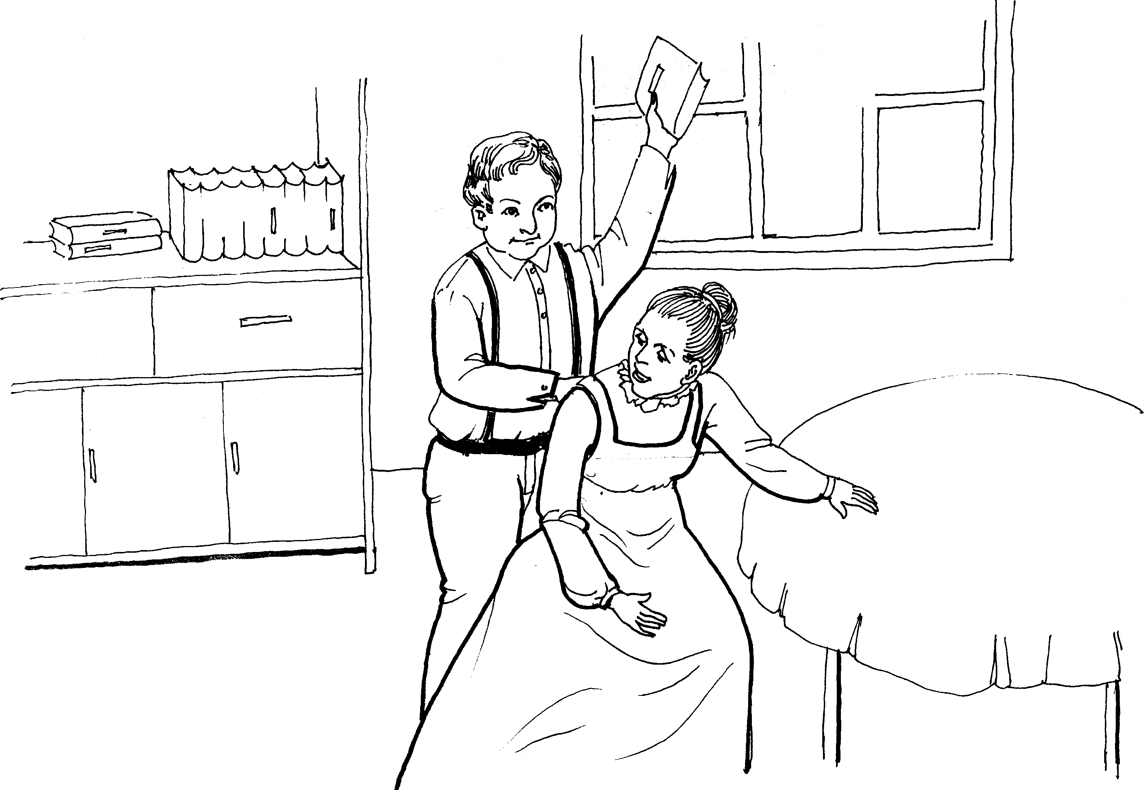
约翰总是欺负我
dreadful to me was the coming home in the raw twilight, with nipped fingers and toes, and a heart saddened by the chidings of Bessie, the nurse, and humbled by the consciousness of my physical inferiority to Eliza, John, and Georgiana Reed.
The said Eliza, John, and Georgiana were now clustered round their mama in the drawing-room: she lay reclined on a sofa by the fireside, and with her darlings about her ( for the time neither quarrelling nor crying) looked perfectly happy. Me, she had dispensed from joining the group; saying, ‘She regretted to be under the necessity of keeping me at a distance; but that until she heard from Bessie, and could discover by her own observation, that I was endeavouring in good earnest to acquire a more sociable and childlike disposition, a more attractive and sprightly manner—something lighter, franker, more natural, as it were—she really must exclude me from privileges intended only for contented, happy, little children.’
‘What does Bessie say I have done?’ I asked.
‘Jane, I don’t like cavillers or questioners; besides, there is something truly forbidding in a child taking up her elders in that manner. Be seated somewhere; and until you can speak pleasantly, remain silent.’
A small breakfast-room adjoined the drawing-room, I slipped in there. It contained a bookcase: I soon possessed myself of a volume, taking care that it should be one stored with pictures. I mounted into the window-seat: gathering up my feet, I sat cross-legged, like a Turk; and, having drawn the red moreen curtain nearly close, I was shrined in double retirement.
Folds of scarlet drapery shut in my view to the right hand; to the left were the clear panes of glass, protecting, but not separating me from the drear November day. At intervals, while turning over the leaves of my book, I studied the aspect of that winter afternoon. Afar, it offered a pale blank of mist and cloud; near a scene of wet lawn and storm-beat shrub, with ceaseless rain sweeping away wildly before a long and lamentable blast.
I returned to my book—Bewick’s History of British Birds: the letterpress thereof I cared little for, generally speaking; and yet there were certain introductory pages that, child as I was, I could not pass quite as a blank. They were those which treat of the haunts of sea-fowl; of ‘the solitary rocks and promontories’ by them only inhabited; of the coast of Norway, studded with isles from its southern extremity, the Lindeness, or Naze, to the North Cape—
‘Where the Northern Ocean, in vast whirls,
Boils round the naked, melancholy isles
Of farthest Thule; and the Atlantic surge
Pours in among the stormy Hebrides.’
Nor could I pass unnoticed the suggestion of the bleak shores of Lapland, Siberia, Spitzbergen, Nova Zembla, Iceland, Greenland, with ‘the vast sweep of the Arctic Zone, and those forlorn regions of dreary space,—that reservoir of frost and snow, where firm fields of ice, the accumulation of centuries of winters, glazed in Alpine heights above heights, surround the pole and concentre the multiplied rigours of extreme cold.’ Of these death-white realms I formed an idea of my own: shadowy, like all the half-comprehended notions that float dim through children’s brains, but strangely impressive. The words in these introductory pages connected themselves with the succeeding vignettes, and gave significance to the rock standing up alone in a sea of billow and spray; to the broken boat stranded on a desolate coast; to the cold and ghastly moon glancing through bars of cloud at a wreck just sinking.
I cannot tell what sentiment haunted the quite solitary churchyard, with its inscribed headstone; its gate, its two trees, its low horizon, girdled by a broken wall, and its newly-risen crescent, attesting the hour of eventide.
The two ships becalmed on a torpid sea, I believed to be marine phantoms.
The fiend pinning down the thief’s pack behind him, I passed over quickly: it was an object of terror.
So was the black horned thing seated aloof on a rock, surveying a distant crowd surrounding a gallows.
Each picture told a story; mysterious often to my undeveloped understanding and imperfect feelings, yet ever profoundly interesting: as interesting as the tales Bessie sometimes narrated on winter evenings, when she chanced to be in good humour; and when, having brought her ironing-table to the nursery hearth, she allowed us to sit about it, and while she got up Mrs. Reed’s lace frills, and crimped her nightcap borders, fed our eager attention with passages of love and adventure taken from old fairy tales and other ballads; or ( as at a later period I discovered) from the pages of Pamela, and Henry, Earl of Moreland.
With Bewick on my knee, I was then happy: happy at least in my way. I feared nothing but interruption, and that came too soon. The breakfastroom door opened.
‘Boh! Madam Mope!’ cried the voice of John Reed; then he paused: he found the room apparently empty.
‘Where the dickens is she !’ he continued. ‘Lizzy ! Georgy ! ( calling to his sisters) Joan is not here: tell mama she is run out into the rain—bad animal !’
‘It is well I drew the curtain,’ thought I; and I wished fervently he might not discover my hiding-place: nor would John Reed have found it out himself; he was not quick either of vision or conception; but Eliza just put her head in at the door, and said at once—
‘She is in the window-seat, to be sure, Jack.’
And I came out immediately, for I trembled at the idea of being dragged forth by the said Jack.
‘What do you want?’ I asked, with awkward diffidence.
‘Say, “What do you want, Master Reed?”’ was the answer. ‘I want you to come here;’ and seating himself in an armchair, he intimated by a gesture that I was to approach and stand before him.
John Reed was a schoolboy of fourteen years old; four years older than I, for I was but ten: large and stout for his age, with a dingy and unwholesome skin; thick lineaments in a spacious visage, heavy limbs and large extremities. He gorged himself habitually at table, which made him bilious, and gave him a dim and bleared eye and flabby cheeks. He ought now to have been at school; but his mama had taken him home for a month or two, ‘on account of his delicate health.’ Mr. Miles, the master, affirmed that he would do very well if he had fewer cakes and sweetmeats sent him from home; but the mother’s heart turned from an opinion so harsh, and inclined rather to the more refined idea that John’s sallowness was owing to over-application and, perhaps, to pining after home.
John had not much affection for his mother and sisters, and an antipathy to me. He bullied and punished me; not two or three times in the week, nor once or twice in the day, but continually: every nerve I had feared him, and every morsel of flesh in my bones shrank when he came near. There were moments when I was bewildered by the terror he inspired, because I had no appeal whatever against either his menaces or his inflictions; the servants did not like to offend their young master by taking my part against him, and Mrs. Reed was blind and deaf on the subject: she never saw him strike or heard him abuse me, though he did both now and then in her very presence, more frequently, however, behind her back.
Habitually obedient to John, I came up to his chair: he spent some three minutes in thrusting out his tongue at me as far as he could without damaging the roots: I knew he would soon strike, and while dreading the blow, I mused on the disgusting and ugly appearance of him who would presently deal it. I wonder if he read that notion in my face; for, all at once, without speaking, he struck suddenly and strongly. I tottered, and on regaining my equilibrium retired back a step or two from his chair.
‘That is for your impudence in answering mama awhile since,’ said he, ‘and for your sneaking way of getting behind curtains, and for the look you had in your eyes two minutes since, you rat!’
Accustomed to John Reed’s abuse, I never had an idea of replying to it; my care was how to endure the blow which would certainly follow the insult.
‘What were you doing behind the curtain?’ he asked.
‘I was reading.’
‘Show the book.’
I returned to the window and fetched it thence.
‘You have no business to take our books; you are a dependant, mama says; you have no money; your father left you none; you ought to beg, and not to live here with gentlemen’s children like us, and eat the same meals we do, and wear clothes at our mama’s expense. Now, I’ll teach you to rummage my bookshelves: for they are mine; all the house belongs to me, or will do in a few years. Go and stand by the door, out of the way of the mirror and the windows.’
I did so, not at first aware what was his intention; but when I saw him lift and poise the book and stand in act to hurl it, I instinctively started aside with a cry of alarm: not soon enough, however; the volume was flung, it hit me, and I fell, striking my head against the door and cutting it. The cut bled, the pain was sharp: my terror had passed its climax; other feelings succeeded.
‘Wicked and cruel boy !’ I said. ‘You are like a murderer —you are like a slave-driver —you are like the Roman emperors!’
I had read Goldsmith’s History of Rome, and had formed my opinion of Nero, Caligula, etc. Also I had drawn parallels in silence, which I never thought thus to have declared aloud.
‘What! what!’ he cried. ‘Did she say that to me? Did you hear her, Eliza and Georgiana? Won’t I tell mama? but first—’
He ran headlong at me: I felt him grasp my hair and my shoulder: he had closed with a desperate thing. I really saw in him a tyrant, a murderer. I felt a drop or two of blood from my head trickle down my neck, and was sensible of somewhat pungent suffering: these sensations for the time predominated over fear, and I received him in frantic sort. I don’t very well know what I did with my hands, but he called me ‘Rat! Rat!’ and bellowed out aloud. Aid was near him: Eliza and Georgiana had run for Mrs. Reed, who was gone upstairs: she now came upon the scene, followed by Bessie and her maid Abbot. We were parted: I heard the words—
‘Dear ! dear ! What a fury to fly at Master John!’

‘Did ever anybody see such a picture of passion!’
Then Mrs. Reed subjoined—‘Take her away to the red-room, and lock her in there.’ Four hands were immediately laid upon me, and I was borne upstairs.

第二章
Chapter 2
我被仆人贝茜和艾略特押往红房子，可是一路上我却不停地挣扎反抗。她们很不满，不停地教训我，说我连仆人都不如，整天白吃白喝。到了红房子，为了避免被她们捆绑起来，我不再挣扎。她们说完那些应该报恩、应该忏悔的言语之后终于走了，我被锁在了红房子中。
这间最宽敞、最豪华的卧室是舅父生前住的，平时除了佣人每周打扫一次，几乎从来没有人在这里过夜。房间没有生火，而且地处偏僻，因此格外凄凉。我站在一个大镜子前，看着自己，产生了一些莫名的恐惧。我愤怒不平，为什么表姐表兄他们那么恶毒、那么蛮横，却依然得到很多人的纵容。而我努力做好任何事情，却天天挨骂挨打。在这里，我跟周遭环境格格不入，不被任何人喜欢。如果舅父还在世，一定会对我很好。我幻想着他能够听到外甥女的冤屈，走到人世间为我报仇。突然，眼前闪过一道光线，耳朵不停地嗡嗡作响，我感到一阵窒息，异常难受，就拼命敲打大门，大叫着放我出去。贝茜她们开了门，并没有让我出去，可是舅妈认为我在耍花招，便又锁上门，让我再待一小时。我的昏倒结束了这场吵闹。

resisted all the way:a new thing for me, and a circumstance which
I

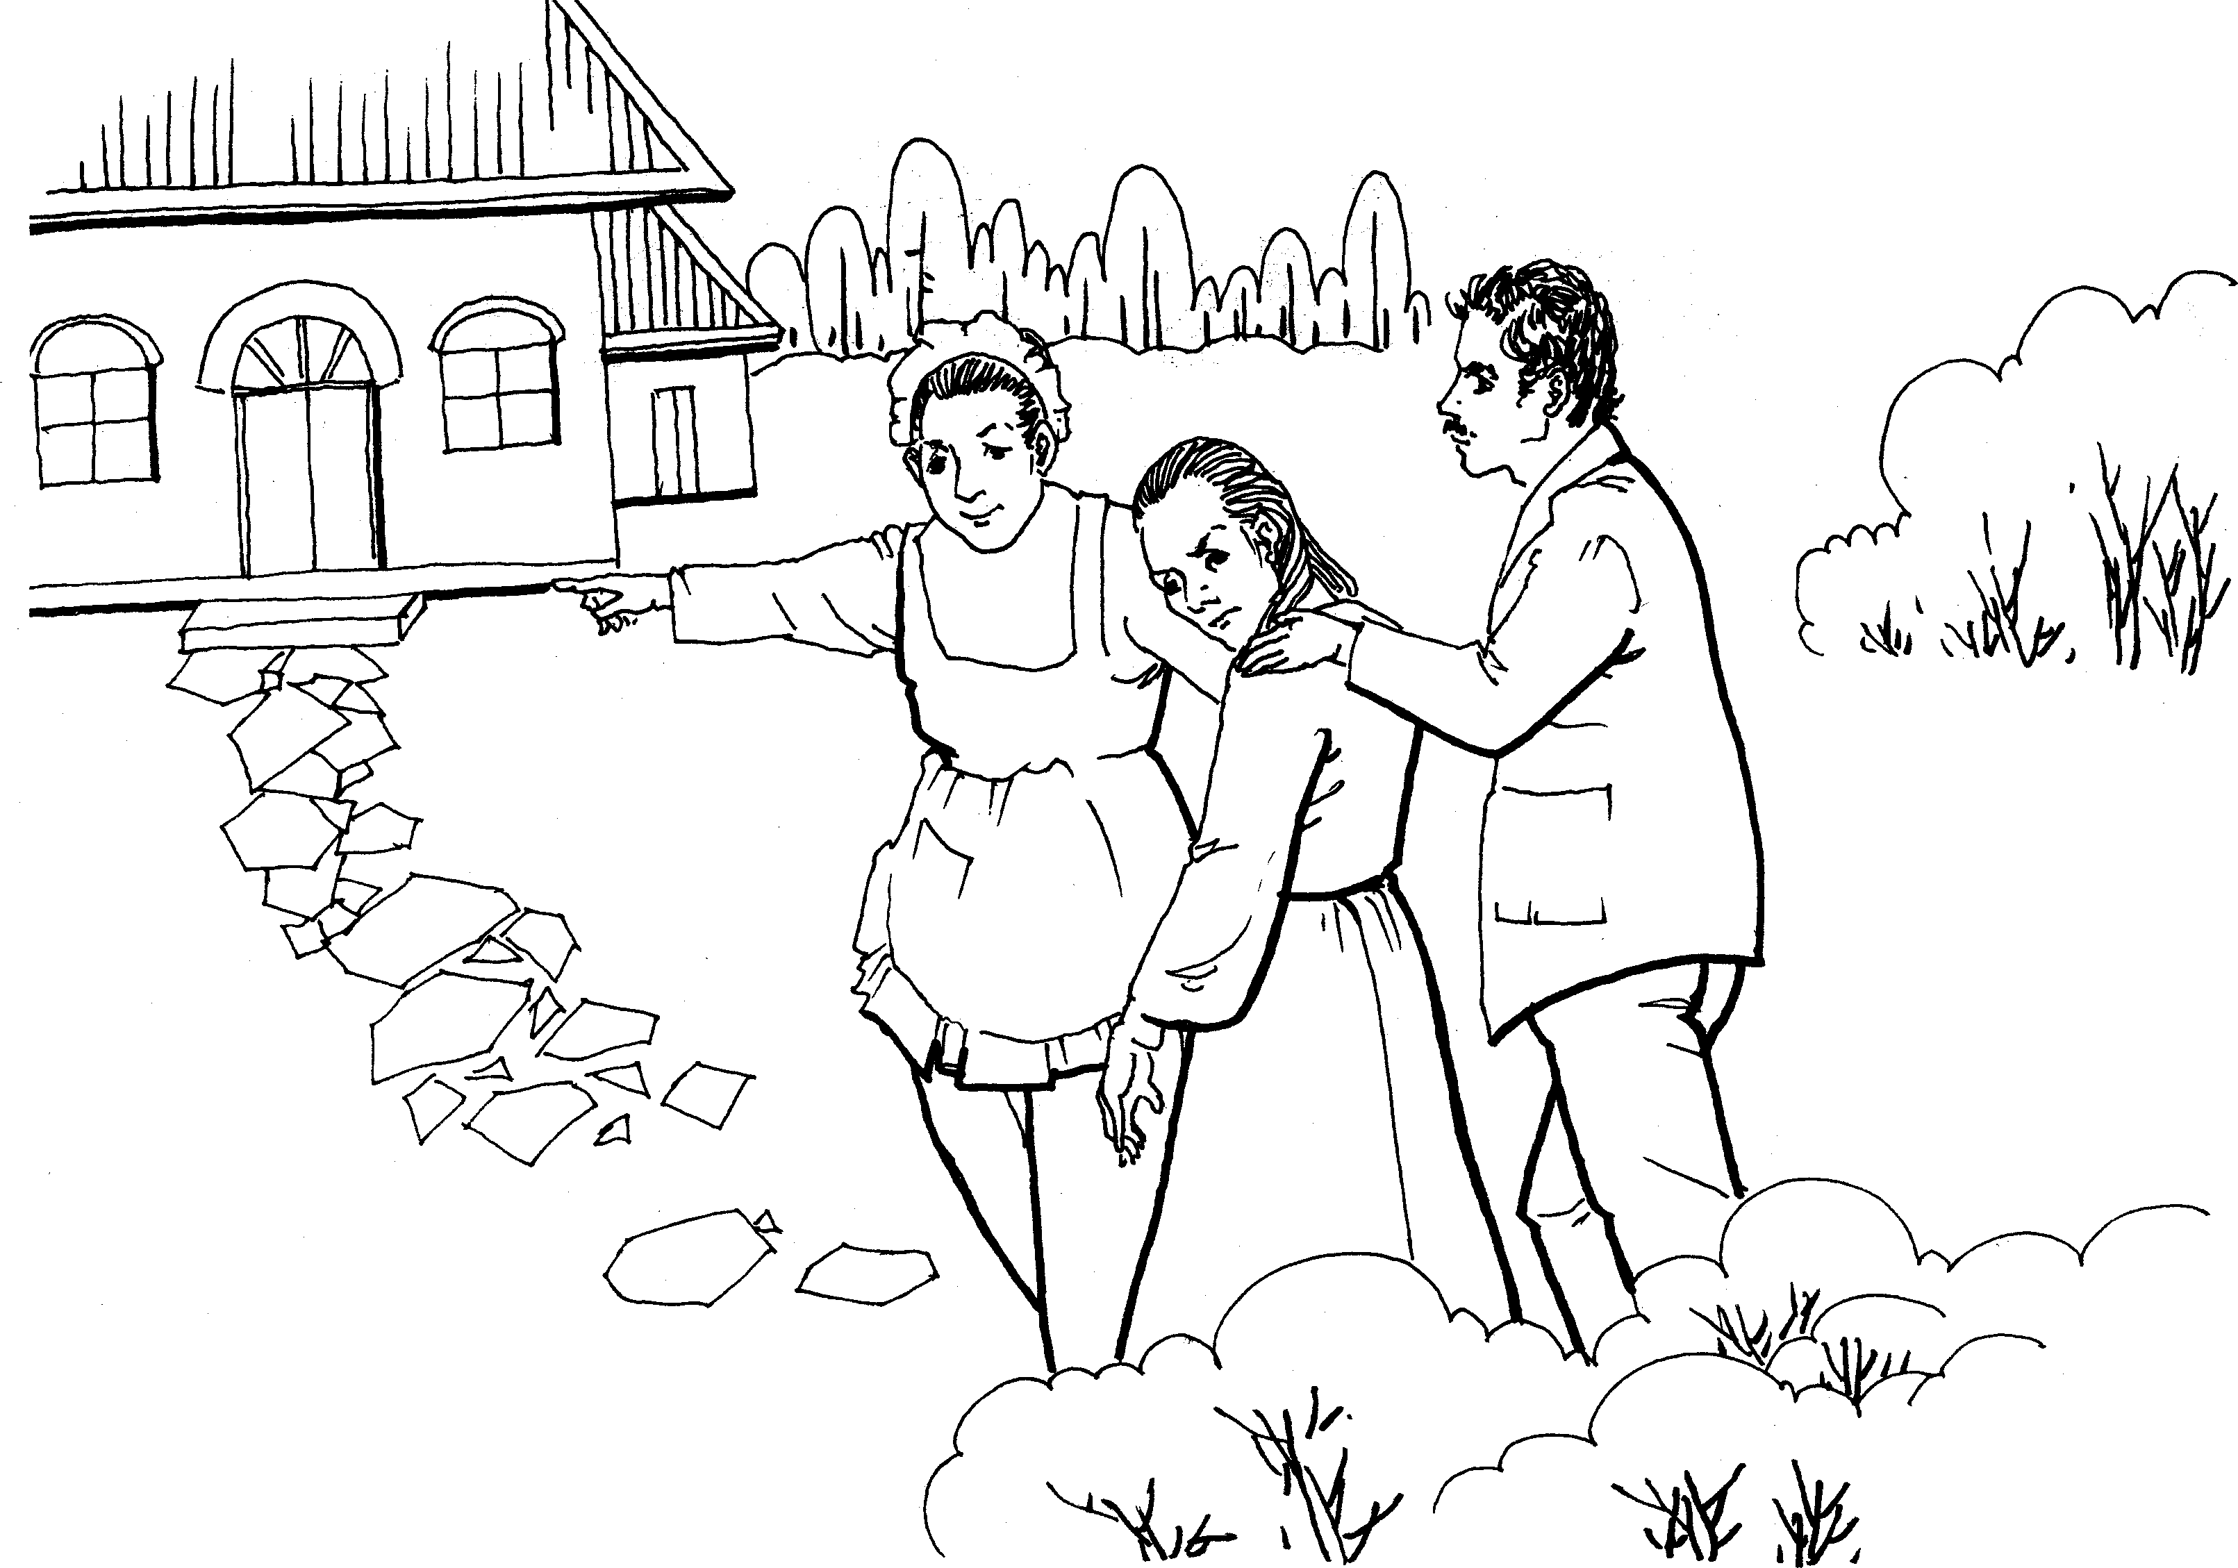
我被押往红房子
greatly strengthened the bad opinion Bessie and Miss Abbot were disposed to entertain of me. The fact is, I was a trifle beside myself;or rather out of myself, as the French would say: I was conscious that a moment’s mutiny had already rendered me liable to strange penalties, and, like any other rebel slave, I fell resolved, in my desperation, to go all lengths.
‘Hold her arms, Miss Abbot: she’s like a mad cat.’
‘For shame! for shame!’ cried the lady’s-maid. ‘What shocking conduct, Miss Eyre, to strike a young gentleman, your benefactress’s son! Your young master.’
‘Master! How is he my master? Am I a servant?’
‘No; you are less than a servant, for you do nothing for your keep. There, sit down, and think over your wickedness.’
They had got me by this time into the apartment indicated by Mrs. Reed, and had thrust me upon a stool: my impulse was to rise from it like a spring; their two pair of hands arrested me instantly.
‘If you don’t sit still, you must be tied down,’ said Bessie. ‘Miss Abbot, lend me your garters; she would break mine directly.’
Miss Abbot turned to divest a stout leg of the necessary ligature. This preparation for bonds, and the additional ignominy it inferred, took a little of the excitement out of me.
‘Don’t take them off,’ I cried; ‘I will not stir.’
In guarantee whereof, I attached myself to my seat by my hands.
‘Mind you don’t,’ said Bessie; and when she had ascertained that I was really subsiding, she loosened her hold of me; then she and Miss Abbot stood with folded arms, looking darkly and doubtfully on my face, as incredulous of my sanity.
‘She never did so before,’ at last said Bessie, turning to the Abigail.
‘But it was always in her,’ was the reply. ‘I’ve told Missis often my opinion about the child, and Missis agreed with me. She’s an underhand little thing: I never saw a girl of her age with so much cover.’
Bessie answered not; but ere long, addressing me, she said—
‘You ought to be aware, Miss, that you are under obligations to Mrs. Reed: she keeps you: if she were to turn you off, you would have to go to the poorhouse.’
I had nothing to say to these words: they were not new to me: my very first recollections of existence included hints of the same kind. This reproach of my dependence had become a vague sing-song in my ear: very painful and crushing, but only half intelligible. Miss Abbot joined in—
‘And you ought not to think yourself on an equality with the Misses Reed and Master Reed, because Missis kindly allows you to be brought up with them. They will have a great deal of money, and you will have none: it is your place to be humble, and to try to make yourself agreeable to them.’
‘What we tell you is for your good,’ added Bessie, in no harsh voice; ‘you should try to be useful and pleasant, then, perhaps, you would have a home here; but if you become passionate and rude, Missis will send you away, I am sure.
‘Besides,’ said Miss Abbot, ‘God will punish her: He might strike her dead in the midst of her tantrums, and then where would she go? Come, Bessie, we will leave her: I wouldn’t have her heart for anything. Say your prayers, Miss Eyre, when you are by yourself; for if you don’t repent, something bad might be permitted to come down the chimney and fetch you away.’
They went, shutting the door, and locking it behind them.
The red-room was a square chamber, very seldom slept in, I might say never, indeed, unless when a chance influx of visitors at Gateshead Hall rendered it necessary to turn to account all the accommodation it contained: yet it was one of the largest and stateliest chambers in the mansion. A bed supported on massive pillars of mahogany, hung with curtains of deep red damask, stood out like a tabernacle in the centre; the two large windows, with their blinds always drawn down, were half shrouded in festoons and falls of similar drapery; the carpet was red; the table at the foot of the bed was covered with a crimson cloth; the walls were a soft fawn colour with a blush of pink in it; the wardrobe, the toilet-table, the chairs were of darkly polished old mahogany. Out of these deep surrounding shades rose high, and glared white, the piled-up mattresses and pillows of the bed, spread with a snowy Marseilles counterpane. Scarcely less prominent was an ample cushioned easy-chair near the head of the bed, also white, with a footstool before it; and looking, as I thought, like a pale throne.
This room was chill, because it seldom had a fire; it was silent, because remote from the nursery and kitchen; solemn, because it was known to be so seldom entered. The housemaid alone came here on Saturdays, to wipe from the mirrors and the furniture a week’s quiet dust: and Mrs. Reed herself, at far intervals, visited it to review the contents of a certain secret drawer in the wardrobe, where were stored divers parchments, her jewel-casket, and a miniature of her deceased husband; and in those last words lies the secret of the red-room—the spell which kept it so lonely in spite of its grandeur.
Mr. Reed had been dead nine years: it was in this chamber he breathed his last; here he lay in state; hence his coffin was borne by the undertaker’s men; and, since that day, a sense of dreary consecration had guarded it from frequent intrusion.
My seat, to which Bessie and the bitter Miss Abbot had left me riveted, was a low ottoman near the marble chimney-piece; the bed rose before me; to my right hand there was the high, dark wardrobe, with subdued, broken reflections varying the gloss of its panels; to my left were the muffled windows; a great looking-glass between them repeated the vacant majesty of the bed and room. I was not quite sure whether they had locked the door; and when I dared move, I got up and went to see. Alas! yes: no jail was ever more secure. Returning, I had to cross before the looking-glass; my fascinated glance involuntarily explored the depth it revealed. All looked colder and darker in that visionary hollow than in reality: and the strange little figure there gazing at me, with a white face and arms specking the gloom, and glittering eyes of fear moving where all else was still, had the effect of a real spirit: I thought it like one of the tiny phantoms, half fairy, half imp, Bessie’s evening stories represented as coming out of lone, ferny dells in moors, and appearing before the eyes of belated travellers. I returned to my stool.
Superstition was with me at that moment; but it was not yet her hour for complete victory: my blood was still warm; the mood of the revolted slave was still bracing me with its bitter vigour; I had to stem a rapid rush of retrospective thought before I quailed to the dismal present.
All John Reed’s violent tyrannies, all his sisters’ proud indifference, all his mother’s aversion, all the servants’ partiality, turned up in my disturbed mind like a dark deposit in a turbid well. Why was I always suffering, always browbeaten, always accused, for ever condemned? Why could I never please? Why was it useless to try to win any one’s favour? Eliza, who, was headstrong and selfish, was respected. Georgiana, who had a spoiled temper, a very acrid spite, a captious and insolent carriage, was universally indulged. Her beauty, her pink cheeks and golden curls, seemed to give delight to all who, looked at her, and to purchase indemnity for every fault. John no one thwarted, much less punished; though he twisted the necks of the pigeons, killed the little pea-chicks, set the dogs at the sheep, stripped the hothouse vines of their fruit, and broke the buds off the choicest plants in the conservatory: he called his mother ‘old girl,’ too; sometimes reviled her for her dark skin, similar to his own; bluntly disregarded her wishes; not unfrequently tore and spoiled her silk attire; and he was still ‘her own darling.’ I dared commit no fault: I strove to fulfil every duty; and I was termed naughty and tiresome, sullen and sneaking, from morning to noon, and from noon to night.
My head still ached and bled with the blow and fall I had received: no one had reproved John for wantonly striking me; and because I had turned against him to avert farther irrational violence, I was loaded with general opprobrium.
‘Unjust!—unjust!’ said my reason, forced by the agonising stimulus into precocious though transitory power: and Resolve, equally wrought up, instigated some strange expedient to achieve escape from insupportable oppression—as running away, or, if that could not be effected, never eating or drinking more, and letting myself die. What a consternation of soul was mine that dreary afternoon! How all my brain was in tumult, and all my heart in insurrection! Yet in what darkness, what dense ignorance, was the mental battle fought! I could not answer the ceaseless inward question—why I thus suffered; now, at the distance of—I will not say how many years, I see it clearly.
I was a discord in Gateshead Hall: I was like nobody there; I had nothing in harmony with Mrs. Reed or her children, or her chosen vassalage. If they did not love me, in fact, as little did I love them. They were not bound to regard with affection a thing that could not sympathise with one amongst them; a heterogeneous thing, opposed to them in temperament, in capacity, in propensities; a useless thing, incapable of serving their interest, or adding to their pleasure; a noxious thing, cherishing the germs of indignation at their treatment, of contempt of their judgment. I know that had I been a sanguine, brilliant, careless, exacting, handsome, romping child—though equally dependent and friendless—Mrs. Reed would have endured my presence more complacently; her children would have entertained for me more of the cordiality of fellow-feeling; the servants would have been less prone to make me the scapegoat of the nursery.
Daylight began to forsake the red-room; it was past four o’clock, and the beclouded afternoon was tending to drear twilight. I heard the rain still beating continuously on the staircase window, and the wind howling in the grove behind the hall ; I grew by degrees cold as a stone, and then my courage sank. My habitual mood of humiliation, self-doubt, forlorn depression, fell damp on the embers of my decaying ire. All said I was wicked, and perhaps I might be so; what thought had I been but just conceiving of starving myself to death? That certainly was a crime: and was I fit to die? Or was the vault under the chancel of Gateshead Church an inviting bourne? In such vault I had been told did Mr. Reed lie buried; and led by this thought to recall his idea, I dwelt on it with gathering dread. I could not remember him; but I knew that he was my own uncle—my mother’s brother—that he had taken me when a parentless infant to his house; and that in his last moments he had required a promise of Mrs. Reed that she would rear and maintain me as one of her own children. Mrs. Reed probably considered she had kept this promise; and so she had, I dare say, as well as her nature would permit her; but how could she really like an interloper not of her race, and unconnected with her, after her husband’s death, by any tie? It must have been most irksome to find herself bound by a hard-wrung pledge to stand in the stead of a parent to a strange child she could not love, and to see an uncongenial alien permanently intruded on her own family group.
A singular notion dawned upon me. I doubted not—never doubted—that if Mr. Reed had been alive he would have treated me kindly; and now, as I sat looking at the white bed and overshadowed walls—occasionally also turning a fascinated eye towards the dimly gleaming mirror—I began to recall what I had heard of dead men, troubled in their graves by the violation of their last wishes, revisiting the earth to punish the perjured and avenge the oppressed; and I thought Mr. Reed’s spirit, harassed by the wrongs of his sister’s child, might quit its abode—whether in the church vault or in the unknown world of the departed—and rise before me in this chamber. I wiped my tears and hushed my sobs, fearful lest any sign of violent grief might waken a preternatural voice to comfort me, or elicit from the gloom some haloed face, bending over me with strange pity. This idea, consolatory in theory, I felt would be terrible if realised: with all my might I endeavoured to stifle it—I endeavoured to be firm. Shaking my hair from my eyes, I lifted my head and tried to look boldly round the dark room; at this moment a light gleamed on the wall. Was it, I asked myself, a ray from the moon penetrating some aperture in he blind? No; moonlight was still, and this stirred; while I gazed, it glided up to the ceiling and quivered over my head. I can now conjecture readily that this streak of light was, in all likelihood, a gleam from a lantern carried by some one across the lawn: but then, prepared as my mind was for horror, shaken as my nerves were by agitation, I thought the swift darting beam was a herald of some coming vision from another world. My heart beat thick, my head grew hot; a sound filled my ears, which I deemed the rushing of wings; something seemed near me; I was oppressed, suffocated: endurance broke down; I rushed to the door and shook the lock in desperate effort. Steps came running along the outer passage; the key turned, Bessie and Abbot entered.
‘Miss Eyre, are you ill?’ said Bessie.
‘What a dreadful noise ! it went quite through me !’ exclaimed Abbot.
‘Take me out ! Let me go into the nursery !’ was my cry.
‘What for? Are you hurt? Have you seen something?’ again demanded Bessie.
‘Oh ! I saw a light, and I thought a ghost would come.’ I had now got hold of Bessie’s hand, and she did not snatch it from me.
‘She has screamed out on purpose,’ declared Abbot, in some disgust. ‘And what a scream ! If she had been in great pain one would have excused it, but she only wanted to bring us all here: I know her naughty tricks.’
‘What is all this?’ demanded another voice peremptorily; and Mrs. Reed came along the corridor, her cap flying wide, her gown rustling stormily. ‘Abbot and Bessie, I believe I gave orders that Jane Eyre should be left in the red-room till I came to her myself.’
‘Miss Jane screamed so loud, ma’am,’ pleaded Bessie.
‘Let her go,’ was the only answer. ‘Loose Bessie’s hand, child: you cannot succeed in getting out by these means, be assured. I abhor artifice, particularly in children; it is my duty to show you that tricks will not answer: you will now stay here an hour longer, and it is only on condition of perfect submission and stillness that I shall liberate you then.’
‘O aunt! have pity! forgive me! I cannot endure it—let me be punished some other way! I shall be killed if—’
‘Silence! This violence is all most repulsive:’ and so, no doubt, she felt it. I was a precocious actress in her eyes; she sincerely looked on me as a compound of virulent passions, mean spirit, and dangerous duplicity.
Bessie and Abbot having retreated, Mrs. Reed, impatient of my now frantic anguish and wild sobs, abruptly thrust me back and locked me in, without farther parley. I heard her sweeping away; and soon after she was gone, I suppose I had a species of fit: unconsciousness closed the scene.

第三章
Chapter 3
我醒来之后，发现自己回到了保育室，而站在我前面的是药剂师劳埃德先生。我把手伸给他，叫出了他的名字，他微笑着说会好起来的，并吩咐贝茜不要让我受到打扰之后就走了。我问贝茜我是不是生病了，她的回答特别礼貌，我有点受宠若惊。晚上听到贝茜和另一个仆人萨拉的对话，我明白她们认为我看见鬼了。
红房子事件使我受到了惊吓，一直持续了很久。第二天，舅妈等人都出去了，我得到了难得的平静。贝茜端来了用图案鲜艳的瓷盘盛装的小烘饼，又应了我的要求拿来了《格列佛游记》。我试图从我所珍爱的书中感受那些插图的魅力，可是却只有怪异和悲凄的感觉。此时，贝茜一边缝着帽子，一边唱着歌。以前听起来很快乐的歌，现在也变得很哀伤。我难受地哭了起来。劳埃德先生又来了，他问我为什么哭泣。在他眼里我很幸福，有和蔼的舅妈和表兄妹，还可以住在很漂亮的房子里。但是我却很想逃离。劳埃德问我是否想上学的时候，我陷入了沉思，最终说出愿意。这时候舅妈回来了，先生建议送我进学校，舅妈欣然同意了。

he next thing I remember is, waking up with a feeling as if I had had a frightful nightmare, and seeing before me a terrible red glare, crossed with
T

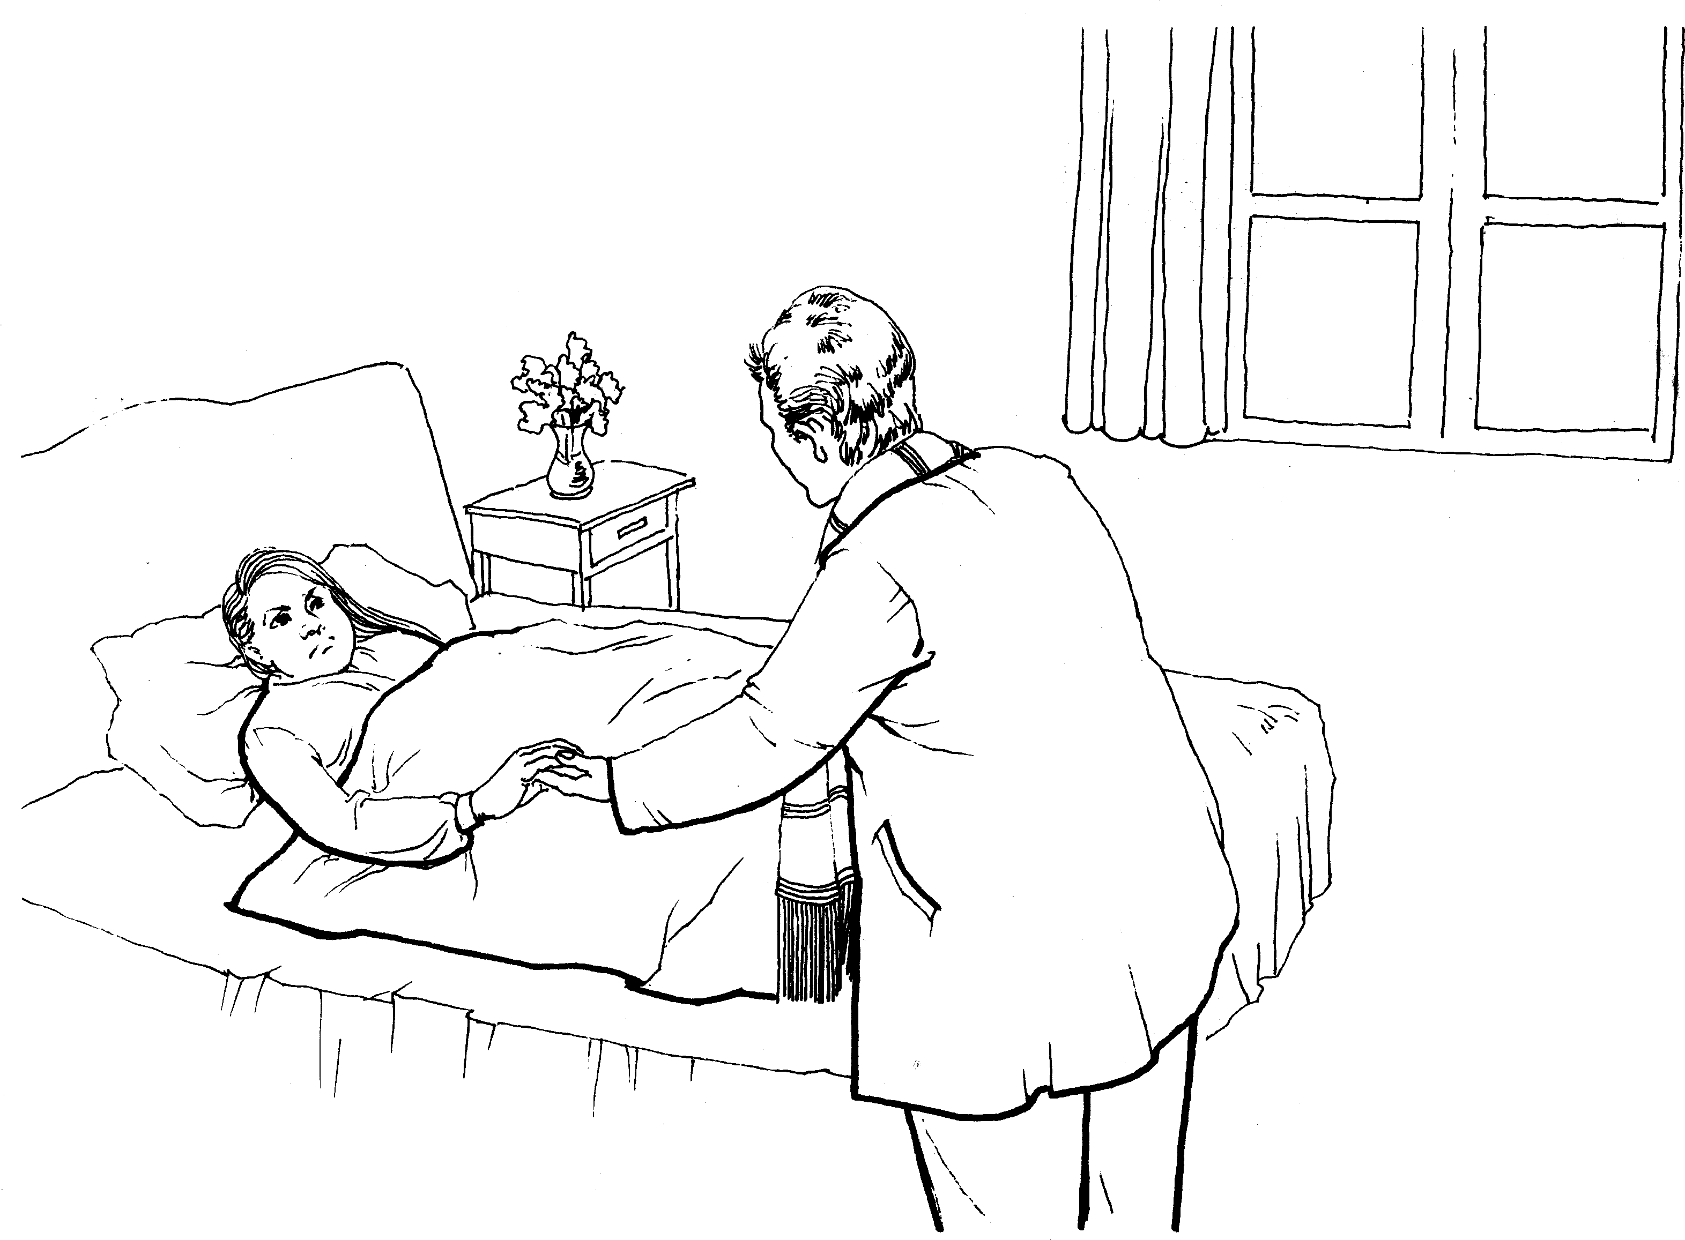
我醒来后，发现自己回到了保育室
thick black bars. I heard voices, too, speaking with a hollow sound, and as if muffled by a rush of wind or water: agitation, uncertainty, and an all-predominating sense of terror confused my faculties. Ere long, I became aware that some one was handling me; lifting me up and supporting me in a sitting posture, and that more tenderly than I had ever been raised or upheld before. I rested my head against a pillow or an arm, and felt easy.
In five minutes more the cloud of bewilderment dissolved: I knew quite well that I was in my own bed, and that the red glare was the nursery fire. It was night: a candle burnt on the table; Bessie stood at the bed-foot with a basin in her hand, and a gentleman sat in a chair near my pillow, leaning over me.
I felt an inexpressible relief, a soothing conviction of protection and security, when I knew that there was a stranger in the room, an individual not belonging to Gateshead, and not related to Mrs. Reed. Turning from Bessie (though her presence was far less obnoxious to me than that of Abbot, for instance, would have been), I scrutinised the face of the gentleman: I knew him; it was Mr. Lloyd, an apothecary, sometimes called in by Mrs. Reed when the servants were ailing: for herself and the children she employed a physician.
‘Well, who am I?’ he asked.
I pronounced his name, offering him at the same time my hand: he took it, smiling and saying, ‘We shall do very well by and by.’ Then he laid me down, and addressing Bessie, charged her to be very careful that I was not disturbed during the night. Having given some further directions, and intimated that he should call again the next day, he departed; to my grief: I felt so sheltered and befriended while he sat in the chair near my pillow; and as he closed the door after him, all the room darkened and my heart again sank: inexpressible sadness weighed it down.
‘Do you feel as if you should sleep, Miss?’ asked Bessie, rather softly.
Scarcely dared I answer her; for I feared the next sentence might be rough. ‘I will try.’
‘Would you like to drink, or could you eat anything?’
‘No, thank you, Bessie.’

