亚 当 日 记
ADAM’S DIARY

星期一
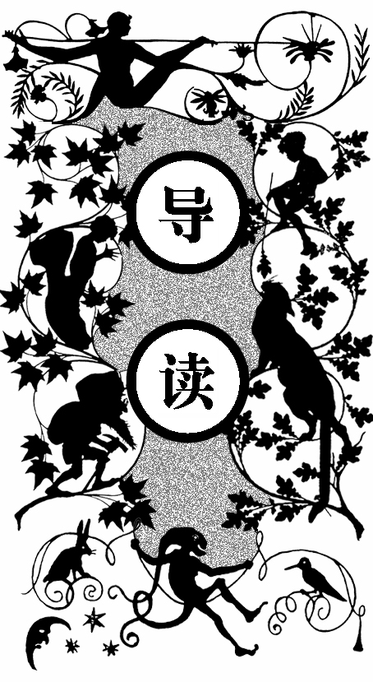
这个头发长长的新生物太烦人了。它在我周围走来走去。我很不习惯有谁陪在我身边。我希望它和其他动物一起活动。天阴着，刮东风，看来我们要淋雨了。我知道“我们”这个词正是因为它经常用这个词。
Monday

his new creature with the long hair is a good deal in the way. It is always hanging around and following me about. I don’t like this; I am not used to company. I wish it would stay with the other animals. Cloudy to-day, wind in the east; think we shall have rain…. Where did I get that word?… I remember now —the new creature uses it.
T

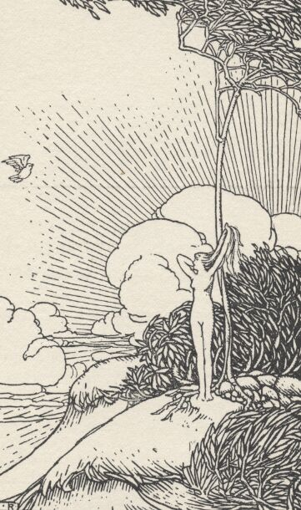
一个头发长长的新生物
星期二
探访大瀑布——它是我眼中这里最美丽的事物。那个新的生物给它起名字为尼阿加拉瀑布。我根本不知道这个名字是怎么来的。新生物任性地说它就像是尼阿加拉瀑布，真是的，我给事物起名字的机会全都被抢走了。
这个新生物总会在我开口给事物命名前抢着说出一个名字，而且它总是觉得那个东西像是什么就应该叫什么。我觉得它给那些东西起的名字和那些东西像什么一点关系都没有。
Tuesday

een examining the great waterfall. It is the finest thing on the estate, I think. The new creature calls it Niagara Falls—why, I am sure I do not know. Says it looks like Niagara Falls. That is not a reason; it is mere waywardness and imbecility. I get no chance to name anything myself. The new creature names everything that comes along, before I can get in a protest. And always that same pretext is offered—it looks like the thing. There is the dodo, for instance. Says the moment one looks at it one sees at a glance that it “looks like a dodo.” It will have to keep that name, no doubt. It wearies me to fret about it, and it does no good, anyway. Dodo! It looks no more like a dodo than I do.
B
星期三
我弄出来一小块地方用来遮风挡雨，现在却不能一个人享受。

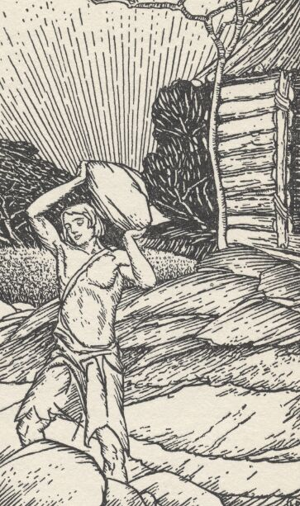
我弄出一小块地方来遮风挡雨
当我想把挤进来的那个新生物赶出去的时候，它开始用观看事物的两个小孔流水，还发出了动物伤心时候发出的声音。
我真希望这个不停说话的生物能够停下来一会儿。我并不是在嘲笑这个生物，以前我从来没有听到过人的声音。然而，任何新鲜和不熟悉的声音在这片圣洁的土地上都会显得刺耳难听。新生物的声音似乎一直围绕在我的周围，而我喜欢的则是离我有一定距离的响动。
Wednesday

uilt me a shelter against the rain, but could not have it to myself in peace. The new creature intruded. When I tried to put it out it shed water out of the holes it looks with, and wiped it away with the back of its paws, and made a noise such as some of the other animals make when they are in distress. I wish it would not talk; it is always talking. That sounds like a cheap fling at the poor creature, a slur; but I do not mean it so. I have never heard the human voice before, and any new and strange sound intruding itself here upon the solemn hush of these dreaming solitudes offends my ear and seems a false note. And this new sound is so close to me; it is right at my shoulder, right at my ear, first on one side and then on the other, and I am used only to sounds that are more or less distant from me.
B

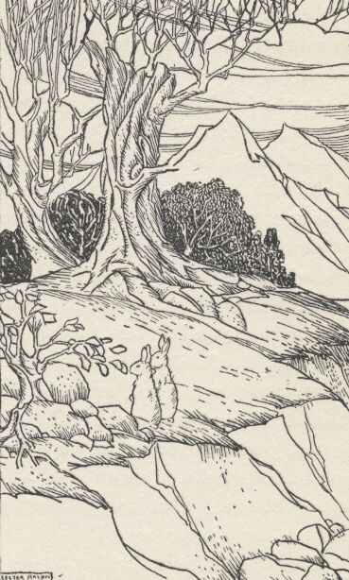
许多事物却有了名字
星期五
我已经尽了自己的努力，可是所有事物仍然在被一一命名。我的这片领地本来名叫伊甸园——悦耳动听又可爱，那个新生物却说这里都是树木和石头，一点也不像个花园，而像一个公园。所以这片地方就被改名为尼阿加拉瀑布公园，草地上还竖着禁止踩踏草坪的牌子，我很不喜欢这种方式。
但我的生活已经无法回到过去了。
Friday

he naming goes recklessly on, in spite of anything I can do. I had a very good name for the estate, and it was musical and pretty —GARDEN-OF-EDEN. Privately, I continue to call it that, but not any longer publicly. The new creature says it is all woods and rocks and scenery, and therefore has no resemblance to a garden. Says it looks like a park, and does not look like anything but a park. Consequently, without consulting me, it has been new-named —NIAGARA FALLS PARK. This is sufficiently high-handed, it seems to me. And already there is a sign up:
T
KEEP OFF THE GRASS
My life is not as happy as it was.
星期六
新生物吃了太多的果子，我们的东西都快被吃光了——听到了太多的“我们”，我也开始用这个词了。今天大雾，我在大雾天不

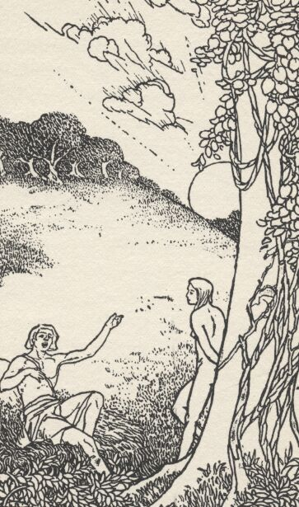
我也开始用“我们”这个词了
会出去，可是新生物喜欢在所有天气里出门，还喜欢到处说话。它在这里总是很快活。
Saturday

he new creature eats too much fruit. We are going to run short, most likely. “We” again—that is its word; mine too, now, from hearing it so much. Good deal of fog this morning. I do not go out in the fog myself. The new creature does. It goes out in all weathers, and stumps right in with its muddy feet. And talks. It used to be so pleasant and quiet here.
TT
星期天
星期天越来越让人难以忍受。这一天本来是特意挑出来用来休息的，我却已经有了太多的休息时间。早上，我还看见新生物试图从那棵禁树上打下苹果。
Sunday

ulled through. This day is getting to be more and more trying. It was selected and set apart last November as a day of rest. I already had six of them per week, before. This morning found the new creature trying to clod apples out of that forbidden tree.
P
星期一
新生物说它的名字叫做夏娃，我可以在找它的时候喊这个名字。我觉得这话纯属多余，却不由自主对这个美妙的名字产生了兴

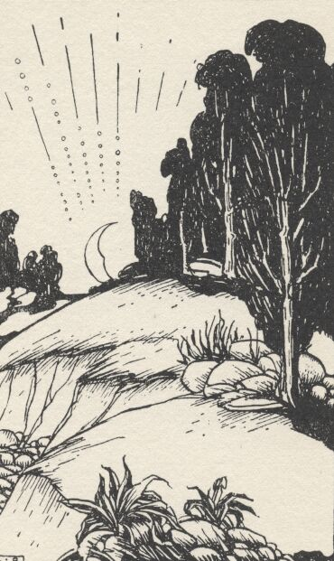
星期天越来越让人难以忍受
趣。新生物还说不能用它称呼它自己，而要用她。这是个问题，但是只要她能够安安静静地待在一边，我觉得这些都完全没有关系。
Monday

he new creature says its name is Eve. That is all right, I have no objections. Says it is to call it by when I want it to come. I said it was superfluous, then. The word evidently raised me in its respect; and indeed it is a large, good word, and will bear repetition. It says it is not an It, it is a She. This is probably doubtful; yet it is all one to me; what she is were nothing to me if she would but go by herself and not talk.
T
星期二
夏娃已经用碍事的指路牌把我的领地搞得乱七八糟，上面指向了各种地方。夏娃发明了太多的词语，我不想知道它们都是什么含义，但夏娃总是很热心地去解释一切。
Tuesday

he has littered the whole estate with execrable names and offensive signs:
S
THIS WAY TO THE WHIRLPOOL.
THIS WAY TO GOAT ISLAND.
CAVE OF THE WINDS THIS WAY.
She says this park would make a tidy summer resort, if there was any custom for it. Summer resort—another invention of

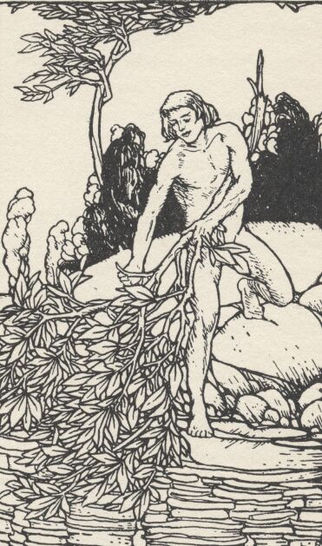
我想换个地方生活

hers—just words, without any meaning. What is a summer resort? But it is best not to ask her, she has such a rage for explaining.
星期五
夏娃希望我不要去瀑布那里玩漂流，她说这让她身心颤栗。我不懂这是什么意思，我一直都喜欢漂流，那种感觉让我激动。我觉得瀑布被创造出来就是用来漂流的。夏娃则说瀑布和其他一些东西一样，是用来点缀风景的。
我用各种东西去瀑布漂流，她都不满意。我乘着树干穿过旋涡，结果受了很重的伤。夏娃开始无休止地批评我太冒险。我在这个地方失去了自由，我想换个地方生活。
Friday

he has taken to beseeching me to stop going over the Falls. What harm does it do? Says it makes her shudder. I wonder why. I have always done it—always liked the plunge, and the excitement, and the coolness. I supposed it was what the Falls were for. They have no other use that I can see, and they must have been made for something. She says they were only made for scenery—like the rhinoceros and the mastodon.
S
I went over the Falls in a barrel—not satisfactory to her. Went over in a tub—still not satisfactory. Swam the Whirlpool and the Rapids in a fig-leaf suit. It got much damaged. Hence, tedious complaints about my extravagance. I am too much hampered here. What I need is change of scene.

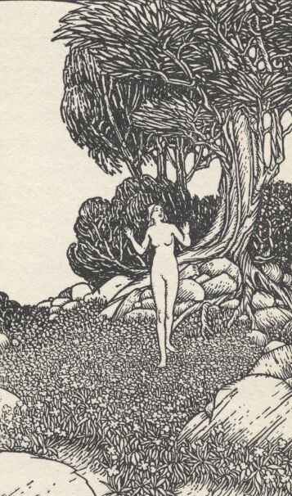
夏娃总是在忙着做一些傻事
星期六
星期二的时候我离开了夏娃，走了很久之后又找了一块地方让自己栖身。结果，尽管我努力清除过痕迹，夏娃还是凭借被驯服的狼找到了我。她那用来看事物的小孔里又开始流水，还发出伤心的声音。我只好跟她回去，虽然还保留了出走的权力。
夏娃总是在忙着做一些傻事，比如她认为狮子和老虎们不应该吃草，而应该相互吞食。我觉得这是个愚蠢的念头，因为我了解“死亡”这个词语的含义，虽然这个园子里还没有出现过死亡。这个事实让我觉得有点遗憾。
Saturday

escaped last Tuesday night, and travelled two days, and built me another shelter, in a secluded place, and obliterated my tracks as well as I could, but she hunted me out by means of a beast which she has tamed and calls a wolf, and came making that pitiful noise again, and shedding that water out of the places she looks with. I was obliged to return with her, but will presently emigrate again, when occasion offers. She engages herself in many foolish things: among others, trying to study out why the animals called lions and tigers live on grass and flowers, when, as she says, the sort of teeth they wear would indicate that they were intended to eat each other. This is foolish, because to do that would be to kill each other, and that would introduce what, as I understand it, is called “death;” and death, as I have been told, has not yet entered the Park.
I

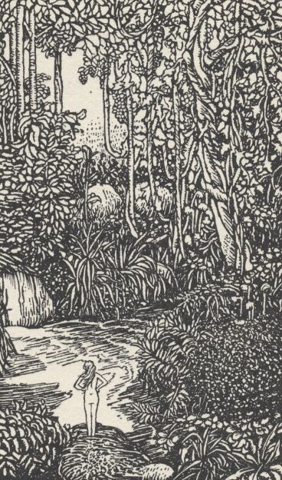
夏娃说她是用我的一根肋骨创造出来的
Which is a pity, on some accounts.
星期天
熬过一日。
Sunday

ulled through.
P
星期一
我觉得，整个星期都是用来消除星期天带来的疲倦的。夏娃又在攀爬那棵禁树，我用土块把她赶了下来。她觉得反正没有人会看见，似乎她觉得这是她行为的正当理由。听了我的话之后，她对“正当理由”这个美妙的词表示出了极大的赞叹，甚至还有一点点嫉妒。
Monday

believe I see what the week is for: it is to give time to rest up from the weariness of Sunday. It seems a good idea…. She has been climbing that tree again. Clodded her out of it. She said nobody was looking. Seems to consider that a sufficient justification for chancing any dangerous thing. Told her that. The word justification moved her admiration—and envy too, I thought. It is a good word.
I
星期二
夏娃说她是用我的一根肋骨创造出来的。我觉得这件事情值得

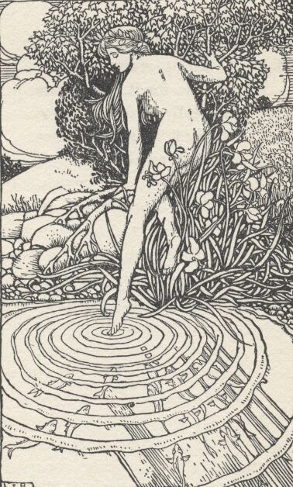
池塘边的夏娃
怀疑，因为我不记得自己丢失过肋骨。夏娃觉得秃鹰应该吃腐肉而不是青草。我认为秃鹰只能靠着园子里的食物活下去，不能为了它而破坏了园子的秩序。
Tuesday

he told me she was made out of a rib taken from my body. This is at least doubtful, if not more than that. I have not missed any rib…. She is in much trouble about the buzzard; says grass does not agree with it; is afraid she can’t raise it; thinks it was intended to live on decayed flesh. The buzzard must get along the best it can with what is provided. We cannot overturn the whole scheme to accommodate the buzzard.
S
星期六
昨天，夏娃掉进了池塘。而之前，她正和往常一样在水中观看自己的影子。她说差点被淹死的感觉很不好，于是她很同情水里的鱼（她继续给各种东西起名字，这些名字没有什么意义，所以她只是个傻瓜而已），并把这些鱼从池塘里捞起来，放到我的床上让它们休息。我没有发现这些鱼更加快乐，它们只是显得很安静。
我要把这些鱼扔出门外，和它们睡在一起是一件很不舒服的 事情。
Saturday

he fell in the pond yesterday, when she was looking at herself in it, which she is always doing. She nearly strangled, and
S

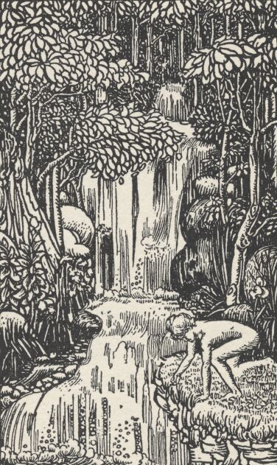
她很同情水里的鱼
said it was most uncomfortable. This made her sorry for the creatures which live in there, which she calls fish, for she continues to fasten names on to things that don’t need them and don’t come when they are called by them, which is a matter of no consequence to her, as she is such a numskull anyway; so she got a lot of them out and brought them in last night and put them in my bed to keep warm, but I have noticed them now and then all day, and I don’t see that they are any happier there than they were before, only quieter. When night comes I shall throw them out-doors. I will not sleep with them again, for I find them clammy and unpleasant to lie among when a person hasn’t anything on.
星期天
又是一天。
Sunday

ulled through.
P
星期二
夏娃和一条蛇走得很近，其他担心自己被做实验的动物都很高兴。我也很高兴，因为那条蛇会说话，我可以轻松一下了。
Tuesday

he has taken up with a snake now. The other animals are glad, for she was always experimenting with them and bothering
S

