1．波 莉 小 姐
Miss Polly
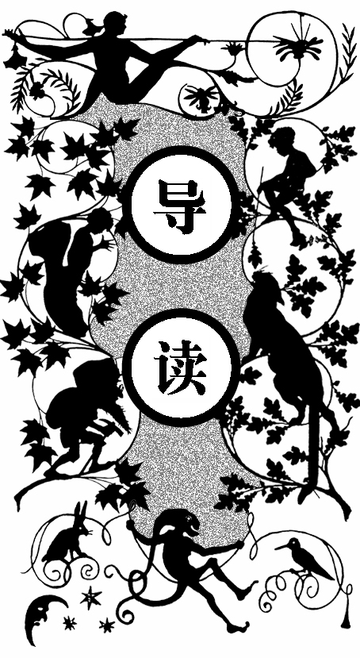
一个六月的清晨，向来以从容矜持的波莉·哈林顿小姐急匆匆地冲进了厨房，把女仆南希吓了一大跳。南希在哈林顿老宅工作了两个月，已经充分体会到了女主人出了名的坏脾气，却从未见过她表现得如此失态。
使得波莉小姐如此匆忙的原因，是她那11岁的外甥女——波莉安娜·惠蒂尔小姐马上要过来和她一起生活了。波莉小姐的姐姐詹妮，在20岁时不顾全家人的反对，拒绝了镇上另一位富有的年轻人的追求，选择和一位牧师私奔。之后就发生了家庭决裂，詹妮寄过来的最后一封信，写的是她用两位妹妹的名字——波莉和安娜——给自己的小女儿取名为“波莉安娜”。几年后，詹妮就过世了。而在两天前，波莉小姐又收到从遥远的西部寄来的一封信，告诉她惠蒂尔牧师也告别了人世，只留下一个女儿，希望波莉小姐将小女孩抚养长大。
波莉小姐立刻回信，表示肯定会收留这个孩子。她眉头紧皱地吩咐南希将阁楼打扫干净，同时又为自己能够好好履行职责而感到自豪。只是，她默默地想：“‘波莉安娜’——这个名字太荒唐了！”

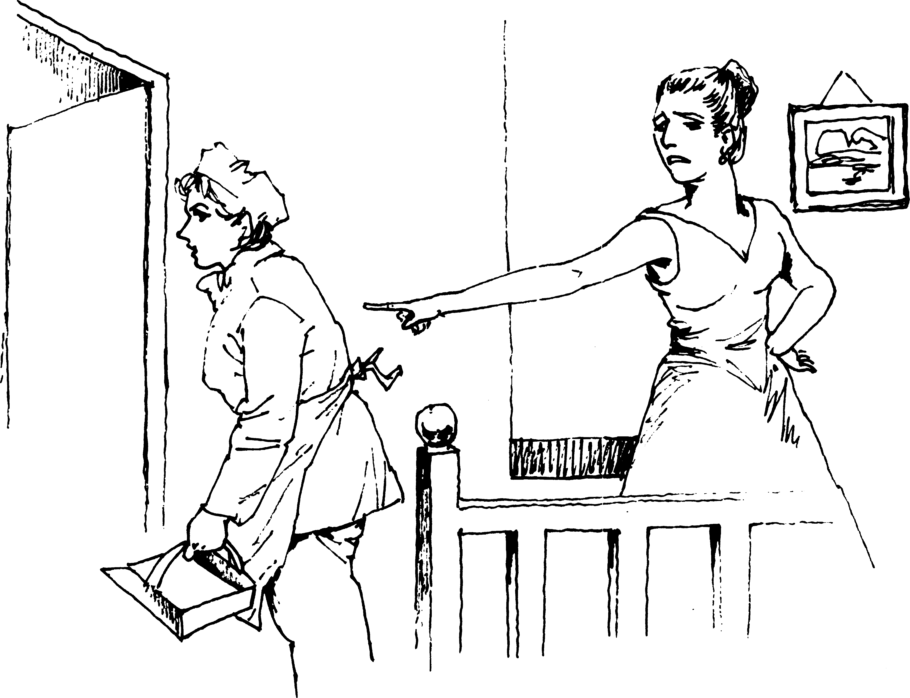
波莉小姐吩咐南希将阁楼打扫干净

iss Polly Harrington entered her kitchen a little hurriedly this June morning. Miss Polly did not usually make hurried movements; she specially prided herself on her repose of manner. But to-day she was hurrying—actually hurrying.
M
Nancy, washing dishes at the sink, looked up in surprise. Nancy had been working in Miss Polly’s kitchen only two months, but already she knew that her mistress did not usually hurry.
“Nancy!”
“Yes, ma’am.” Nancy answered cheerfully, but she still continued wiping the pitcher in her hand.
“Nancy,”—Miss Polly’s voice was very stern now— “when I’m talking to you, I wish you to stop your work and listen to what I have to say.”
Nancy flushed miserably. She set the pitcher down at once, with the cloth still about it, thereby nearly tipping it over—which did not add to her composure.
“Yes, ma’am; I will, ma’am,” she stammered, righting the pitcher, and turning hastily. “I was only keepin’ on with my work ‘cause you specially told me this mornin’ ter hurry with my dishes, ye know.”
Her mistress frowned.
“That will do, Nancy. I did not ask for explanations. I asked for your attention.”
“Yes, ma’am.” Nancy stifled a sigh. She was wondering if ever in any way she could please this woman. Nancy had never “worked out” before; but a sick mother suddenly widowed and left with three younger children besides Nancy herself, had forced the girl into doing something toward their support, and she had been so pleased when she found a place in the kitchen of the great house on the hill—Nancy had come from “The Corners,” six miles away, and she knew Miss Polly Harrington only as the mistress of the old Harrington homestead, and one of the wealthiest residents of the town. That was two months before. She knew Miss Polly now as a stern, severe-faced woman who frowned if a knife clattered to the floor, or if a door banged—but who never thought to smile even when knives and doors were still.
“When you’ve finished your morning work, Nancy,” Miss Polly was saying now, “you may clear the little room at the head of the stairs in the attic, and make up the cot bed. Sweep the room and clean it, of course, after you clear out the trunks and boxes.”
“Yes, ma’am. And where shall I put the things, please, that I take out?”
“In the front attic.” Miss Polly hesitated, then went on: “I suppose I may as well tell you now, Nancy. My niece, Miss Pollyanna Whittier, is coming to live with me. She is eleven years old, and will sleep in that room.”
“A little girl—coming here, Miss Harrington? Oh, won’t that be nice!” cried Nancy, thinking of the sunshine her own little sisters made in the home at “The Corners.”
“Nice? Well, that isn’t exactly the word I should use,” rejoined Miss Polly, stiffly. “However, I intend to make the best of it, of course. I am a good woman, I hope; and I know my duty.”
Nancy colored hotly.
“Of course, ma’am; it was only that I thought a little girl here might—might brighten things up for you,” she faltered.
“Thank you,” rejoined the lady, dryly. “I can’t say, however, that I see any immediate need for that.”
“But, of course, you—you’d want her, your sister’s child,” ventured Nancy, vaguely feeling that somehow she must prepare a welcome for this lonely little stranger.
Miss Polly lifted her chin haughtily.
“Well, really, Nancy, just because I happened to have a sister who was silly enough to marry and bring unnecessary children into a world that was already quite full enough, I can’t see how I should particularly want to have the care of them myself. However, as I said before, I hope I know my duty. See that you clean the corners, Nancy,” she finished sharply, as she left the room.
“Yes, ma’am,” sighed Nancy, picking up the half-dried pitcher—now so cold it must be rinsed again.
In her own room, Miss Polly took out once more the letter which she had received two days before from the far-away Western town, and which had been so unpleasant a surprise to her. The letter was addressed to Miss Polly Harrington, Beldingsville, Vermont; and it read as follows:
“Dear Madam: —I regret to inform you that the Rev. John Whittier died two weeks ago, leaving one child, a girl eleven years old. He left practically nothing else save a few books; for, as you doubtless know, he was the pastor of this small mission church, and had a very meagre salary.
“I believe he was your deceased sister’s husband, but he gave me to understand the families were not on the best of terms. He thought, however, that for your sister’s sake you might wish to take the child and bring her up among her own people in the East. Hence I am writing to you.
“The little girl will be all ready to start by the time you get this letter; and if you can take her, we would appreciate it very much if you would write that she might come at once, as there is a man and his wife here who are going East very soon, and they would take her with them to Boston, and put her on the Beldingsville train. Of course you would be notified what day and train to expect Pollyanna on.
“Hoping to hear favorably from you soon, I remain,
“Respectfully yours,
“Jeremiah O. White.”
With a frown Miss Polly folded the letter and tucked it into its envelope. She had answered it the day before, and she had said she would take the child, of course. She hoped she knew her duty well enough for that!—disagreeable as the task would be.
As she sat now, with the letter in her hands, her thoughts went back to her sister, Jennie, who had been this child’s mother, and to the time when Jennie, as a girl of twenty, had insisted upon marrying the young minister, in spite of her family’s remonstrances. There had been a man of wealth who had wanted her—and the family had much preferred him to the minister; but Jennie had not. The man of wealth had more years, as well as more money, to his credit, while the minister had only a young head full of youth’s ideals and enthusiasm, and a heart full of love. Jennie had preferred these—quite naturally, perhaps; so she had married the minister, and had gone south with him as a home missionary’s wife.
The break had come then. Miss Polly remembered it well, though she had been but a girl of fifteen, the youngest, at the time. The family had had little more to do with the missionary’s wife. To be sure, Jennie herself had written, for a time, and had named her last baby “Pollyanna” for her two sisters, Polly and Anna—the other babies had all died. This had been the last time that Jennie had written; and in a few years there had come the news of her death, told in a short, but heart-broken little note from the minister himself, dated at a little town in the West.
Meanwhile, time had not stood still for the occupants of the great house on the hill. Miss Polly, looking out at the far-reaching valley below, thought of the changes those twenty-five years had brought to her.
She was forty now, and quite alone in the world. Father, mother, sisters—all were dead. For years, now, she had been sole mistress of the house and of the thousands left her by her father. There were people who had openly pitied her lonely life, and who had urged her to have some friend or companion to live with her; but she had not welcomed either their sympathy or their advice. She was not lonely, she said. She liked being by herself. She preferred quiet. But now—
Miss Polly rose with frowning face and closely-shut lips. She was glad, of course, that she was a good woman, and that she not only knew her duty, but had sufficient strength of character to perform it. But—pollyanna!—what a ridiculous name!

2．老汤姆和南希
Old Tom and Nancy
南希在小小的阁楼上忙活了一上午，之后，她在花园里和老汤姆聊了会儿天。
老汤姆在老宅干活已经有些年头了，他听说会有个小女孩过来和波莉小姐一起住，立刻露出嘲讽而不可置信的神色。在南希一再担保下，他才小声地猜测道：“那么，一定是詹妮小姐的女儿，只有她结婚了！感谢上帝！”
南希接道：“可是波莉小姐居然安排那个女孩住在阁楼里，这简直是侮辱！”
老汤姆听出了南希对女主人的不满，他咧开嘴笑了：“看来你不喜欢波莉小姐。”
“好像会有人喜欢她似的！”南希的语气充满了不屑。
老汤姆又古怪地笑了一下，慢悠悠地说：“那你一定不知道波莉小姐的爱情故事。大家都知道这件事，那个人也还住在镇上。而且，波莉小姐以前真的很美，只是自打遇到了爱情挫折之后，她就彻底变了，整天生活在痛苦之中，变得越来越不可理喻。”
南希听得目瞪口呆，还来不及多说什么，波莉小姐那尖利的声音又响了起来：“南希！”她只得一边回应着，一边忙不迭地朝房子

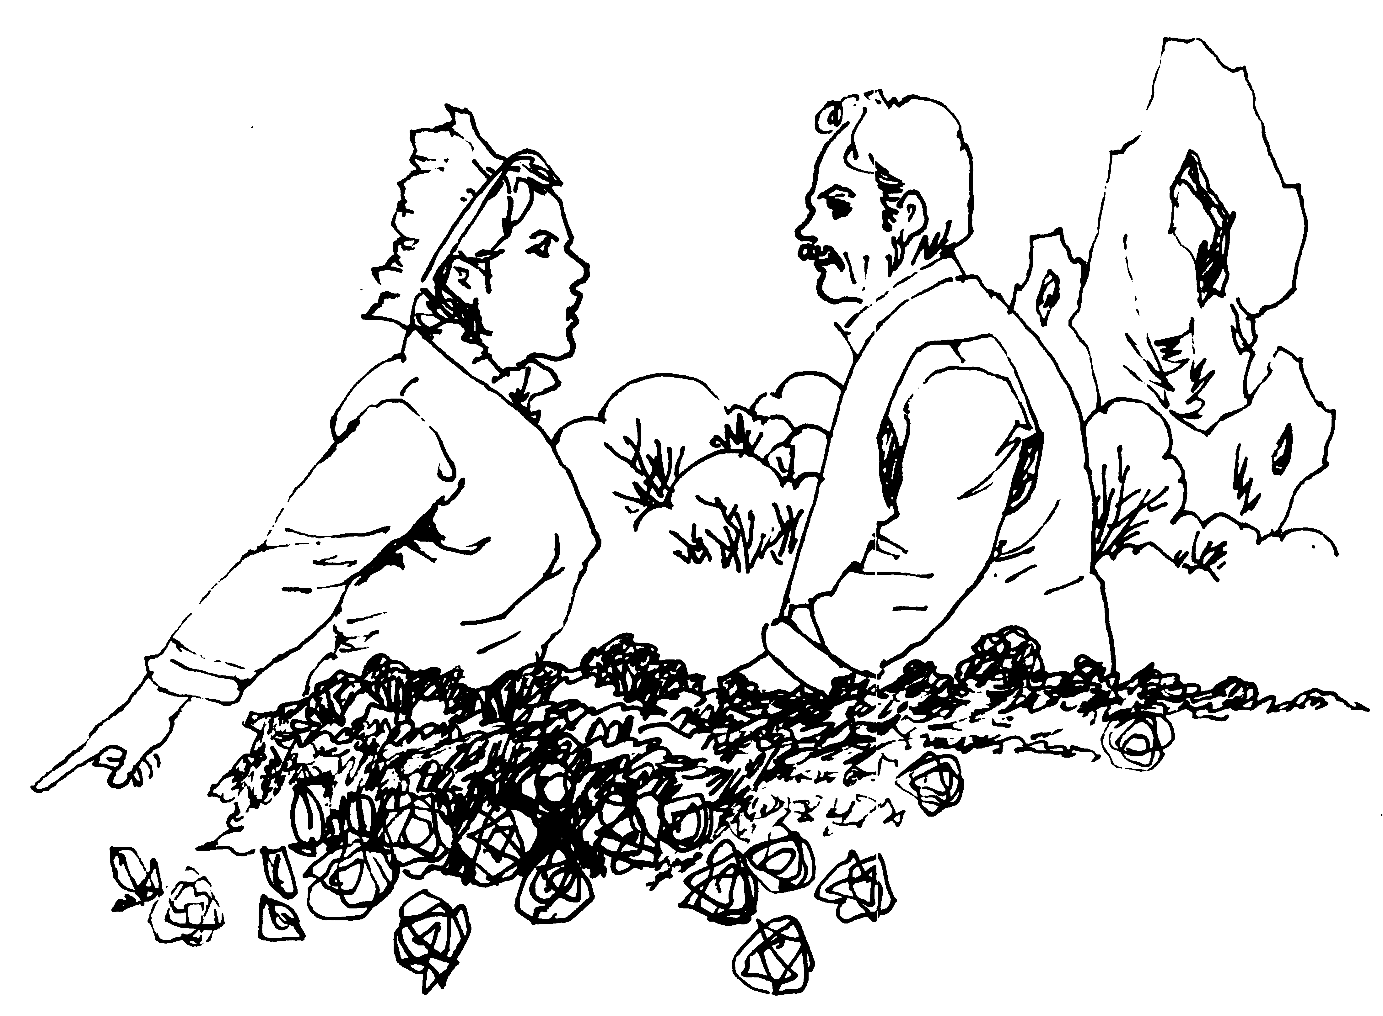
南希和老汤姆在花园聊天
走去。

n the little attic room Nancy swept and scrubbed vigorously, paying particular attention to the corners. There were times, indeed, when the vigor she put into her work was more of a relief to her feelings than it was an ardor to efface dirt—Nancy, in spite of her frightened submission to her mistress, was no saint.
I
“I—just—wish—I could—dig—out the corners—of—her— soul!” she muttered jerkily, punctuating her words with murderous jabs of her pointed cleaning-stick. “There’s plenty of ‘em needs cleanin’ all right, all right! The idea of stickin’ that blessed child ‘way off up here in this hot little room—with no fire in the winter, too, and all this big house ter pick and choose from! Unnecessary children, indeed! Humph!” snapped Nancy, wringing her rag so hard her fingers ached from the strain; “I guess it ain’t children what is most unnecessary just now, just now!”
For some time she worked in silence; then, her task finished, she looked about the bare little room in plain disgust.
“Well, it’s done—my part, anyhow,” she sighed. “There ain’t no dirt here—and there’s mighty little else. Poor little soul!—a pretty place this is ter put a homesick, lonesome child into!” she finished, going out and closing the door with a bang, “Oh!” she ejaculated, biting her lip. Then, doggedly: “Well, I don’t care. I hope she did hear the bang,—I do, I do!”
In the garden that afternoon, Nancy found a few minutes in which to interview Old Tom, who had pulled the weeds and shovelled the paths about the place for uncounted years.
“Mr. Tom,” began Nancy, throwing a quick glance over her shoulder to make sure she was unobserved; “did you know a little girl was comin’ here ter live with Miss Polly?”
“A—what?” demanded the old man, straightening his bent back with difficulty.
“A little girl—to live with Miss Polly.”
“Go on with yer jokin’,” scoffed unbelieving Tom. “Why don’t ye tell me the sun is a-goin’ ter set in the east ter-morrer?”
“But it’s true. She told me so herself,” maintained Nancy. “It’s her niece; and she’s eleven years old.”
The man’s jaw fell.
“Sho!—I wonder, now,” he muttered; then a tender light came into his faded eyes. “It ain’t—but it must be—Miss Jennie’s little gal! There wasn’t none of the rest of ‘em married. Why, Nancy, it must be Miss Jennie’s little gal. Glory be ter praise! ter think of my old eyes a-seein’ this!”
“Who was Miss Jennie?”
“She was an angel straight out of Heaven,” breathed the man, fervently; “but the old master and missus knew her as their oldest daughter. She was twenty when she married and went away from here long years ago. Her babies all died, I heard, except the last one; and that must be the one what’s a-comin’.”
“She’s eleven years old.”
“Yes, she might be,” nodded the old man.
“And she’s goin’ ter sleep in the attic—more shame ter HER!” scolded Nancy, with another glance over her shoulder toward the house behind her.
Old Tom frowned. The next moment a curious smile curved his lips.
“I’m a-wonderin’ what Miss Polly will do with a child in the house,” he said.
“Humph! Well, I’m a-wonderin’ what a child will do with Miss Polly in the house!” snapped Nancy.
The old man laughed.
“I’m afraid you ain’t fond of Miss Polly,” he grinned.
“As if ever anybody could be fond of her!” scorned Nancy.
Old Tom smiled oddly. He stooped and began to work again.
“I guess maybe you didn’t know about Miss Polly’s love affair,” he said slowly.
“Love affair—her! No!—and I guess nobody else didn’t, neither.”
“Oh, yes they did,” nodded the old man. “And the feller’s livin’ ter-day—right in this town, too.”
“Who is he?”
“I ain’t a-tellin’ that. It ain’t fit that I should.” The old man drew himself erect. In his dim blue eyes, as he faced the house, there was the loyal servant’s honest pride in the family he has served and loved for long years.
“But it don’t seem possible—her and a lover,” still maintained Nancy.
Old Tom shook his head.
“You didn’t know Miss Polly as I did,” he argued. “She used ter be real handsome—and she would be now, if she’d let herself be.”
“Handsome! Miss Polly!”
“Yes. If she’d just let that tight hair of hern all out loose and careless-like, as it used ter be, and wear the sort of bunnits with posies in ‘em, and the kind o’ dresses all lace and white things—you’d see she’d be handsome! Miss Polly ain’t old, Nancy.”
“Ain’t she, though? Well, then she’s got an awfully good imitation of it—she has, she has!” sniffed Nancy.
“Yes, I know. It begun then—at the time of the trouble with her lover,” nodded Old Tom; “and it seems as if she’d been feedin’ on wormwood an’ thistles ever since—she’s that bitter an’ prickly ter deal with.”
“I should say she was,” declared Nancy, indignantly. “There’s no pleasin’ her, nohow, no matter how you try! I wouldn’t stay if ‘twa’n’t for the wages and the folks at home what’s needin’ ‘em. But some day—some day I shall jest b’ile over; and when I do, of course it’ll be good-by Nancy for me. It will, it will.”
Old Tom shook his head.
“I know. I’ve felt it. It’s nart’ral—but ‘tain’t best, child; ‘tain’t best. Take my word for it, ‘tain’t best.” And again he bent his old head to the work before him.
“Nancy!” called a sharp voice.
“Y-yes, ma’am,” stammered Nancy; and hurried toward the house.

3．波莉安娜来了
The Coming of Pollyanna
第二天，蒂莫西驾驶着马车带南希一同去车站接波莉安娜。波莉小姐告诉南希，电报上说小女孩是“浅色头发，穿红格子裙，戴草帽”，并且在南希发表意见之前，态度严厉地表示她不认为自己需要亲自去接她的外甥女。
一到车站，南希就跳下车，全神贯注地望着乘客下车的方向。很快，一个苗条的、穿着红格子裙、草帽下有着长满雀斑的小脸的小姑娘出现在了南希的视野中。小姑娘神色急切，显然是在找什 么人。
南希一眼就认出了这孩子，她的双腿变得十分不听使唤，半天才走到女孩面前，试探性地问道：“你是——波莉安娜小姐？”
一个热切的声音顿时响了起来，小女孩踮起脚尖使劲地打量着尴尬的南希，嚷嚷着：“啊，见到您实在太高兴了！没错，我是波莉安娜，我一直希望您能来接我。我一路上都在想象您长什么样儿呢，现在我知道了，您就该是这个模样。”
蒂莫西走了过来，三个人一起上了马车。波莉安娜舒适地坐在蒂莫西和南希中间，不停地说这说那，像连珠炮似的，弄得南希晕

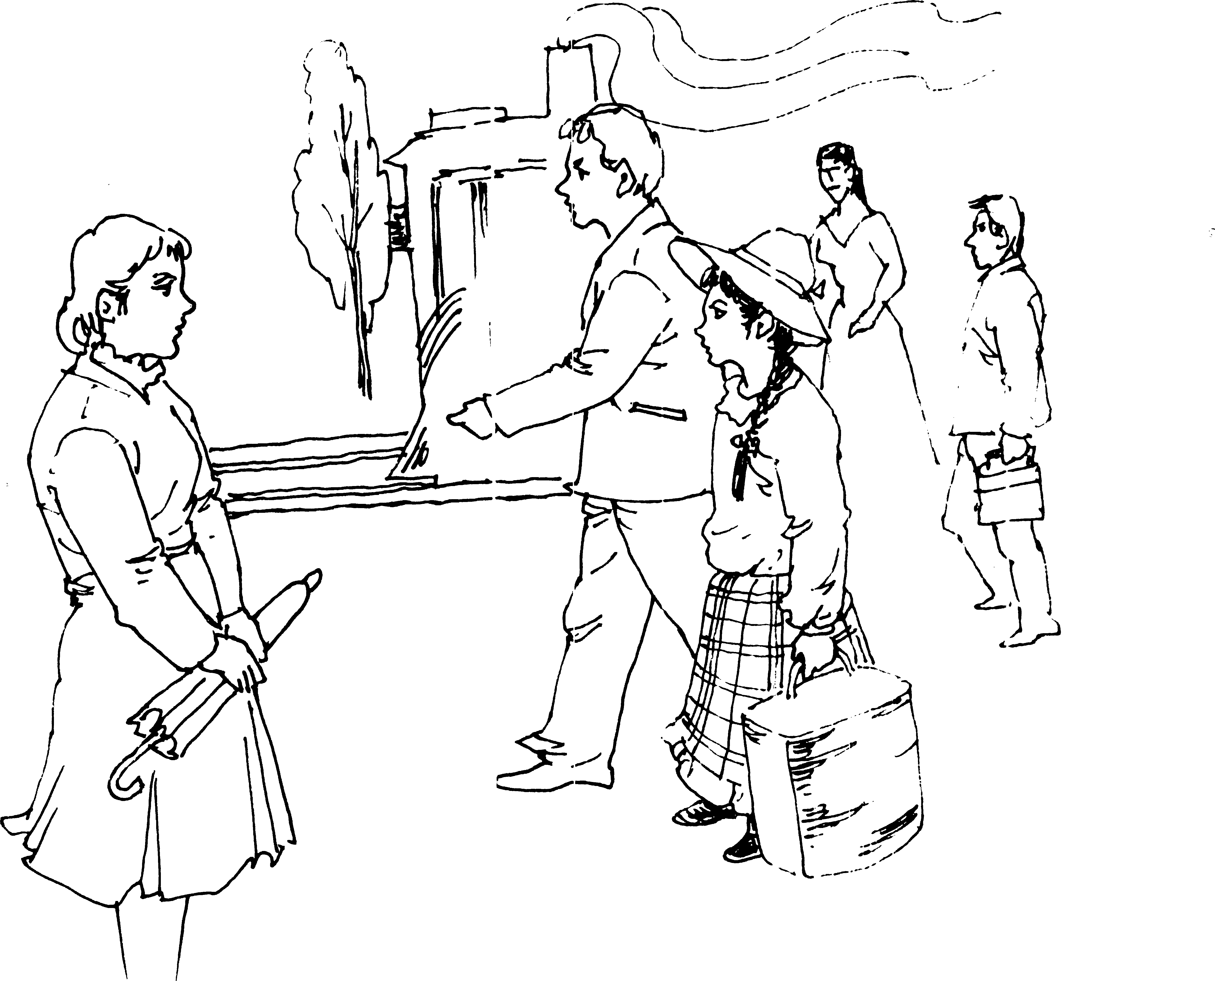
小姑娘显然在找什么人
晕乎乎的。直到女孩对南希说：“爸爸到天堂和妈妈还有姐姐们重逢了，不过，现在有波莉姨妈你在，我相信日子一定会过得很开心的！”顿时把可怜的南希给吓醒了。
“亲爱的……你犯了个大错误，我不是你的波莉姨妈……我是南希，波莉小姐雇的女仆。”南希磕磕巴巴地解释道。
波莉安娜脸上显出了失望的神色，她沉默了一会儿，突然欢快地说：“但是有波莉姨妈这个人，不是吗？而且，我也很高兴身边还有你做伴儿呀。”

n due time came the telegram announcing that Pollyanna would arrive in Beldingsville the next day, the twenty-fifth of June, at four o’clock. Miss Polly read the telegram, frowned, then climbed the stairs to the attic room. She still frowned as she looked about her.
I
The room contained a small bed, neatly made, two straight- backed chairs, a washstand, a bureau—without any mirror—and a small table. There were no drapery curtains at the dormer windows, no pictures on the wall. All day the sun had been pouring down upon the roof, and the little room was like an oven for heat. As there were no screens, the windows had not been raised. A big fly was buzzing angrily at one of them now, up and down, up and down, trying to get out.
Miss Polly killed the fly, swept it through the window (raising the sash an inch for the purpose), straightened a chair, frowned again, and left the room.
“Nancy,” she said a few minutes later, at the kitchen door, “I found a fly up-stairs in Miss Pollyanna’s room. The window must have been raised at some time. I have ordered screens, but until they come I shall expect you to see that the windows remain closed. My niece will arrive to-morrow at four o’clock. I desire you to meet her at the station. Timothy will take the open buggy and drive you over. The telegram says ‘light hair, red-checked gingham dress, and straw hat.’ That is all I know, but I think it is sufficient for your purpose.”
“Yes, ma’am; but—you—”
Miss Polly evidently read the pause aright, for she frowned and said crisply:
“No, I shall not go. It is not necessary that I should, I think. That is all.” And she turned away—Miss Polly’s arrangements for the comfort of her niece, Pollyanna, were complete.
In the kitchen, Nancy sent her flatiron with a vicious dig across the dish-towel she was ironing.
“‘Light hair, red-checked gingham dress, and straw hat’—all she knows, indeed! Well, I’d be ashamed ter own it up, that I would, I would—and her my onliest niece what was a-comin’ from ‘way across the continent!”
Promptly at twenty minutes to four the next afternoon Timothy and Nancy drove off in the open buggy to meet the expected guest. Timothy was Old Tom’s son. It was sometimes said in the town that if Old Tom was Miss Polly’s right-hand man, Timothy was her left.
Timothy was a good-natured youth, and a good-looking one, as well. Short as had been Nancy’s stay at the house, the two were already good friends. To-day, however, Nancy was too full of her mission to be her usual talkative self; and almost in silence she took the drive to the station and alighted to wait for the train.
Over and over in her mind she was saying it “light hair, red-checked dress, straw hat.” Over and over again she was wondering just what sort of child this Pollyanna was, anyway.
“I hope for her sake she’s quiet and sensible, and don’t drop knives nor bang doors,” she sighed to Timothy, who had sauntered up to her.
“Well, if she ain’t, nobody knows what’ll become of the rest of us,” grinned Timothy. “Imagine Miss Polly and a noisy kid! Gorry! there goes the whistle now!”
“Oh, Timothy, I—I think it was mean ter send me,” chattered the suddenly frightened Nancy, as she turned and hurried to a point where she could best watch the passengers alight at the little station.
It was not long before Nancy saw her—the slender little girl in the red-checked gingham with two fat braids of flaxen hair hanging down her back. Beneath the straw hat, an eager, freckled little face turned to the right and to the left, plainly searching for some one.
Nancy knew the child at once, but not for some time could she control her shaking knees sufficiently to go to her. The little girl

